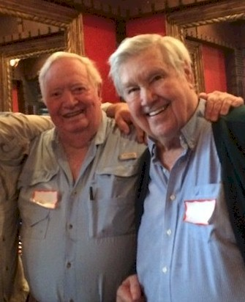
King Sprott

Notable – Montgolfier Award, Records
THE BEGINNING
In January, 1970, I spotted a magazine article about hot air ballooning that mentioned Deke Sonnichsen, Charles MacArthur, and Tracy Barnes. I called each the same day, and made arrangements with Tracy for instructions.
In June, 1970, at 36, I trained for four days with Tracy in Charlotte, North Carolina, and received my commercial ballooning license and instructors permit. My mandatory 5000 foot flight, my one hour solo, and my solo check ride all occurred on June 16, 1970. I made my first flight in my Raven S-50 in my home town of Lakeland, Florida on December 12, 1970. My swan song to ballooning occurred in the same place on August 2, 2003, at age 69.
2015 Joe Kittinger & King Sprott
BALLOONING COMPETITION
I actually saw another balloon flying for the first time when I went to the BFA Nationals in 1972. I competed there and finished virtually last (Deke Sonnichsen deliberately finished last to display his contempt for ballooning competition - I, on the other hand, was doing my very best and barely finished ahead of him). At the Nationals the barograph competition had been critical, and I was totally incompetent. However, I went home and bought one to prepare for the US team trials for the World Championship to be held in February, 1973. The team trials were to be the first week in Albuquerque and the World Championship the second week.
Against the same competition I faced in Indianola the preceding August, I missed making the US team by only one position. The competitor next above me made the US team. That, I am compelled to add, was the high water mark of my BFA balloon competition skills. I was never very good at navigating the winds. After I mastered the barograph it was abolished as a competition tool, and I was forever thereafter baying at the back of the pack in the hound and hare, and such.
COMMERCIAL
Raven Industries awarded me their Southeastern balloon distributorship in 1973, and I actively pursued the operation of it with numerous dealers in numerous states until 1980 when I transferred it to my premier dealer, Colvin Rouse. My dealers and I sold many commercial and personal balloons for Raven in that period, but my most spectacular sale came in the first month of the distributorship. Walt Disney World had just moved to Orlando and I sold them four S-55 super-pressure super-electric-lighted balloons to be flown 250 feet high in their late night fireworks show!
During the time I was with Raven there were only seven national distributorships. They were held by Bob Waligunda, Matt Wiederkehr, Dennis Floden, Chauncey Dunn, Sid Cutter, myself, and a chap from California whom I can no longer recall. It was quite a lineup - I had a couple of records and the Andes, Sid had all the goings-on at Albuquerque, Chauncey had records and his aura, Denny had the First World Championship, Matt had countless records, and Waligunda was simply Waligunda. There were no shrinking violets at Distributors meetings!
During my life as a commercial balloonist I instructed a relatively small number of students, just thirteen. One of those was Colvin Rouse, who I know subsequently taught a stupendous number.
A year or so ago I was chatting with Bob Carlton, an old friend and a very experienced balloonist, and he made reference to a LIFE check list. I asked, what is that? He said, “lines,” “fuel,” “that sort of stuff.” I asked where he got it, and he said “it’s around.” Here’s where he got it . .
After a particularly stupid flight in 1972, in which I flew with the vent line beyond reach outside the balloon skirt, it came to me, after the crash landing, that some form of pre-flight check list could be a useful safety measure. I puzzled over it for several days and came up with LIFE: L=lines (are they tied off within reach); I=instruments (are they in place and are they functioning); F=fuel (is it sufficient for your purposes, with surplus); E=envelope (inspect it inflated for anomalies from top to bottom before takeoff). Every one of my students after 1972 had the benefit of that checklist, Colvin included. Colvin then passed it on to his students, and to Bob who started working for Colvin as a professional balloonist several decades ago . .
BALLOON FEDERATION OF AMERICA
I had, of course, gotten to know all the attendees at the Nationals in 1972, and then all over again at the Albuquerque event in February, 1973. Pretty much the same folks attended the 1973 Nationals. That year I was elected to the Board of Directors of the BFA and served a three year term, and in my third year was elected by the Board to serve as Treasurer.
In January, 1974, I was asked to travel to Santa Ana, California to participate as an “instructor” in a four day FAA seminar for thirty flight examiners. The mission was to give them the skills to check-ride balloonists across thirty FAA regions of the US. My fellow-instructors in the endeavor were Bruce Comstock (then President of the BFA), Clayton Thomas, and Ted Farrell. Also assisting, as “manufacturers’ representatives,” were Jim Winker, Deke Sonnichsen, and several others I can no longer recall. We conducted the instruction in a cavernous naval blimp hangar. At the conclusion, for our considerable expense and effort, we each received an FAA’s big “E” on a wood plaque! (I discovered a few years ago it did not have much negotiation value when the FAA coveted my license for 60 days, in consequence of landing - uninvited - 2000 feet from a taxiway on Lakeland’s class D airport).
That seminar was quintessentially significant. When I had my so-called check-ride on June 16, 1970, the FAA examiner had refused to fly with me. This was a common occurrence across the country. In fact, the area FAA examiner for central Florida had declined to fly with any of my students up until the time of that seminar, which he attended, but he started flying with the students after the seminar. That seminar seemingly turned the tide in some, if not all, the regions across the country.
In my last year on the Board Don Kersten was President and he assigned me as liaison to the National Aeronautics Association, making me therefore a member of the NAA Board. I held that position for some years (can’t remember how long anymore), and for that time I flew to Washington every three months to attend their Board meetings on behalf of the BFA.
ALTITUDE RECORDs
In the years of 1974 through 1977 I made seven open-basket flights above 30,000 feet. One of those flights, on December 7, 1974, established an AX-7 world record at 32,260 feet. Another, on September 27, 1975, established both AX- 8 and AX-9 world records at 38,789 feet.
The 38,789 foot flight was an unpressurized flight in all respects. The balloon was able to reach that rarefied altitude only because of an oxygen augmentation system I devised and integrated into Raven’s burner assembly.
Joseph Starkbaum, of Austria, exceeded my AX-7 record 21 years later with a flight to 45,979 feet, which still stands. Twenty-four years after my AX-8 flight, Starkbaum took that record with a flight to 49,236 feet, which also still stands. And, finally, my dear friend, Chauncey Dunn, in 1979, stripped me of the AX-9 jewel with a heroic flight to 52,985 feet. C’est la guerre.
ANDES
My good friend, and one-time student pilot, Bill Spohrer, and I, decided in 1976 to do something no one else had ever done before . . . i.e., fly a hot air balloon over the Andes from Chile to Argentina. To that end I purchased from Raven an experimental AX-9 (they had no type certificate for that size balloon, and I was not about to buy one for them!)
With that balloon we made several test flights in Florida simulating loads and altitudes and were totally satisfied. Chauncey Dunn was enlisted as crew chief. Bill and I went down in October and selected a takeoff point northeast of Santiago, at the foot of the Andes.
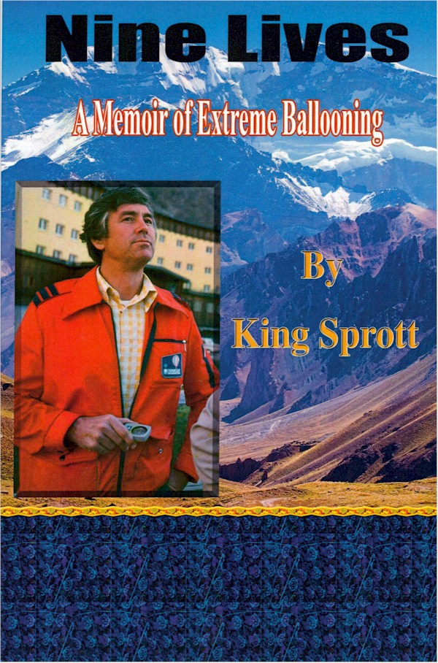
The whole team arrived in Chile on January 19, 1977, and made the trans-Andes flight on January 27. The game plan was simple: take off from a mile-wide valley, ascend to 20-25,000 feet (as needed), flow in the 50-75 mph current, land near an available village in Argentina in a couple of hours, and MISSION ACCOMPLISHED.
This was, obviously, not viewed as a high risk venture by the participants. But we were wrong. On three distinct occasions during that flight I thought I was drawing my last breath. Once when it seemed we would inexorably smash on a canyon wall; then, again, when we were laid horizontal - both envelope and basket - by a wind shear with 25 feet burned out of the envelope; and then when the burner inexplicably quit for some minutes over the High Andes.
WE MADE IT. The canyon wall was barely surmounted. The horizontal balloon righted itself like a sailboat laid on its side at sea. And the burners finally came to life after minutes of silence and thousands of feet of descent to peaks-level - when I finally cleared an ice-clogged valve, caused by watery propane.
(If anyone reading this biography should be interested in more detailed information about the Andes flight or the altitude flights, it is available in Nine Lives: A Memoir of Extreme Ballooning by King Sprott, available at Amazon.com.)

AWARDS AND HONORS
For each of the World Records I received a Diplome de Record from the FAI. And since each of the records was a US record, it resulted in a Certificate of Record from the National Aeronautics Association. I was awarded the Diplome Montgolfière by the FAI for the “remarkable ascension in a hot air balloon” resulting in the AX-8 and AX-9 records. I am extremely proud of it. When Don Piccard called to tell me it had been awarded, I almost exploded with joy. And no other messenger could have been more appropriate or have pleased as much.
Honors truly lie in the eye of the beholder. In my eye three events, based upon the venue and the individuals who accorded them, constituted “honors” I have received, and of which I am proud.
In 1979 Sid Cutter asked me to address the attendees of the banquet at his Albuquerque Fiesta about my multifarious experiences in ballooning. I did, and considered it a distinct honor that he would ask me to do so. In January of that same year Matt Wiederkehr invited me to address the attendees at the banquet of his St Paul Winter Carnival on the same broad subject. I did, and I likewise considered it an honor that he asked me to do so.
And at that same Winter Carnival, Maxie Anderson arrived with his brand new hot air replica of the Double Eagle trans-Atlantic gas balloon. He asked me to pilot him on a demo flight from White Bear Lake. I happily did so. We made a three mile tree-top flight over the snow covered landscape, and finished with a stand up landing in five feet of snow. We wrote our names in the snow, waiting for the chase crew. That happening was an altogether unique honor.

