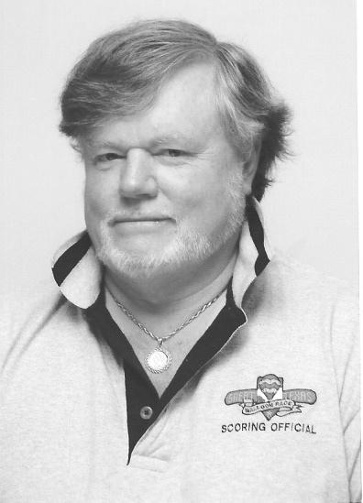
Jim Birk
Notable – Accomplishments/Contributions, Ed Yost Master Pilot Award
Jim Birk holds a graduate degree from Ball State University and was chairman of the Geology Department at Defiance College in Ohio from 1970 to 1982 and at Ashland University from 1982 to 1985. He has been married 39 years to his wife, Maryjo, a retired teacher and is the father of four daughters: Sara K. Birk, associate professor at University of Louisiana; Dr. Megan Birk, professor at the University of Texas Rio Grande Valley; Abbey Bauer, market research analyst and Dana Birk, sixth grade teacher at Lumberton, North Carolina.
Birk has spent nearly 50 years as a pilot, event director and organizer, competitor, business owner and promoter of hot air ballooning in the United States and around the world. He became a balloon pilot in 1970 and has over 4,000 hours of flight time. Soon after becoming a pilot he began teaching ballooning to students at Defiance College in Ohio where he was a professor of Geology.
At the college he began learning about balloon flight and taught an interterm class on ballooning which resulted in 13 students being licensed over five years in the program. The program was featured by Hughes Rudd on CBS. He taught similar classes at Indiana University/Purdue University at Fort Wayne (Ind.) which resulted in several more licensed pilots and the beginnings of the Fort Wayne Balloon Club. He assisted teaching at the Fort Wayne Ground School at Baer Field for students taking and passing the written free balloon test.
Birk organized the three race circuit in 1975 of the Azar’s Corporation in Fort Wayne, Angola and Elkhart. He served with Tom Sheppard and others as a representative to the FAA Conference in Phoenix to rewrite FAA 8900.
He was a competitor on the Kool Professional Balloon Tour and finished as a top ten money winner in 1978, 1979, 1980 and 1981. He was champion of six Kool Tour Regional Races. He has finished in the top 10 at six United States National Championships. He won the 1985 Wisconsin Dells Championship and 25 other local Regional Championships. He won the Findlay (Ohio) Flag City Balloon Race in 2014. In 1991 he was the top ranked pilot in the United States Competition Division. He was a member of the United States World Team in 1981, 1983, 1985 and 1991.
Birk was event director of the 1995 World Championships and Balloon Federation of America’s National Championship in 1981, 1982, 1983, 1984, 1987, 1989, 2012, 2013, 2014 and 2015. He was director of the North American Balloon Association (NABA) national championships from 1999 to 2007 and the NABA Team Championships in 1999 and 2000. He has been director of the Great Texas Balloon Race from 1993 to 2016, the Michigan Challenge from 1994 to 2016 and the Battle Creek Field of Flight from 1992 to 2016.
He has been director of the North American Championships, Lone Star Weekend Aloft, Summer Heat Championships, Freedom Weekend Aloft, Carson City (MI) Shoot Out Championship, Empire Polo Club $100,000 Race, Barrie Ontario Molson Championships and the Southeast Regional Championship and has organized 25 regional and national events.
He has been president of Air Venture of Fort Wayne, Inc., from 1978 to the present and Air Venture Contracting Inc. from 1985 to present. Birk was owner and operator of the Kroger Hot Air Balloon Program for 17 years and accumulated three million impressions. He also was owner and operator of the Pepe’ Hot Air Special Shape Balloon Program.
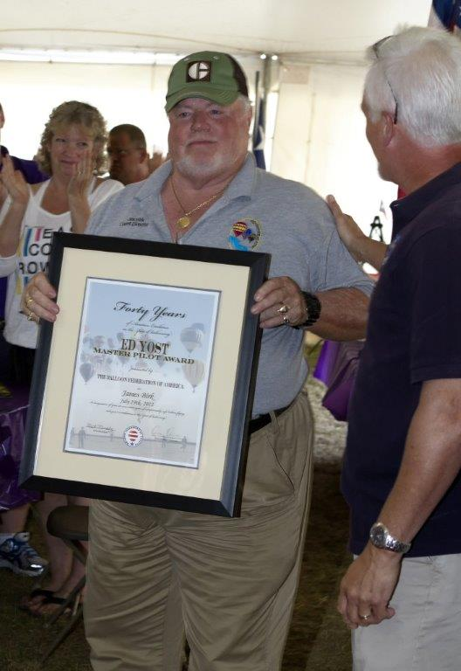
He is former Chairman of the BFA Events Committee and of the BFA Competition Division. He is past chairman of NABA. He has received eight BFA director’s awards, and eight president’s awards. His awards include the Shields Trauger Award in 1986, the Albert Desmond Award in 1991 for his contributions to competitive ballooning, the Rudy Briese Award from the Great Texas Balloon Race in 2012 and the Ed Yost Award in 2014. He was a consultant or expert witness for the defense in 19 cases involving ballooning accidents.

