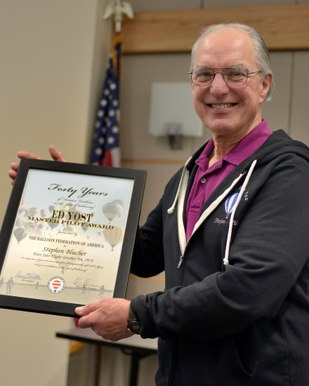
Stephen Blucher

Notable - Ed Yost Master Pilot Award

It is said there is no such thing as a coincidence, but something, in 1970, brought me together with Chauncey Dunn and the second hot air balloon in Colorado. As a commercial airplane pilot this different mode of flight was a come-on to a whole new adventure. The following four years were filled with learning experiences for me in the air and on the ground. I soloed 5 October 1974, when the balloon owner with whom I was flying, landed, got out and left me with her balloon while Chauncey and the other aerostat and pilots were across the highway discussing the finer points of trespassing with a landowner and sheriff’s deputy. The following day, I added the lighter-than-air, free balloon rating to my pilot certificate. (See attached certificate)
In 1974, I accompanied Chauncey to Albuquerque Fiesta where the Raven Industries promotional film “Ride the Gentle Breeze” was having final shots done (we had worked on it in Colorado). During that time I met Denny Floden who was to drift in and out of my ballooning career for several years until he hired me to fly Tony the Tiger in 1993. I was fortunate during my LTA history to also fly the Conoco and Interstate Bank balloons for the Granthams/World Balloons of Albuquerque.
Since 1984, I have had my own balloon company known as Rocky Mountain Hot Air Lines doing rides, promotions and teaching fledgling aeronauts the beauty and fun of flight. (see attached FAA Advanced Ground Instructor Rating) During my lighter-than-air career I have also had the pleasure of writing articles for various aviation publications, the longest running of which has been the on-going series of “FAR out” columns concerning regulations dealing with LTA flight, which have appeared in Ballooning, Balloon Life and various club newsletters.
From early in my ballooning career until 2015, announcing balloon events in various parts of the United States; Colorado, Ohio, Montana, Nevada, New York and Texas have added to the life adventures. I have also been pleased to participate, as an instructor, in LTA safety seminars in venues around our country.
Per the question about accidents; while not having any formal proceedings by the FAA or NTSB, and not being classified as an accident or incident, in January 1998, there was a situation. While I was in the basket, as the balloon was being moved from landing to a more suitable location for chase pickup, despite my direction, one of those helping, changed to “a better arroyo crossing route” before I could countermand the shift. In doing so, the envelope was walked into an overhead powerline, electricity grounded through the pyrometer cable into the dirt via a basket runner bolt. Two people helping were jolted but not enough to warrant a report per the NTSB representative I talked to shortly after.
Ballooning has been, and continues to be, a huge part of my life and I thank the committee for the opportunity to apply for this prestigious award.

