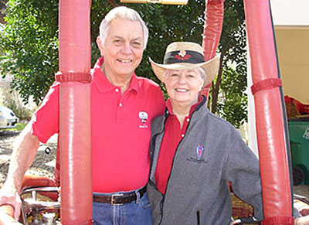
Sam Edwards

Notable – Ed Yost Master Pilot Award

Lives in Lakeway, Texas

Born August 24, 1935. Started flying airplanes in 1966; private pilot license on Dec. 16, 1966. First lesson in hot air balloons on Jan. 25, 1975; First solo in hot air balloon on May 31, 1975; instructor Bill Murtorff.
Commercial Hot Air Pilot with 2353.5 pilot hours; last biannual flight review on October 12, 2013. Balloon Federation of America Life Member #013300; served on BFA Board in the late 1970’s as Vice President.
Was a competitor in 26 National Championships starting in 1976 in Indianola, Iowa and a competitor in 3 World Championships and 3 North American Championships. .
Sam trained both of his daughters Cheri and Denise and his granddaughter Renai Eads as hot air pilots.
Helped start and run one of the first ballooning clubs in Texas, Tejas Aeronauts in 1975 and served as its President as well as helping instruct its members. Corporate Balloon Pilot for Touchstone Energy Cooperatives from 2000 thru 2014.
Sam and his wife Jean operate “A Better Way to Fly”, a small ride company.

