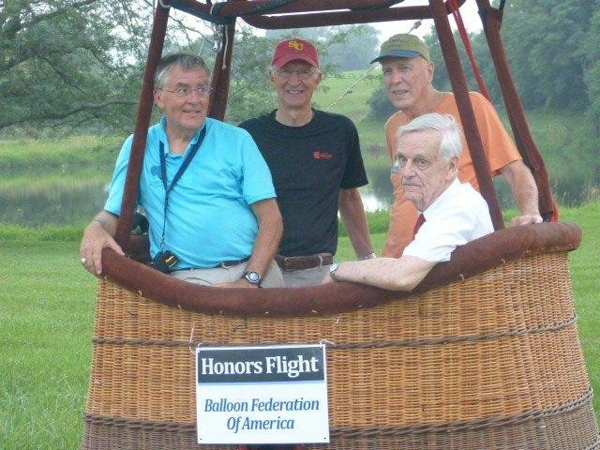
Harold Graves

Notable – Ed Yost Master Pilot Award

- First flight lesson 4/16/1974

- Solo Flight 5/21/1974

- Obtained Commercial

- Certificate 7/31/1974
BFA Award Committee Chair - Orvin Olivier , Master Pilot Recipient Gary Ruble, Ed Yost Master Pilot Recipient Harold Graves, Ed Yost Hall of Fame Member Don Piccard (Sitting)
- Has logged over 2000 LTA hours

- Attended over 350 balloon events including more than 25 US National

- Flew on US World Team in 2 World Championships

- Flown over 1000 tasks including more than 500 BFA sanctioned tasks, starting with the first BFA sanctioned event on 3/1/1975 in West Bend, WI

- Obtained Gas Balloon Pilot rating at age 73

- Founding member of Wisconsin Balloon Group 1975

- Original editor of Vent Line (WBG Newsletter) 1979

- More than 10 State Championships in both Wisconsin and South Dakota

- Attended 1974 US Nationals after seeing only 1 balloon (the one I learned to fly in)

- Every flight is still as thrilling as the early years

