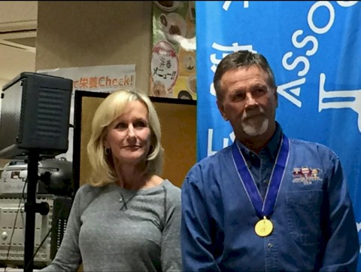
Joe Heartsill

Notable – Accomplishments/Contributions

My hot air ballooning adventures began in October 1979 when my wife, Nancy, and I were passing through Albuquerque, New Mexico on the way to Colorado. We couldn’t help but notice so many colorful balloons flying along the Rio Grande. Intrigued, we decided to stay the night in Albuquerque and get a closer look the next day. Less than twenty four hours later I had purchased my first hot air balloon, not even knowing how to fly. With the balloon and trailer in tow, I headed back home to Texas where I found out very quickly how important wind conditions are for flying balloons. I met pilot and now longtime friend, Steve Jones, who became my instructor. For the next several years, I was a fiesta pilot, flying for fun at various hot air balloon events. In July 1986, I attended my first Great Texas Balloon Race in Longview, Texas – The future was competition. In 1987, I won Rookie of the Year at the U.S. Nationals in Indianola, Iowa. I was the champion at Battle Creek International in 1988. Competitive hot air ballooning quickly became my passion.
U.S. National Championships:
1992 U.S. Nationals - Middletown, Ohio
1997 U.S. Nationals - Columbia, Missouri
1999 U.S. Nationals - Rantoul, Illinois
2007 U.S. Nationals - Anderson, South Carolina
2008 U.S. Nationals - Waco, Texas
1997 U.S. Team Champion – Battle Creek, Michigan
World Championships:
1995 World Champion – Battle Creek, Michigan
1993 World Championship, 3rd Place – Luxembourg
1997 World Championship, 3rd Place – Saga, Japan
2006 World Championship, 2nd Place – Motegi, Japan
Honda World Grand Prix Champion – Motegi, Japan
1998, 1999, 2002, 2004, 2005, 2008
2014 - Tochigi International Champion - My favorite and most rewarding championship.
Most Memorable Flight: Flying over spectacular Niagara Falls

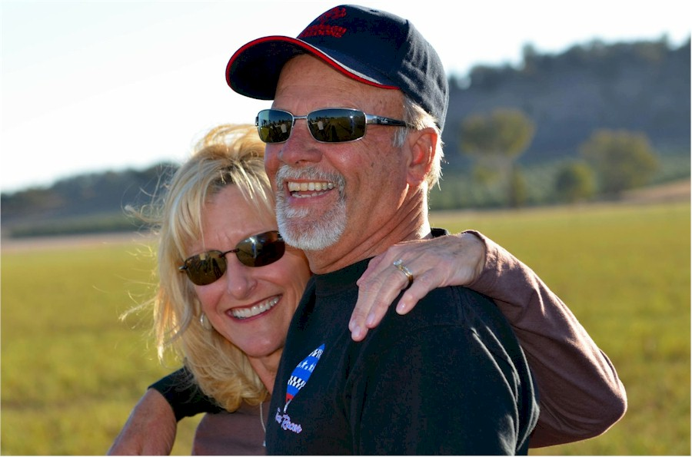
To my good fortune, my wife, Nancy Heartsill, is the “best crew chief in the world.”
Joe Heartsill

