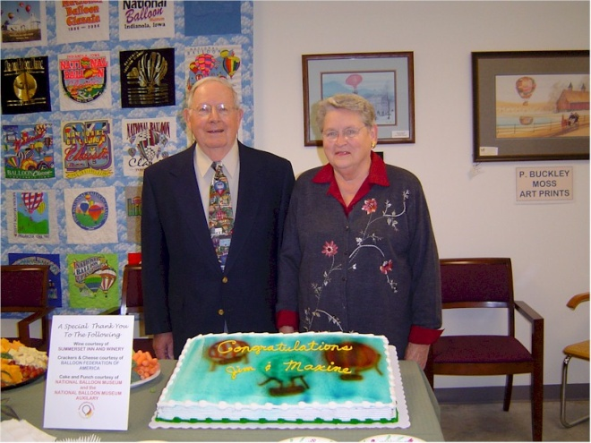
Jim & Maxine Weinman

Notable – Shield Trauger Award

Following is the 2005 nomination for Jim and Maxine Weinman for the Balloon Federation of America’s Shields/Trauger Award.
There are no two people more deserving for this award. Jim and Maxine have been involved on behalf of the BFA in the National Balloon Museum in Indianola, Iowa for more than 25 years. The Museum houses the BFA artifacts and serves as the focal point for the organizations history and the history of ballooning. These two people have dedicated their lives to keeping the history of the BFA and ballooning alive for our and future generations.
It all began in the spring of 1973, The Balloon Journal reported; "BFA president Bill Grabb has announced plans to establish a balloon museum in Indianola Iowa, with the cooperation of Simpson College". BFA, at that time, had a curator of their collection and a committee for the ballooning museum that worked with a committee from Indianola Balloon Incorporated.
Thus begins this journey of love and dedication to the BFA and to the National Balloon Museum for Jim and Maxine Weinman.
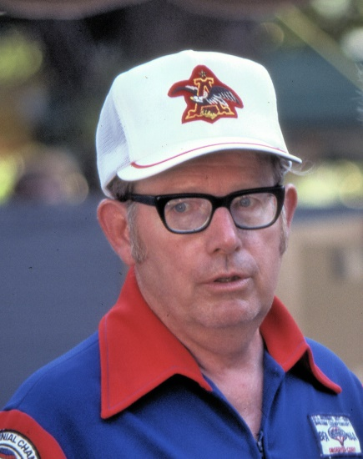
On August 30, 1977, Jim Weinman, President of Indianola Balloons Incorporated, asked Bryce Gause to see that the newly appointed National Balloon Museum board meet and organize. September 1, 1977, was the official date for the National Balloon Museum, Inc.
to commence existence. On September 30, 1977, the Indianola Balloons Incorporated museum committee reported a continued attempt to locate a building site and ongoing discussions with Balloon Federation of America.
For the 1979 BFA National Championships, Jim and Maxine, as Co-chairpersons for the combined BFA and IBI balloon museum committee developed the Balloon Museum display which was located in the old Lentz Chevrolet building located on Hwy. 65 & 69 just of east of the Indianola square.
On September 29, 1980, the treasurer of National Balloon Museum opened a National Balloon Museum building fund savings account with proceeds from pin sales by Maxine Weinman and others at the 1980 Nationals.
In 1983 the National Balloon Museum issued a commendation to Jim and Maxine Weinman for work done preparing the Museum display for the Nationals.
In 1987, Jim, charter board member of the National Balloon Museum, was elected as President. Maxine was appointed to serve on the National Balloon Museum Endowment Fund Committee. Jim also served on the building program as a co-chair and both were involved in the success of the original fund raising activity for the new Museum building in 1987. They were also involved in the most recent fund raising for the addition to the building that was completed this past year. This addition provided space for the BFA offices which were moved into the Museum this year.
Maxine has been the Museum curator with Jim from almost the beginning and has managed the gift shop since the beginning. She has personally picked out the items for the gift shop, which is one of the premier ballooning gift shops in the country. The proceeds from the gift shop have provided much of the funding that is needed for the operational expenses of the Museum.
The National Balloon Museum to this day does not have paid employees; volunteers run the entire museum. Maxine was instrumental in initiating the Museum Auxiliary, the volunteer organization that provides the daily staff to keep the Museum open. She probably has more volunteer hours than any other member of the Auxiliary.
Jim and Maxine's involvement with BFA and with the National Balloon Museum has been ongoing for many years. Jim was a BFA member from 1971 to 2003 when both chose to retire from active Museum participation. It is the appropriate time to honor them with the Shields Trauger Award.

