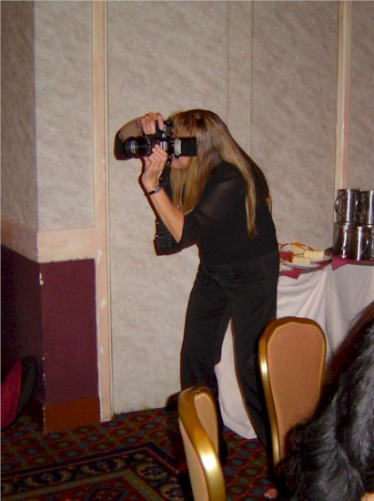
Cindy Petrehen

Notable – Shields Trauger Award

Cindy’s was born into the first family of ballooning. With five of her 11 sibling’s balloon pilots as well as her world record holding father, Cindy was a balloon pilot as well. However, it was very rare that you would find Cindy at the controls of the burners of a balloon. That is not to say she did not fly. Cindy logged more hours than most pilots per year and in more countries than most pilots will ever fly in a life time. Cindy had flown in balloons in the US, Mexico, Japan, Canada, Swaziland, and Europe to name of few of the countries.
She had attended events in all but a very few states in the United States. It is also a very safe bet to say that Cindy had flown at most if not all of the major events in the United States over the past 20 years. Not many pilots can say that.
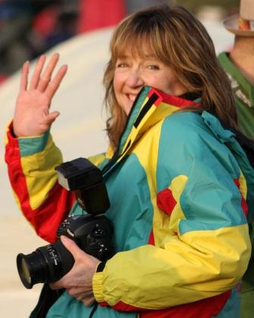
Through Cindy’s work, she has helped document our sport’s history thru pictures. Cindy’s had the ability to capture in pictures what most of us have tried to explain in a lifetime of words and are still trying to perfect. Cindy always wanted to get the shot right whether it was high from inside a balloon basket looking down on the canopies of color at Fiesta, to lying on her back looking up from a rice paddy road to get the view from the target looking up in Mogeti Japan during Worlds, she always had a way of getting the shot. Her pictures have drawn so many into our world that would never have experienced the beauty of our sport from the pilot view from the small child in Maine to the 83 year lady in Iowa that looks forward to Cindy’s calendar every year.
Cindy attended and was often a guest speaker at many safety seminars around the country. She attended the last BFA conference and who could forget her role as the poor plaintiff in the mock trial of the balloon pilot. Cindy was always ready and willing to help out to promote our sport.
Cindy had served the BFA as a reporter, photographer, and as Goodwill Ambassador for the BFA throughout the world. Cindy’s easy personally made her so approachable that most people would consider her a friend. She always was promoting the BFA where ever her travels would take her.

