Greg Winker

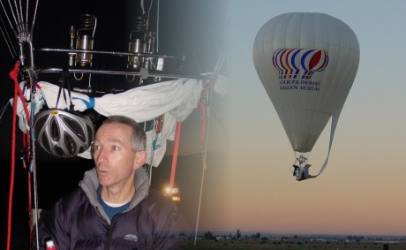
Notable – Accomplishments/Contributions, Montgolfier Diploma, Record
- Taught by his HOF father – Jim Winker
- First balloon flight – 8/22/62 at age 4
- Balloon Flights on 5 continents
- Solo flight 3/30/1974
- License 1/23/1975
- Gas certificate 2001
- AM-3 Rozier World Record Holder
- Montgolfier Diploma 2006
- 5 Time America’s Challenger competitor
- Constructed 11 balloon envelopes including the Ed Yost replica
- AX-3 Gas Balloon World Record Holder

Congratulations to Greg Winker for unofficially setting a new AX-3 duration record of 9 hours 26 minutes. The flight took place from Sioux Falls, SD on Sunday January 10, 2016 and breaks the previous record by almost two hours. The balloon that Greg was flying was an impressive homebuilt of his own design and manufacture. All the documentation and claim forms for this new record will soon be sent to the NAA for ratification by them and the FAI.

Following is information submitted by Orvin E. Olivier, Awards Chair, Balloon Federation of America in 1995 as justification for the Montgolfier Diploma

The basis for this nomination is Greg Winker’s record breaking flight in a AM-3 category Rozier balloon on October 1, 2005. Pending (as of 11/26/2005) is his record distance claim for both a USA National record and World Record.
Greg flew 573 miles, a 62% improvement over the current World Record of 353 miles.
As with other record attempts, this flight had its challenges. It proved that with careful planning, good technical gas ballooning knowledge and excellent piloting skills, difficulties can be overcome.
In preparing for the flight, Greg used computer models to plan the flight. Also, being a small balloon, and launching at a higher than normal altitude of 6000 feet, take-off weight was very critical. With a special built basket and nothing but essential gear, Greg was able to keep the weight very low.
The flight started out well with good speed; however during one part of the flight Greg was approaching a restricted military operating airspace and was forced to fly under it at an altitude below 500 feet. Not a good altitude for speed. Later in the flight, as the balloon was approaching its pressure altitude, Greg decided to try the gas valve. Greg pulled and pulled and pulled, but nothing happened; something was not allowing it to open. This was a serious problem.
With sunset approaching, Greg made a decision to keep flying. While flying through the night, his speed continued to increase; making the possibility of a fast landing without the important gas valve a real probability. Another potential problem is Greg was starting to approach a line of severe thunderstorms. He would have to cut his flight shorter than originally planned. At 4:00 in the morning, planning for his upcoming fast landing, Greg fired up the burners and took the balloon up to 13,200 feet, past its pressure altitude. This forced some of the helium out of the appendix, now causing the Rozier balloon to be heavy. This would assist with the landing.
At sunrise, Greg started his landing approach. At 800 feet above the surface, Greg was doing 70 miles per hour. At 300 feet, he was still going 65 miles per hour. This was going to be a thrilling landing. At the surface he was doing 30 miles per hour. After touching down and sliding for a quarter of a mile, the balloon came to rest. The AM-3 world distance record had just been shattered!
For this reason, the Balloon Federation of America would like to nominate Greg Winker for the Montgolfier Diploma in the Rozier category for 2005.

