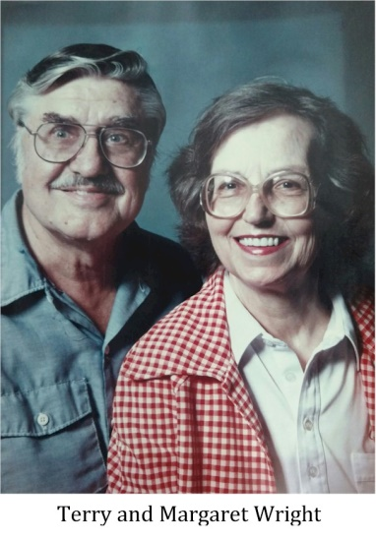
Theron (Terry) Wright

Notable – Accomplishments/Contributions, Development

Terry Wright was born in Farmersville, Ohio on November 25, 1927. He received his Bachelor of Aeronautical Engineering, with distinction in 1951 and a Master of Science in Mechanical Engineering in 1958 from the University of Minnesota. His aeronautical background goes back several generations. Milton Wright, the father of Orville and Wilbur Wright, who famously made the first successful airplane flight in 1903 at Kitty Hawk is a great-uncle of Terry. Terry got into flying balloons almost by accident. In the 1960s, he happened upon a guy in Minnesota who was having a technical problem with a hot air balloon and assisted the man, offering advice from his knowledge as an engineer. That man was Tracy Barnes. Terry caught the hot air balloon bug that day. He moved his family to Chester, SC a few years later in 1965 with Tracy Barnes and several others. The company was to later become The Balloon Works in Statesville, NC, one of the first hot-air balloon manufacturers in the country.

BALLOONING EXPERIENCE
- Tracy Barnes Corporation November 1965 – October 1966
Technical and management work in small hot-air balloon manufacturing and operating business. Assisted in design, building and operation of large (91,000 cf) hot air balloon which made the first crossing of the U.S. Worked on unique pressurized hot air balloon system for tethered operation. Performed initial work on FAA Type Certification for sport hot air balloon.
- Raven Industries, Sioux Falls, SD November 1966 – March 1973
- Project Engineer, Applied Technology Division (formerly Balloon Systems Division). Responsible for design, development, manufacturing supervision, and field test of heavy lifting balloons and associated equipment to transport logs and similar payloads across inaccessible terrain.
- Program responsibility for hot air balloon development and production, including sport hot air balloons and applications of hot air balloons to industrial uses. This work included development of super-pressured tethered hot air balloon systems to allow operations in high winds, and development and FAA Type Certification of four models of sport hot air balloons.
- Independent Consultant, Brandon, SD March 1973 – March 1974
Independent engineering consultant in the lighter-than-air field including logging operations. Consultant to the Balloon Works, Statesville, NC in the design, development, and FAA liaison in refining a sport hot air balloon design and obtaining FAA Type Certification. Approved some of the technical data submitted to the FAA in connection with this type certification activity under authority of FAA Designated Engineering Representative appointment.
- Balloons Ascensions, Ltd., Statesville, NC March 1974 – July 1977
- Independent businessman and associate in a lighter-than-air oriented company, specializing in hot air sport balloon sales and operations of Piccard and The Balloon Works systems.
- Pilot in command of display and promotional balloons. Flight and ground instructor in connection with Federal Aviation Administration approved Balloon Flight School.
- Owned and operated an FAA approved Balloon Repair Station.
- Technical consultant in lighter-than-air aviation technology.
- The Wright Place, Statesville, NC July 1977 – 1989
- Proprietor of Federal Aviation Administration Certified Repair Station. Specializing in repair and modification of manned hot air balloons.
- Consultant in lighter-than-air aviation technology.
- Balloon and airplane pilot and instructor.

BALLOON PATENTS
Heavy load Lift Balloon, Theron Wright, US 3773297, issued November 20, 1973, assigned to Raven Industries.

PROFESSIONAL AFFILLATIONS
- Balloon Federation of America pilot member
  - 1974-75 Chairman of the Safety Committee
  - 1976-77 Safety Manager of the Events Committee
  - 1974, 75, 76 Safety Officer, National Hot Air Balloon Championships
  - 1978 Balloon Inspector, National Hot Air Balloon Championships
- Former member of American Institute for Aeronautics and Astronautics

FEDERAL AVIATION ADMINISTRATION LICENSES AND RATINGS
- Commercial Pilot #545444 – Airplane, single and multi-engine (instrument), glider, Lighter-than-air free balloon.
- Flight Instructor #545444 CFI – Airplane, single and multi-engine (instrument), glider
- Ground Instructor #1554175 – Advanced Ground Instructor, Instrument ground instructor
- Repairman # 2005258 – Authorized to perform all repair and maintenance operations on hot air balloons. Authorized to return-to-service and act as Chief Inspector at FAA Approved Certified Balloon Repair Station No. 703-9.

FEDERAL AVIATION ADMINISTRATION DESIGNATIONS
- Designated Manufacturer’s Inspection Representative DMIR CE-40 and RM-501, April 1970 to March 1973. Authorized to perform all inspections under Raven Industries, Inc. production certificate, and issue U.S. and export Airworthiness Certificates.
- Designated Engineering Representative DER KC-197 & RM-101, March 1970 to August 1974. Authorized to act as Independent Consultant DER for all Federal Aviation Regulations part 31, Free Balloon Airworthiness, to issue approvals in connection with hot air balloons, including acting as Flight Test Analysist and Flight Test Pilot.

FLIGHT EXPERIENCE
- Airplanes
  - Approximately 3500 hours logged total time of varied experience, including charter, instructional and high-density operation, and extensive cross-country experience.
  - 800 hours dual instruction given
  - 250 hours actual instrument
- Glider
  - 100 hours total time
  - 30 hours dual instruction given
- Hot Air Free Balloon
  - Estimated 450 hours total time
  - 100 hours dual instruction given
AWARDS
Terry was awarded the Sid Cutter Award in 1993. This Award is a trophy presented annually in Sid Cutter's name by the Albuquerque Aerostat Ascension Association (AAAA) to a person who has made an outstanding contribution to the sport of hot air ballooning.

