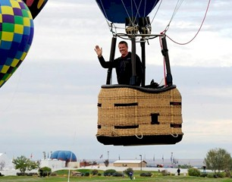
Paul J. Petrehn

Notable – Accomplishments/Contributions

- Private License: 1993
- Commercial License: 1995
- FAA Certified Repairman 2000-2015
- Total Hours: 1,720+
- 2012 Albuquerque International Balloon Fiesta Champion
- 2004, 2005 & 2013 US National Champion
- 2006 World Championship (Motegi, Japan): 11th place
- 2008 World Championship (Hofkirchen, Austria): 4th place
- 2010 World Championship (Debrecen, Hungary): 19th place
- 2014 World Championship (Rio Claro, Brazil): 13th place
- 2016 World Championship (Saga, Japan) 17th place
- 23rd Ranked Hot Air Balloon Pilot FAI/CIA World Ranking List (January 2016)
- Countries Flown: United Arab Emirates, Brazil, Canada, Australia, Japan, Austria, Hungary & Luxembourg
- 2009-2011 BFA Hot Air Competition Division (HACD) Chairman
- 1997-2003 Pilot Renaissance Balloons, Inc.
- 2003-2004 Production Inspector for Lindstrand Balloons US
- 2004-2015 Account Representative for Cameron Balloons US
- 2010-2014 Event Director North Central Championship (Brookfield, MO)
- 2012-2015 Event Director Frontier Days Balloon Shoot-Out (Carson City, MI)
- 2015 to Current Event Director Albuquerque International Balloon Fiesta

