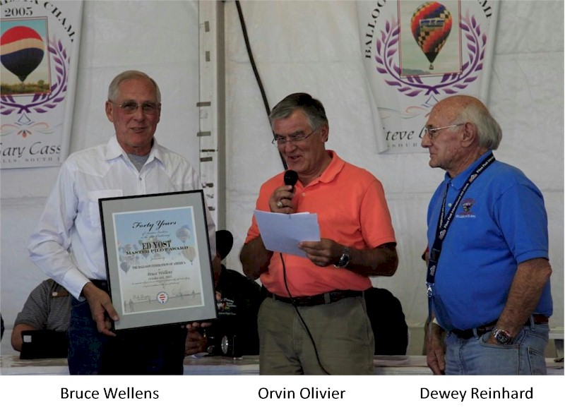
Bruce Wellens

Notable – Ed Yost Master Pilot Award

Bruce started flying hot air balloons in September of 1973. Bruce was looking for a new adventure and found a life time of memories in “Big Blue.”
Bruce is a citizen of the United States since birth and is also a current BFA member. (Bruce has the entire collection of the BFA Ballooning Magazine, or most of it.) As documented above in the scanned image of his log book Bruce took his first LTA flight lesson in Albuquerque on September 29th, 1973 from the legend Don Barz. They did two flights that day. Bruce and Don were Ski Patrol members so they thought it would be a good idea to fly from Sandia Peak Ski Area. That was the last time anyone flew from the top! They survived and 40 years later Bruce is still current and flying.
Bruce is a citizen of the United States since birth and is also a current BFA member. (Bruce has the entire collection of the BFA Ballooning Magazine, or most of it.) As documented above in the scanned image of his log book Bruce took his first LTA flight lesson in Albuquerque on September 29th, 1973 from the legend Don Barz. They did two flights that day. Bruce and Don were Ski Patrol members so they thought it would be a good idea to fly from Sandia Peak Ski Area. That was the last time anyone flew from the top! They survived and 40 years later Bruce is still current and flying.
Bruce has had a distinguished career hot air ballooning. From Sport to Commercial Bruce has done it all. Bruce’s first balloon was a commercial account for United Banks of Colorado. Bruce traveled the state of Colorado performing many first ascents in the beautiful valleys around the state. A typical weekend included three Free Flights and two tethers at the new bank location. Tethers were not a fine art at the time and Bruce developed many a new tactic.
Bruce has had a distinguished career hot air ballooning. From Sport to Commercial Bruce has done it all. Bruce’s first balloon was a commercial account for United Banks of Colorado. Bruce traveled the state of Colorado performing many first ascents in the beautiful valleys around the state. A typical weekend included three Free Flights and two tethers at the new bank location. Tethers were not a fine art at the time and Bruce developed many a new tactic.
After his first balloon wore out Bruce entered the sport world for a period of time flying “Generic Blue”. An A type competitor Bruce’s home is littered with trophies and medals from events across the region. After an extended absence from the Snowmass rally, Bruce returned in 2011 and medaled all three days. Bruce’s sport balloon duties have included balloonmeister , festival advisor and board member for the BSOPP.
Bruce has had a distinguished career hot air ballooning. From Sport to Commercial Bruce has done it all. Bruce’s first balloon was a commercial account for United Banks of Colorado. Bruce traveled the state of Colorado performing many first ascents in the beautiful valleys around the state. A typical weekend included three Free Flights and two tethers at the new bank location. Tethers were not a fine art at the time and Bruce developed many a new tactic.
After his first balloon wore out Bruce entered the sport world for a period of time flying “Generic Blue”. An A type competitor Bruce’s home is littered with trophies and medals from events across the region. After an extended absence from the Snowmass rally, Bruce returned in 2011 and medaled all three days. Bruce’s sport balloon duties have included balloonmeister, festival advisor and board member for the BSOPP.
The final 20 years of Bruce’s ballooning career had him at the helm of Adventures Out West and Unicorn Balloon Company. Bruce led his team and grew the company from one 105 to Five 245’s. Bruce ran several contract including the Broadmoor Balloon “5-Star” and The Miller Light Special shape balloon. The business operates in both Colorado and Arizona. Bruce has over 3500 flight hours and his companies have flown over 100,000 customers.
Most importantly for this award it is important to note that Bruce is accident and incident free for 40 years. A safe fun experience has always been his focus and he continues this way today with all of his toys. (Boats, Motor Cycles, Horses, Golf and RV)
A balloonist is only as good as his crew chief and his wife Patty was the best. After 40 years on the chase and several threats of abandonment in the field, Patty is still the preferred crew chief of Adventures Out West. Patty was a pro at the rarely seen running launch technique developed in the windy fields east of Pueblo. Patty and Bruce have a fabulous balloon memorabilia collection spanning 40 years. Patty decorates her 20 foot tall Christmas tree with a thousand balloon ornaments each year. Please include her name in the recognition.

