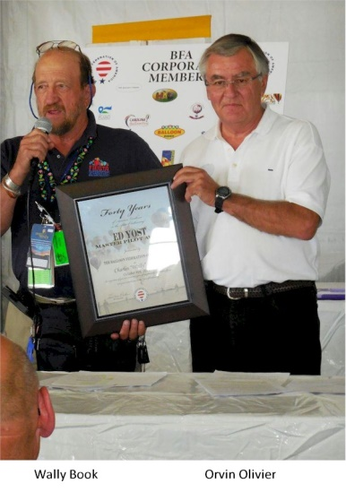
Wally Book

Notable – Accomplishments/Contributions, Ed Yost Award

Wally started working for Sid Cutter at Cutter Flying Service in Albuquerque in January 1972, so it was probably inevitable that he got into ballooning. He worked in their parts department for many years and worked in their maintenance department from 1987 until May of 1992.
He started his balloon pilot training in April 1973 under Gary Higman, then chief pilot for AAAA. He soloed in April 1973 after 1 ½ hours of instruction and got his Commercial LTA license with airborne heater in May 1973. He had to drive to Phoenix for his check ride because the Albuquerque FSDO was covered up.
Gary has owned and flown the Chariot of the Gods (Navis Caelestrium), a RavenS50, N1996R and a Thunder AX7-77, N65207, called Fudpucker. He has trained at least 6 new pilots, has 1350 hours of LTA time and at 150 or so of fixed wing. In 1976, during the Fiesta, he broke a rule by landing back on the field. Then Safety Officer Jim Bird asked him to take a day off from flying for the violation and on his day off … and “by the way” asked him, on his day off, to help as a launch director. That began his long days of volunteering for the Fiesta. Gary has held many volunteer positions, except launch chief and scoring official. He has been Safety Official and Safety Chief many times, Assistant Balloonmeister in 1999 and 2000, and Balloonmeister in 2001 and 2002. He has worked in safety since and has served as safety official for the America’s Challenge Gas race.
Wally speaks fluent French and has served as an ambassador for the Fiesta’s international pilots and guests. In 2014 he was awarded the Balloon Fiesta’s Heritage Award presented to individuals who have made significant contributions to the Fiesta through the creation of new traditions or events, through improving the safety and comfort of Fiesta participants and guests or through preservation of the event’s history. He was presented the BFA Ed Yost Master pilot award at the BFA 2014 Annual Meeting at the Fiesta.

