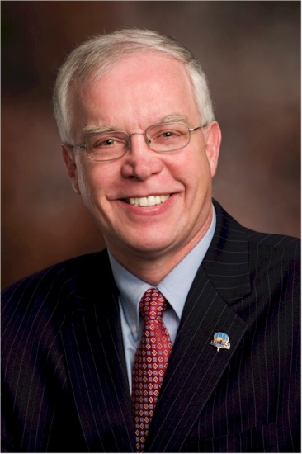
Al Nels

Notable – Accomplishments/Contributions, Ed Yost Award

Ratings:
- Commercial
  - Airplane, Single Engine, Instrument
  - Balloon rating earned October 18, 1974
  - Repairman

Significant Balloon Accomplishments
- 1984 US National Champion
- 1985 US National Champion
- 1987 World Champion
- 1991 World Champion
- Represented the USA as a pilot in World Competition 1981, 1985, 1987, 1989, 1991, 1993, 2008
- Team USA Worlds ‘Coach’ Manager, 2006, 2010, 2012

My first hot air balloon flights occurred in 1965 at 13 years old using birthday candles, paper straws from the school cafeteria for a ‘burner frame” and a large dry-cleaning bag. I quickly discovered that mid-day is not the time to fly a balloon as errant winds deposited one of my aerostats on a neighbor’s roof resulting in a quick scramble to the roof to put out the small fire. Later the following year, I read that if you mix aluminum and lye the resulting reaction, while toxic, generates hydrogen and I was soon sending postcards aloft in sealed dry-cleaning bags partially filled with hydrogen. The return of a mud covered postcard from a West Virginia potato farmer further fueled my passion for balloon flight. These flights and experiments with rockets and model airplanes continued through High School, with a few antics; such as having the balloons impersonate UFO’s considering Wright Patterson Air Force Base was only 7 miles away.
Leaving Ohio for Flint Michigan to purse a mechanical engineering degree at General Motors Institute (GMI) left little time for flying until in 1974 I was invited to crew for out of town pilots at a weekend balloon event in September. My pilot was Bill Grabb (former BFA President) who flew a chair balloon. On Sunday morning Bill elected not to fly so I moved over to help Greg Wilson from Albuquerque who was piloting the Budweiser balloon for legendary World Balloons. After flying across town, Greg landed and asked if I wanted a ride. I was so afraid he would take his offer back that I literally dove into the basket of the 56,000 cubic foot Raven S-50 aluminum and fiberglass basket. As a child, and even today, I dream that I can levitate, not fly like Superman but will myself to float and drift. The dream came true as I watched the Earth leave us. It was exactly like my dreams. GMI was a 5 year coop program and I was entering into a nine week work period at Chevrolet in Flint. The Monday after the weekend event I told my boss I would like to take my vacation a half day at a time, in the mornings and with limited notice. He agreed. My next call was to my oldest brother, Hobby, to borrow enough money to learn how to fly. He too graciously agreed. Next call was to Denny Floden to make arrangements to learn to fly and he hooked me up with Tommy Allen of Fenton, Michigan.
Tommy and I met at his father’s funeral home to talk about flight lessons and I self-taught in preparation for the written. I started flight training about a week after the event and one month later headed to Ann Arbor to meet the designated examiner, Bruce Comstock. At the conclusion of the check ride I later found out Bruce whispered to Tucker, “It was a noisy flight but this guy will be a good balloon pilot”. I used a series of small burns to maintain precise control as I did not want to mess this up. It was a flight interrupted with frequent short burns indeed making it a bit noisy. The date was October 18, 1974 and I was the proud holder of a Commercial Airman certificate for balloons.
Bruce and Tucker convinced me to use my organization skills to be the Balloonmeister at numerous events. Adrian Air Days, Howell Michigan, Pickney Balloon Festival, non-competitive Balloonmeister at the US Nationals, and the list goes on. After a few years of watching all my buddies fly while I sat on the ground, I decided to try being in the basket instead of running the events. What a learning experience. If there was a mistake to be made flying competition, I probably made it. Ground contact, wrong marker order, transposed coordinates, time limits, distance limits, . . . . . I messed them all up. I learned from those mistakes, and slowly increased my skills and performance.
It was in 1984 that I finally won a US Nationals, but was frankly amazed that I had won. My confidence increased and I was focused and prepared for the following years Nationals and this too resulted in a first place finish. Next challenge was a World Championship. It was 1987 in Austria that David Levin (current champion), Sid Cutter, Tim Darrin, and I arrived in Schielleiten Austria to represent the United States of America. The odds were against us as the Europeans had a leg up having flown the site dozens of times.
When I made the final marker drop on the last flight I knew then that the United States was the winner and the resulting emotion made it difficult to fly as tears streamed down my cheeks. My Mother, who was there in Austria along with my Dad, told me as a child that there was something I could do better than anyone else in the World, all I had to do was find out what it was. Her prophecy came true before her eyes.
In the following years I was able to win a second World championship in 1991 and coach the US Team to multiple podium finishes. I am a Dad and a patriot and proud to represent the greatest country in the World. It is important to share my love of flying with my family and friends, and I continue to flight Instruct and encourage entry into aviation. My students have been as young as my Grandson Jackson to the legendary Walter Cronkite. I have been blessed with passengers from Soviet cosmonauts to Governors. As my airplane instructor told me about flying “There is just nothing like it”.
This has not been a solo endeavor for me, but rather one with support of parents, teachers, a great wife, kids, other family and friends. My life has been forever changed by those around me.
Al was presented the Balloon Federation of America Ed Yost Master pilot Award for 40 years of safe flying on October 4, 2014.

