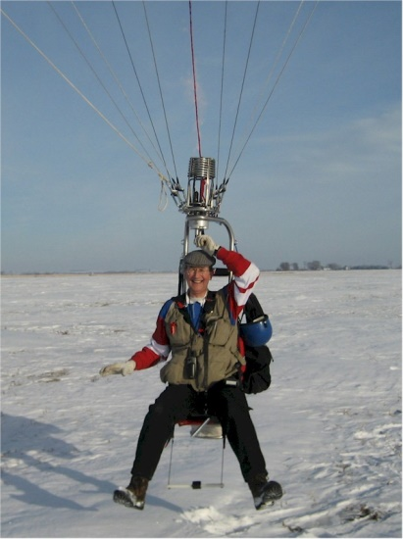
Gary Stewart Palmer

Notable – Ed Yost Master Pilot Award

Date of Birth: 19th January 1950

Place of Birth: Luton, Bedfordshire, England

Nationality: British

Residence: US Permanent Resident [USCIS #043-638-894]

2219 Burleigh Street
Yankton
SD 57078-1800
USA

Licences: UK Civil Aviation Authority Pilot’s Licence
Private – Free Balloons Hot Air Filled No.118512PP59B
Issued 12th August 1976 [no expiry date]

US Federal Aviation Administration Airman’s Certificate
Commercial – Free Balloons with Airborne Heater No.3424553
Issued 28th May 2009 [no expiry date]

BFA Member: No.110727, since 1993
BBAC Member: from 1974 until 2014

Hours Logged: 1240, as of 4th February 2017

Curriculum Vitae:

My life in ballooning started in the spring of 1974, when a work colleague casually stated he was going flying and asked if I wished to join him. What I thought was going to be a fixed-wing outing turned out be a balloon flight with pilot David Dokk-Olsen, in his Cameron O-84 G-BAKO ‘Pied Piper’. My colleague never flew again but I became hooked! Over the next two years, I crewed for David and in return he trained me for my private license. I qualified with an exam by Laurie Ryan and in August 1976 received CAA Balloon Pilots License number 59, which is still valid.
Almost immediately, I was approached by the London Balloon Club and offered the chance to purchase a share in the syndicate, flying Cameron O-65 G-AZXB ‘London Pride 2’. LBC was formed by eight of the first modern hot air balloonists in the UK and their original ‘London Pride’ balloon was purchased from Don Piccard. Later, we purchased Thunder 77 G-BDGH ‘London Pride 3’. The club was based – and did most of its flying – close to the very complex and busy airspace which surrounds London’s main airports and all the minor satellite airfields; so complex flight planning and good ATC contact were regular activities for ourselves and the many other balloonists in the area.
I remained with LBC until 1985, when I was approached by Don Cameron to fly one of his early special shapes for the Engineering Appliances Company, of London. The balloon was a Cameron 80SS G-BIUL ‘Bellows Expansion Joint’ and proved to be quite a challenge to fly, due to its very small throat, tall thin profile and three large wobbly rings around the equator! This turned out to be more of a social than a business venture, since the CEO of the company was looking to use his business as a vehicle to get him into the social circle of European ballooning. Thus it was that we spent many happy long weekends towing the trailer around England, France and Germany to balloon meets, armed with road maps in one hand and the Michelin Guide to 5-Star Restaurants in the other! Sadly, this generous, funny gentleman succumbed to cancer way too early in his life and I found myself a beneficiary of his will, to the tune of one special shape and one standard shape balloon. In addition to these specific balloons, I flew many other makes and models of balloon, either as an instructor for student owners, or for corporate sponsors at various events, including several national championship events.
I spent time working on the BBAC [British Balloon & Airship Club] Safety Committee and was eventually elected to be BBAC National Safety Officer in 1981 [if I remember the date correctly.] This position required regular liaison with the AAIB [Air Accident Investigation Branch] of the Civil Aviation Authority; with whom I developed a more standardized balloon incident reporting system, to line up with those of other GA organizations. During my tenure as Safety Officer, I was fortunate to not have any major accidents to handle; however, I did make it a personal goal to encourage more pilots of all experience levels to participate in the Incident Reporting Form system.
I was deeply involved in helping to select Castle Howard, Yorkshire, as the venue for the 1977 World Hot Air Balloon Championships. In 1976, we held a UK National Championship there, as a trial for the world event and I assisted Martin Moroney in discussions with the Castle Howard owner for use of his estate.
In 1981 and 1985, I attended the World Hot Air Balloon Championships in Battle Creek, Michigan, as a member of the British contingent of competition officials. During the second visit, I met the lady who would subsequently become my wife of thirty years; Brenda Brocklesby, daughter of noted US balloonist Douglas Adam, of Sioux City, Iowa. Brenda and I were married on Hallowe’en 1987, at the Savoy Chapel, in London. I subsequently gave her flight instruction, enabling her to gain her UK license for balloons in 1989.
On 6th January 1993, we relocated to Yankton, South Dakota, [to where Brenda’s parents had also relocated, from Sioux City, Iowa.] We brought with us a Cameron Viva 77 G-BMNU ‘The Wytch’, and additionally took over operation of a Cameron O56 N29259 ‘Integrity II’ from Doug Adam, upon his retirement from ballooning due to health issues. We re-registered G-BMNU to N50UL [looks like SOUL from a distance]. Later on we replaced the envelope on Integrity II and also changed the registration to N510UX [looks like SIOUX from a distance, as we live and fly among the Sioux Indian nations.

Although Brenda no longer flies, I am still active with local instructional flights. I also really enjoy flying my Cameron M34 hopper N510UX ‘Hobbit’, when the weather is suitable.
In forty one years of flying, I have managed to avoid injuring any passengers or myself; have incurred no infringements nor made any insurance claims and have only managed to cause minor fabric damage to any of the balloons I have flown. I remain in good health for my sixty seven years and hope to remain active in our wonderful sport for as long as medical and financial factors permit!

