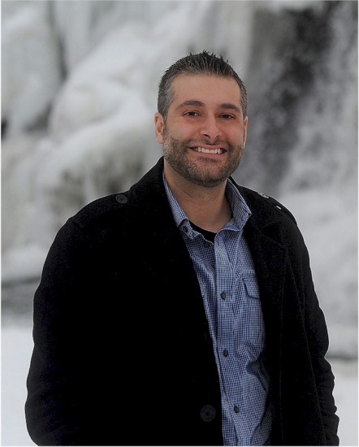
Brad Temeyer

Notable – Accomplishments/Contributions

Brad was born in Rockford, IL on July 31, 1979. He graduated on the Dean’s List from Iowa State University with a BS Degree in Atmospheric Sciences. He also earned his MS Degree in Atmospheric Sciences at Iowa State University and continued his education with a MS in Public Administration from the University of South Dakota.
His professional career started in 2003 with the National Weather Service as an Intern Meteorologist in Glasgow, Montana where he regularly utilized observations and model data to create public, aviation and fire weather forecasts. He continues as a General Forecaster with the Sioux Falls, South Dakota office of the National Weather Service where, among other duties, he continued to produce public, aviation and fire weather forecasts. He led a team charged with developing Digital Aviation Services at the Sioux Falls and other offices.
His first exposure to ballooning was in 1982 at the National Championships in Indianola, IA when he was 3 years old. He soloed on August 7, 2007, received his private license on June 1, 2008 and his commercial license on June 6, 2010 all in Indianola, IA. To date he has amassed over 200 hours of flight time. His most memorable flights were in 2007 when he flew box winds over Devil's Tower and in 2009 when he flew with Jim Winker on the day of Jim’s induction into the United States Balloon Hall of Fame. He is a member of the following ballooning organizations:
- Iowa Balloonist Association
- Balloons over Iowa
- Balloon Federation of America
- Sioux Falls Balloon Association
  - Vice President 2009
  - President 2010
Brad has participated in balloon events throughout the US and the World, has participated in a number of safety seminars and has received several ballooning awards as listed below:
- 1999 Bully Bullhead Weekend - Ruthven, IA (Weather Officer)
- 2000 Bully Bullhead Weekend - Ruthven, IA (Weather Officer)
- 2001 Summer Breeze Balloon Festival - Ames, IA (Meteorologist)
- 2002 Summer Breeze Balloon Festival - Ames, IA (Meteorologist)
Hot Air Affair-Council Bluffs, IA (Meteorologist)
- 2003 Summer Breeze Balloon Festival - Ames, IA (Meteorologist)
Iowa Balloonist Association Newsletter Contributor of the Year
- 2004 Iowa Safety Seminar
- 2005 Wisconsin Balloon Group Safety Seminar
Hot Air Affair-Council Bluffs, IA (Meteorologist)
Great Plains Balloon Race - Sioux Falls, SD (Meteorologist)
Iowa Balloonist Association Newsletter Contributor of the Year
- 2006 Invited presentation to Sioux Falls Balloon Association
Wisconsin Balloon Group Safety Seminar
Minnesota Ballooning Association Safety Seminar
Great Plains Balloon Race - Sioux Falls, SD (Meteorologist)
Annual Mayor’s Cup Invitational Hot Air Balloon Race - Rochester, MN (Meteorologist)
Balloon Event - Columbus, NE (Meteorologist)
Hot Air Affair - Council Bluffs, IA (Meteorologist)
Balloon Event – Medora, ND (Meteorologist)
Festival de Globo leon - Leon MX (Meteorologist)
Iowa Balloonist Association Newsletter Contributor of the Year
- 2007 Iowa Safety Seminar
Great Plains Balloon Race - Sioux Falls, SD (Meteorologist)
Annual Mayor’s Cup Invitational Hot Air Balloon Race- Rochester, MN (Meteorologist)
BFA Nationals - Waco TX (Meteorological support/crew for Al Nels, Andy Baird, Paul Petrehn)
Devils Tower Balloon Event - Hulett, WY (Meteorologist)
Supported Richard Jaworski’s Duration flight –AX-4 & AX-5 Duration (23 hours 11 minutes), flight recognized as Montgolfier flight
Iowa Balloonist Association Crew of the Year
Iowa Balloonist Association Newsletter Contributor of the Year
- 2008 Wisconsin Balloon Group Safety Seminar
Iowa Balloonist Association Safety Seminar
Private pilot’s license
Great Plains Balloon Race – Sioux Falls SD (Meteorologist)
Annual Mayor’s Cup Invitational Hot Air Balloon Race - Rochester, MN (Meteorologist)
Wakefield Hot Air Balloon Days - Wakefield, NE (Meteorologist)
Meteorological Support for AX-4 Distance flight Richard Jaworski’s, 250 miles
Meteorological Support for Long jump from Sisseton SD to near Charles City, IA
- 2009 Oklahoma Safety Seminar - Oklahoma City, OK
Iowa Balloonist Association Safety Seminar
Great Plains Balloon Race -Sioux Falls, SD (event coordinator)
National Balloon Classic-Indianola IA (flew with Jim Winker-Hall of Fame Inductee/meteorologist)
Great Lakes Regional Championship - Frankenmuth, MI (Meteorologist)
Nationals- Battle Creek, MI (Meteorologist)
Creston IA Balloon Days - Creston IA (Meteorologist)
Wakefield Hot Air Balloon Days - Wakefield, NE (Meteorologist)
Meteorological support for Rich Jaworski’s flight to 26K feet
BFA Elizabeth Dumont Safety Award for exceptional forecasting under difficult conditions
- 2010 National Balloon Classic – Indianola, IA (Meteorologist)
World Championship – Debrechen HU (US Team manager)
Great Lakes Regional Championship - Frankenmuth, MI (Meteorologist)
Great Plains Balloon Race -Sioux Falls, SD (Meteorologist)
US Nationals- Battle Creek, MI (Meteorologist)
- 2011 BFA National Seminar – Des Moines IA
Great Plains Balloon Race- Sioux Falls, SD (Meteorologist)
NFL Hall of Fame-Canton, OH (Meteorologist)
National Balloon Classic - Indianola, IA (Meteorologist)
Lake Red Rock Balloon Fest - Knoxville IA (Meteorologist)
US Nationals - Battle Creek, MI (Meteorologist)
National Balloon Classic - John Russell Award
- 2012 Northeast Ohio Balloon Association Safety Seminar
Great Plains Balloon Race – Sioux Falls, SD (Meteorologist)
Flag City Balloonfest - Findlay, OH (Meteorologist)
NFL Hall of Fame – Canton, OH (Meteorologist)
FAI World Championship - Battle Creek, MI (Meteorologist)
National Balloon Classic - Indianola, IA (Meteorologist)
- 2013 Safety Seminar-Salem, OR
Flag City Balloonfest - Findlay, OH (Meteorologist)
Great Plains Balloon Race – Sioux Falls, SD (Meteorologist)
NFL Hall of Fame – Canton, OH (Meteorologist)
FAI World Championship - Battle Creek, MI (Meteorologist)
National Balloon Classic - Indianola, IA (Assistant Race Director)
Creston IA Balloon Days - Creston IA (Meteorologist)
- 2014 Safety Seminar - Salem, OR
FAI World Championships - Rio Clario, BR (Meteorologist)
Creston Iowa Balloon Days - Creston IA (Meteorologist)
- 2015 Iowa Balloonist Association - Safety Seminar
National Balloon Classic - Indianola, IA (Assistant Race Director)
Devils Tower Balloon Event - Hulett, WY (Meteorologist)
- 2016 Greater Eastern Balloon Association Safety Seminar - Princeton NJ
Carolina Balloon Association Safety Seminar - Charlotte, NC
Meteorologically supported Greg Winker AX-3 duration flight - January 11, 2016, Sioux Falls, SD (9 hrs, 26 min.)
Meteorologically supported Andrew Holly’s Guinness World Record to Fly all 50 states
Great Plains Balloon Race - Sioux Falls, SD (Meteorologist)
FAI Junior World Championships - Marijampole Lithuania (Meteorologist)
FAI Woman’s World Championships - Birstonas, Lithuania
National Balloon Classic - Indianola, IA (Assistant Race Director)
US Woman’s Championship - Albuquerque NM (Meteorologist)
- 2017 Following are events that Brad has tentatively scheduled for this year:
    - Carolina Balloon Association Safety Seminar- Charlotte, NC
    - Safety Seminar - Denver, CO
    - BFA Online Safety Seminar - Central IL
    - National Balloon Classic - Indianola, IA (Assistant Race Director)
    - BFA US Nationals - Shreveport, LA (Meteorologist)
    - Albuquerque International Balloon Fiesta - Albuquerque, NM (Meteorologist)

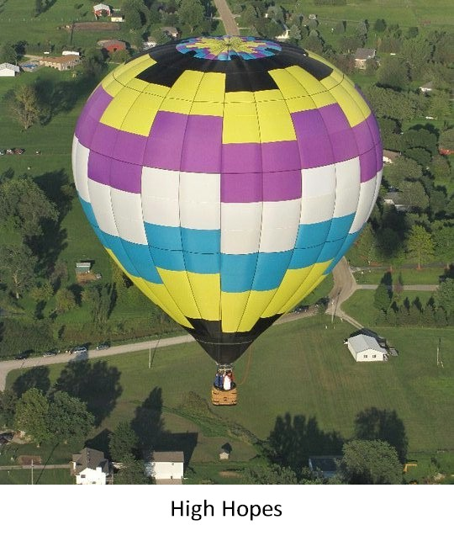
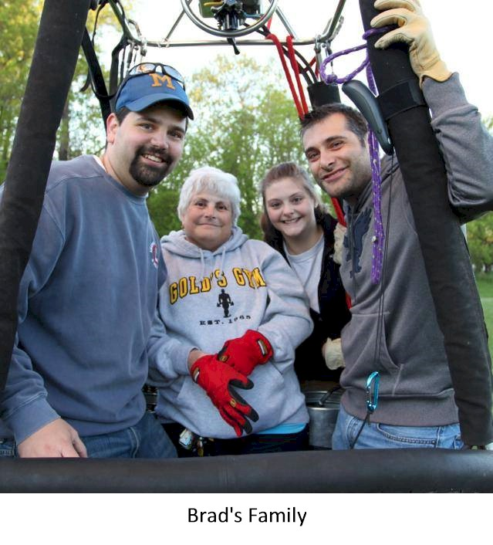

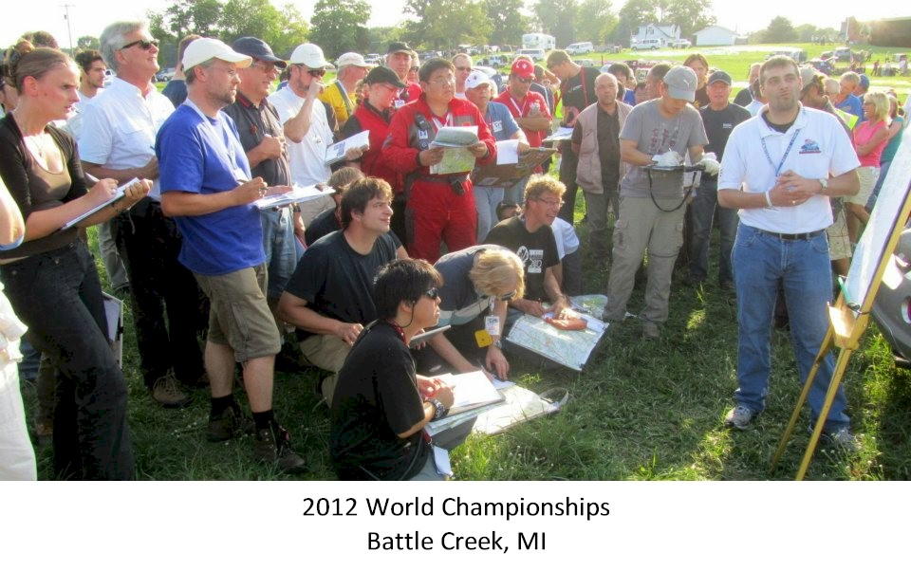

See additional pictures on following page

