
Richard Brown/Donna Brown

Notable – Accomplishments/Contribution, Montgolfier Diploma, Shields Trauger Award

PO Box 2620, Tijeras, NM 87059
dbrown779@aol.com, 505-281-2069

- Introduced to ballooning by Sid Cutter in 1971
- Albuquerque Aerostat Ascension Association (AAAA) member since 1972, Cloudbouncer newsletter editor for AAAA in early 70s
- Solo balloon flight ended on wagon-wheel ruts of the historic Santa Fe Trail in northern NM
- Licensed commercial balloon pilot since 1973
- Flew his AX-7 “Blue Dragon N616DB” in the early days of the Balloon Fiesta
- BFA President’s Service Award in 1976
- Editor BFA Ballooning Journal 1974-1979, moved publication from a quarterly to its present bimonthly schedule
- AAAA Sid Cutter Award in 1979,
- Honorary life member of AAAA in 1979
- Authored “how to” book Hot Air Ballooning, published by Tab Books in 1978
- BFA Shields-Trauger Memorial Award to Dick & Donna Brown in 1979 for exemplary service
- FAI Montgolfier Diplome for the year 1979 for service to the sport of ballooning, primarily as Ballooning Journal editor and book author

- Produced a monthly newsletter for a major balloon manufacturer for 17 years
- Member of Albuquerque International Balloon Fiesta (AIBF) Heritage Committee & official program contributor, 2000-present
- Co-authored award-winning book “The World Comes to Albuquerque”, published by Rio Grande Books in 2011 in celebration of the 40th Balloon Fiesta, won Best of Show in New Mexico Book Awards
- Winner of AIBF’s 2012 Heritage Award, added to AIBF Wall of Fame
- Co-authored book “Albuquerque International Balloon Fiesta”, published by Arcadia in 2016 in celebration of the 45th Balloon Fiesta, finalist in two categories in NM Book Awards competition
- Inducted into AIBF Hall of Fame in 2016
- AIBF team leader for books planned to celebrate 50th Balloon Fiesta
- For 45 years, Dick has been writing about ballooning history and people who have played a pivotal role in sport ballooning, over 100 published articles
- Co-authored award-winning book “The World Comes to Albuquerque”, published by Rio Grande Books in 2011 in celebration of the 40th Balloon Fiesta, won Best of Show in New Mexico Book Awards
- Winner of AIBF’s 2012 Heritage Award, added to AIBF Wall of Fame
- Co-authored book “Albuquerque International Balloon Fiesta”, published by Arcadia in 2016 in celebration of the 45th Balloon Fiesta, finalist in two categories in NM Book Awards competition
- Inducted into AIBF Hall of Fame in 2016
- AIBF team leader for books planned to celebrate 50th Balloon Fiesta
- For 45 years, Dick has been writing about ballooning history and people who have played a pivotal role in sport ballooning, over 100 published articles
- Co-authored award-winning book “The World Comes to Albuquerque”, published by Rio Grande Books in 2011 in celebration of the 40th Balloon Fiesta, won Best of Show in New Mexico Book Awards
- Winner of AIBF’s 2012 Heritage Award, added to AIBF Wall of Fame
- Co-authored book “Albuquerque International Balloon Fiesta”, published by Arcadia in 2016 in celebration of the 45th Balloon Fiesta, finalist in two categories in NM Book Awards competition
- Inducted into AIBF Hall of Fame in 2016
- AIBF team leader for books planned to celebrate 50th Balloon Fiesta
- For 45 years, Dick has been writing about ballooning history and people who have played a pivotal role in sport ballooning, over 100 published articles
- Dick is also a retired engineer, an active member of three historical societies and a frequent contributor to the Naval Submarine League’s quarterly journal. He and Donna live in the mountains east of Albuquerque


Dick Brown is a Navy submariner and a balloonist. Here he is aboard submarine USS New Mexico in January 2016. Balloons and submarines both depend on Archimedes Principle – balloons float in air, subs float underwater.

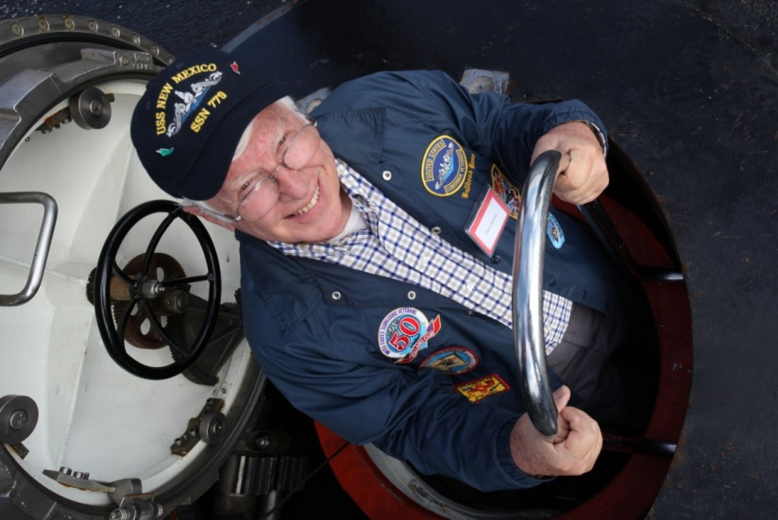
Down the hatch

