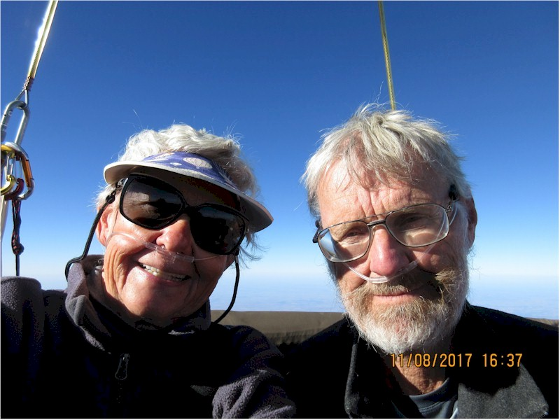
Peter Cuneo
Barbara Fricke and Peter Cuneo

Notable – Accomplishments/Contributions

Born April 10, 1951, Chicago, IL

petercuneo@msn.com

Received his Private Pilot Certificate in September, 1989, his LTA Commercial Certificate in 1992 and his Gas Pilot Certificate in 1995.

- Peter served as Co-editor (with Barbara Fricke) of the BFA Gas Division Newsletter from 2000 to present. He authored (with Astrid Gerhardt, Walter Muller and Gerhard Hurck) the Second Edition of Gone with the Wind – The Gas Balloon; 2016.
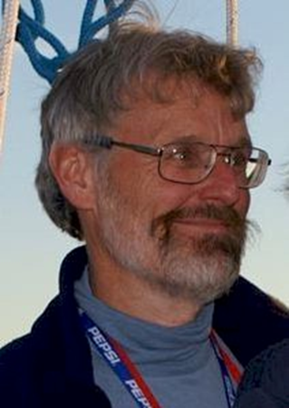
- Peter has teamed with Barbara Fricke to win the America’s Challenge Gas Balloon Race wins: 2001. 2010, 2013, 2016 and finish second three times. The pair also has a third place finish in the Coupe Aeronautique Gordon Bennett.
- 2006 Coupe Aeronautique Gordon Bennett: 72 hours from Waasmunster Belguim to Finland – 7th place.
- Research gas balloon flight carrying 10 geese attempting to re-establish migration route – featured on ABC’s 20/20 March/April 2003
- A smoke balloon flight over the Nazca Lines of Peru with Julian Nott, April, 1998 was featured in Ballooning
- He has logged a gas balloon flight with Julian Nott from Otis, KS to Aurora, MO using liquid helium instead of sand ballast to maintain altitude control. Duration 21.30 hours – ref Balloon Life
- Peter & Barbara have organized two seminars on gas ballooning.
- Peter has been part of a team than has built a gas envelope and basket.
- He has flown helium, hydrogen and anhydrous ammonia gas balloons
- He has recently teamed with Bert Padelt to produce an experimental hydrogen-safe gas balloon envelope.

