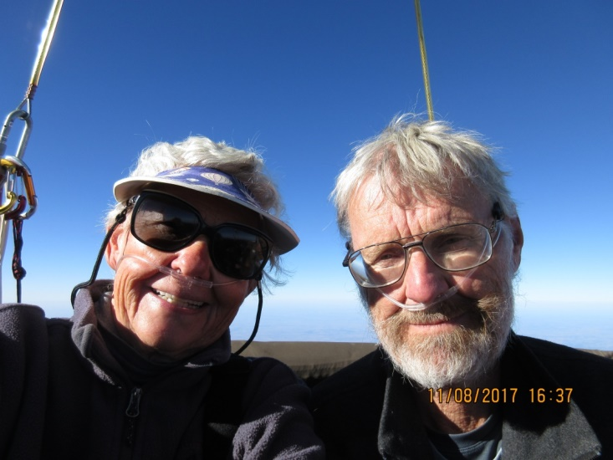
Barbara Fricke
Barbara Fricke with Pete Cuneo

Notable – Accomplishments/Contributions

barbarafricke@msn.com

Aviation Experience
- May 1989 – Private Pilot LTA with airborne heater
- May 1991 – Commercial Pilot LTA with airborne heater
- September 1996 – Removed “airborne heater” restriction
- July 2005 – Private pilot single engine land (fixed wing)

Involvement with Albuquerque International Balloon Fiesta:
- October 1982 – Signed up with Fiesta to crew for a balloon. Was assigned to crew for a pilot from Las Cruces, New Mexico. Crewed for him at every Fiesta until 1989, when I started flying at Fiesta. Also crewed for him at other balloon rallies around New Mexico.
- 1998-present – Fly our hot air balloon at Fiesta.
- 1997-present – Fly in the America’s Challenges at Fiesta, except for 2008 when we were part of the Gordon Bennett Gas Balloon race in which we took third place. Won the AC race in 2001, 2010, 2013, 2016; took second place four times; third place four times. Qualified to represent the U.S. at the Gordon Bennett Gas Balloon numerous times.
- 2014-present – Serve on Board of Directors for Balloon Fiesta

Involvement with AAAA (Albuquerque Aerostat Ascension Association) Balloon Club:
- 1989 – Joined AAAA. Served on various committees, usually the Education Committee, except for the year when I served as AAAA President. Chaired the Education committee several times, as well as serving as Board liaison for the committee. Teach in ground schools, usually teaching Aviation Weather Services. Also have done presentations at safety seminars.
- 1994 – Received the Bob Ruppenthal Education Award
- 1995 – President of AAAA
- 2003 – Received the Allen Jones Volunteer Award
- 2006 – Received the Sid Cutter Award

Competed in the Coupe Aeronautique Gordon Bennett Gas Balloon competition
- 2004 from Thionville France
- 2006 from Wassmunster Belgium
- 2008 from Albuquerque, NM – Third place
- 2009 from Genève, Switzerland
- 2011 from Gap, France
- 2012 from Ebnat/Kappel, Switzerland
- 2016 from Gladbeck, Germany
- 2017 from Freiburg, Switzerland

Accomplishments:
- 2000-present - Co-Editor (with Peter Cuneo)) the BFA Gas Division Newsletter
- 2001 – Carried geese in research experiment for migration routes, featured on ABC’s 20/20 March 2002
- Longest duration gas flight: Waasmunster, Belgium to Finland in 2006 in 72 hours. Crossed 3 bodies of water, over 5 countries.
- Longest distance gas flight: Albuquerque, NM to Island Pond, Vermont in 2017, 1944 miles.
- Has flown in balloon rallies mainly in the southwest (New Mexico, Colorado, Arizona), but also has flown in California, Missouri, Oklahoma, Arkansas, St. Jean sur Richelieu Quebec Canada and Lorraine France.
- Has flown over, or in, the countries of: Canada, France, Poland, Belgium, England, Norway, Sweden, Finland, Switzerland, Austria, Italy, Czech Republic, Japan and Peru.
- Currently (November 13, 2017) has 1014 balloon flights with over 2400 hours in the sky, and still enjoying it.

