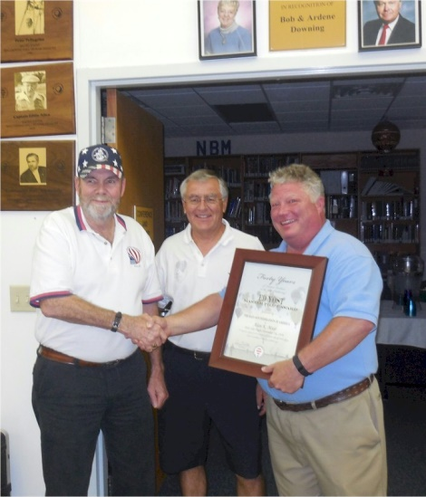
Al Muir
Al Muir Orvin Olivier Dean Carlton
Ed Yost Master Pilot Award

Notable: Ed Yost Master Pilot Award

Bear Creek Balloons
5330 Addicks-Satsuma
Suite B700
Houston, TX 77084

- Pilot of the 93Q radio station balloon for seven years and known by the radio audience as "Captain Al"
- Began flying balloons in 1975 and has over 4000 hours of flight time.
- Ranked nationally every year since beginning competition.
- Budweiser trophy winner in 1980. (Top competitive pilot for the year or the number 1 pilot in the ranking system.)
- Winner of several races in North America, including the Great Houston Balloon Race, The Valley Rally in Alamosa Colorado, The Fort Hamilton Balloon Rally in Hamilton, Ohio. The Port Arthur Cavalcade Balloon Rally, The Calgary Stampede Balloon race in Calgary Alberta Canada, The Jonesboro, Arkansas Balloon rally, the Oldsmobile Balloon Classic in Danville, Illinois, Sky fest, Billings Montana.
- Finished 4th in the 1984 U.S. National Championships held in Indianola, Iowa.
- Participated in the 1985 World Championships, held in Battle Creek, Michigan as a member of the U.S. Team.
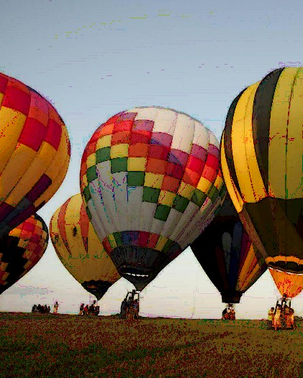
- B.F.A. Certified flight instructor. Has trained several pilots in North America. Former F.A.A. Designated Balloon Pilot Examiner in the Houston area.
- Organizer of several successful races in the South Texas area, including, the Missouri City Balloon Festival, the Houston Live Stock Show and Rodeo, Red Lobster Balloon Rally, and the Messina Hof Harvest Fest Balloon Rally.
- Past President of the Houston Balloon Association for 6 years, until it was dissolved in 1996.
- Ed Yost Master Pilot Award. Al Muir is one of only a handful of pilots in the entire United States awarded the Master Pilot award for 40 years of incident free safe flight operations.

