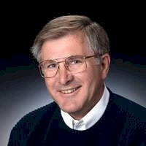
Ray Bair

Notable – Accomplishments/Contributions, Past President

abqbair@comcast.net

Ray has been involved in ballooning since the late 1970’s and purchased his first balloon (a used one with six partners) in 1981. He has been active ever since. It has been a family affair for him and his wife, Carol, and two sons, John and David. Both boys are also commercial balloon pilots. Albuquerque is home to the Bair’s and to the greatest ballooning weather to be found. He is commercially rated for hot air and gas balloons, serves as a FAAST Member for the FAA, is an active flight instructor and a Designated Pilot Examiner. As a Designated Flight Examiner he has provided over 500 check rides.
Ray has served multiple terms on the Board of Directors of the Albuquerque Aerostat Ascension Association, a large (over 600 members) local balloon club which began in 1972. He currently serves on the Board of Directors for the Albuquerque International Balloon Fiesta which conducts the premier ballooning event in the world. It hosts over 500 balloons for its grand October ten-day event. He has served as President. Ray also is actively involved in the Balloon Federation of America, the national ballooning organization for the United States. He has also served two terms as President there.
Over the course of the years Ray has been presented the following awards.
- 1990 and 2005 AAAA Bob Ruppenthal Education Award in recognition of contributions to Hot Air Ballooning
- 2000 AAAA Allan C. Jones Award for Volunteer of the Year
- 2000 BFA Director's Award for contributions to Youth Ballooning
- 2003 AAAA Sid Cutter Award for outstanding contributions to the sport of Hot Air Ballooning
- 2005 he was presented the Elizabeth J. Domont Safety Award, an award presented annually at the US National Balloon Championship to recognize the pilot who, in the judgement of the highest race official, best exemplifies the highest degree of safety.
- 2012 he was elected to the Albuquerque International Balloon Fiesta Hall of Fame which recognizes volunteers that have made unique and distinguished contributions to Albuquerque’s ballooning heritage
- 2015 FAI En temoignage de Gratitude for contributing to the success and development of Aeronautique
He has over 2200 flight hours in hot air and gas balloons and has flown throughout the United States and foreign countries. A recent whoop-de-do was a hydrogen gas balloon flight over the Alps from Sonthofen, Germany to just southwest of Venice Italy. He and the family have flown in Mexico, Canada and France as well.

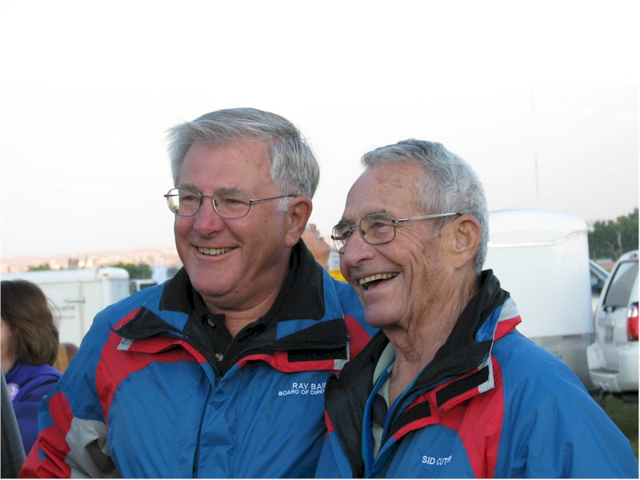
Ray and Sid Cutter

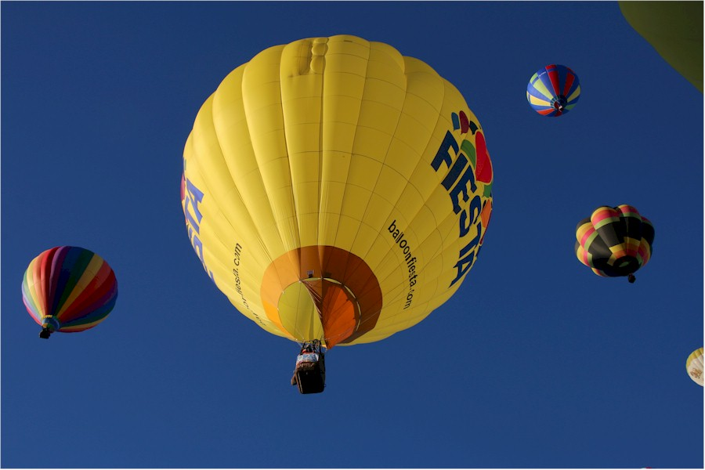
Fiesta

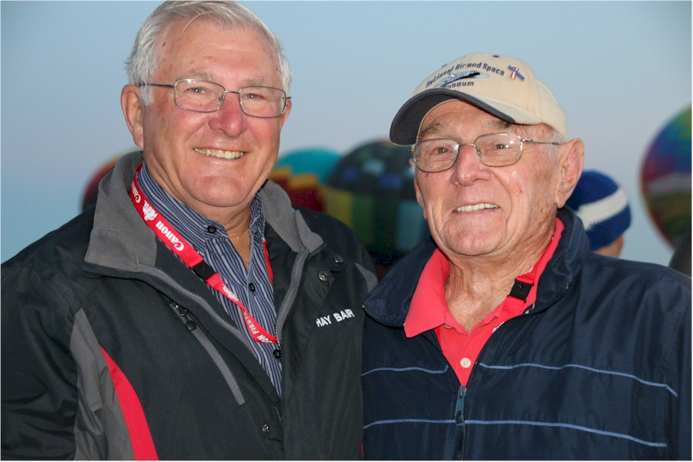
Ray & Dewey Reinhard

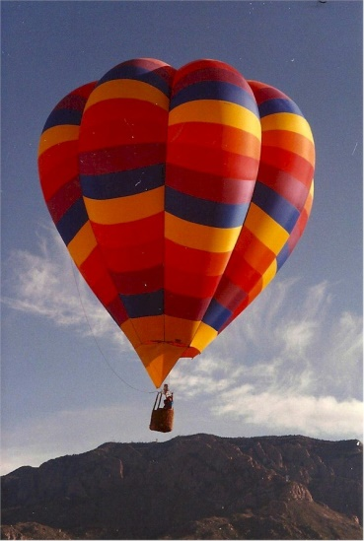
Kaleidoscope

