Tom McConnell II

Notable – Ed Yost Master Pilot Award

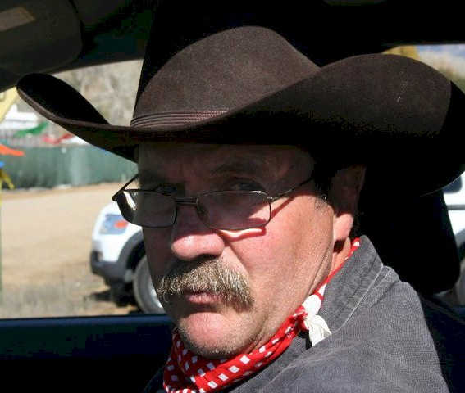
- Nickname: “Ziaburger”
- First balloon ride: Sometime in 1973
- First balloon instruction date: Sept 13, 1973
- Solo: October 28, 1973
- Certificate: Commercial March 17, 1974- Check ride with Sid Cutter
- Students instructed: Steve Komadina,
Bruce Hale
Mark Devaney,
Connie March,
Ed Osburne,
and others
- Zia Balloons flown: Zia I (Raven S-50A, AX-6), N1912N
Zia II (Raven S-55A, AX-7), N1912N
Zia III (Aerostar RX-7), N1912N
Zia IV (Aerostar S-57H, AX-8), sold to me by my
Dad in 2007-changed N # to N1912M in 2012
- Most famous passenger: Col Swalm, leader of the US Air Force
Thunderbirds, October 9, 1975
- Member of AAAA
- Member of BFA
- BFA Ed Yost Award 2016
- Airplane Single Engine Land
- Instrument Airplane
- Have flown in every Albuquerque Balloon Fiesta since 1974
- Have worked as an estimator in the Construction Industry for over 35 years
- Play String Bass in my Jazz Band “Richmond Street” for the last 15 years
- 2nd Lieutenant in Squadron 2 of the Civil Air Patrol in ABQ- certified Mission
Scanner, Mission Observer, Mission Photographer, and Assistant Operations
Officer

See photos on next page.

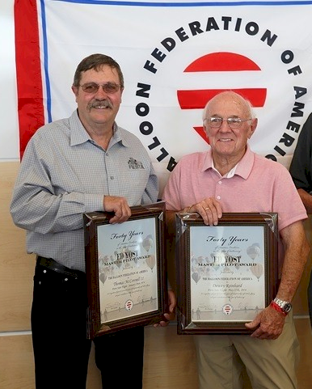
Ed Yost Master Piot Award Tom McConnell II and Dewey Reinhard

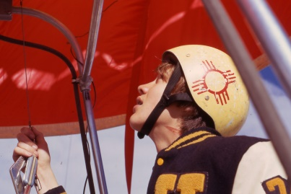
Tom McConnell II - 16 Years Old

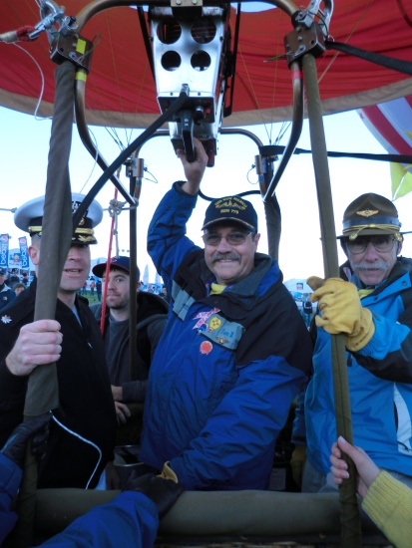
Comdr. Moore, Tom McConnell II and Dr.Tom McConnel1

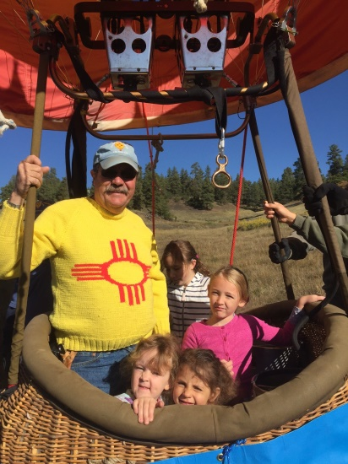

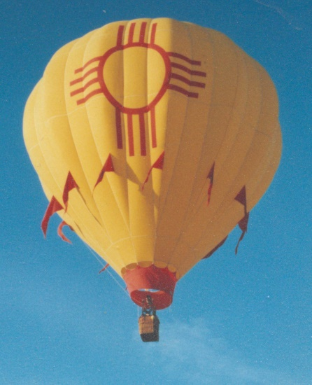
Zia 3

