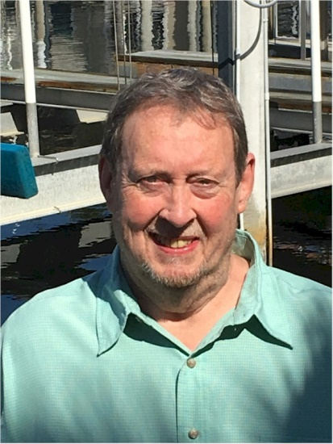
Maury Sullivan

Notable – Accomplishments/Contributions, Shields Trauger Award

6509 Yost St NW
Canton, OH 44718
tequilatom@aol.com

Pilot Background
- Private pilot certificate 1982
- Commercial pilot certificate 1984
- 900 hours PIC
Flying Experience
- Owned and operated commercial ride business and commercial contracts
- Participated as competitive pilot in US Team Nationals 1995 – 2002
- Participated as competitive pilot in US NABA Nationals 2000 and 2005
Balloon Event Officiating Experience
- Event Director
  - The Great Wadsworth Balloon Festival, Wadsworth, OH 2001 – 2002
  - Honda Grand Prix, Monroe, WI 2006
  - New York State Festival of Balloons, Dansville, NY 2006 – 2007
  - Ashland BalloonFest, Ashland, OH 2008 - 2009
  - Bluegrass Balloon Festival, Louisville, KY 2008 - 2010
  - Pro Football Hall of Fame Festival Balloon Classic, Canton, OH 1986–1988 and 1993–2018
  - Ohio Challenge, Middletown, OH 2003 – 2017
  - Thurston Classic, Meadville, PA 2011 – 2018
  - BFA US National Championship, Battle Creek, MI 2009 – 2010 & Shreveport, LA 2016 - 2018
- Assistant Director
  - Battle Creek’s Field of Flight Air Show and Balloon Festival 2003 – 2004
  - BFA US Nationals and International Challenge (Pre-Worlds) 2011
  - 20th FAI World Championship 2012
- Weather Officer
  - Blossom Time Balloon Festival 1987 – 2005
  - Thurston Balloon Classic 1989 – 2005, 2007-2010
  - Coshocton Hot Air Balloon Races 2001 – 2011
  - New York State Festival of Balloons 2001 – 2005
- Safety Officer
  - Battle Creek’s Field of Flight Air Show and Balloon Festival 2005
  - Blossom Time Balloon Festival 2006 – 2008
  - BFA US Nationals, Anderson SC 2008
  - Albuquerque International Balloon Fiesta, 2013 – 2018
Event Organization Experience
- Organized and initiated the Pro Football Hall of Fame Festival Balloon Classic in 1986 and served as its chairman 1986-1989. Have served in an advisory capacity to the Canton Chamber of Commerce on this event since inception.
- Chaired the 20th FAI World Championship Planning Committee
- Chaired the 2011 committee to write Balloon Event Guidelines -- the first comprehensive guide to organizing and implementing safe balloon events. Served as the publication’s editor in 2011 and again for Volume 2 published in 2018.
- Assisted US National Organizers in Shreveport, LA in the organization and implementation of the US National Championships. This was their first balloon event in over thirty years
US and International Balloon Affiliations
- BFA member since 1980
- BFA Board member and Treasurer since 2015 currently serving second term.
- NOBPA: served as Treasurer 1997-1998; President 2000; Safety Seminar Chairman 2001-2004
- At-Large Director BFA Hot Air Competition Division 2009 – 2017. Served as Division Treasurer since first elected to the Board.
- Member of CIA sub committees: Rules, Event Development and Competitors
- Chairman BFA Investment Committee
- Chairman BFA ad hoc Committee to review FAA’s rewrite of Order 8900.1 (FSIMS) 2018
Awards and Recognition
- NOBPA Club competition champion 1994, 1996, 2001-2002, 2005
- NABA US Nationals Rookie of the Year 2000
- NOBPA’s 2008 Gayle Meyers Founders Award for sustained contributions
- BFA’s 2009 Spirit of Annie Award for contributions to competitive ballooning
- BFA’s 2010 President’s Award
- BFA Shields Trauger Award 2012
Safety Seminar Participation
- NOBPA Safety Seminar presenter on various topics from 1998 – 2006, 2009-10
- Served as chairman of Balloonowledge ’02, ’03, and ‘04
- Chaired safety and programming portion of BFA National Convention, Louisville, KY 2008
- Authored text On Target – A Competitor’s Guide and presented topic at Balloonowledge ’04, Indianapolis 2005, and Louisville, KY 2007
- Served as Chairman of BFA’s Balloon Event Guidelines published in 2011 and 2nd Edition published in 2018

Most Memorable Flights
- Flew hot air balloon at 300’ AGL over Soviet MIG air force base during May, 1990 first Russian balloon Festival in Leningrad.
- In August 1993, flew over the Horseshoe Falls at Niagara Falls, Canada.
- Winter long-jump flights especially one with my wife Lynn as a passenger in which she quoted, “This was really fun now that I know I’m not going to die!”

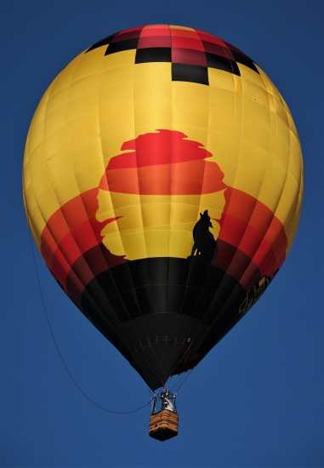
Breaking Wind
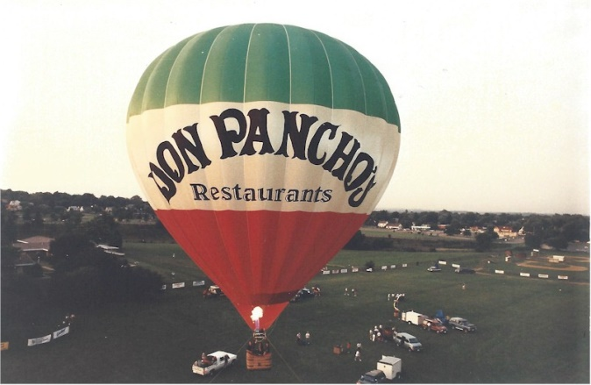
Panchos

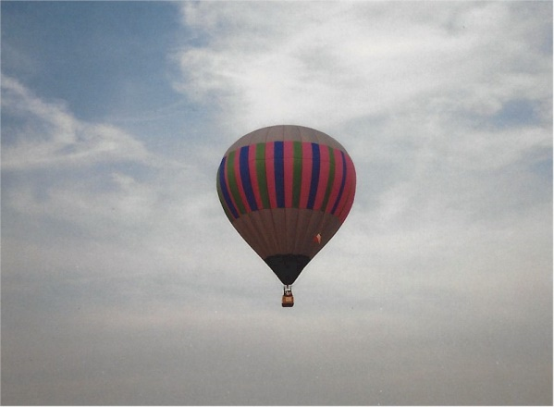
Glasnost

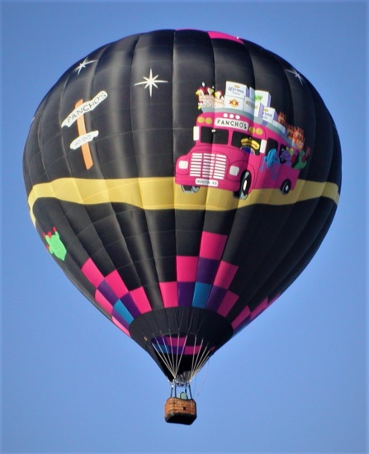
Road Trip
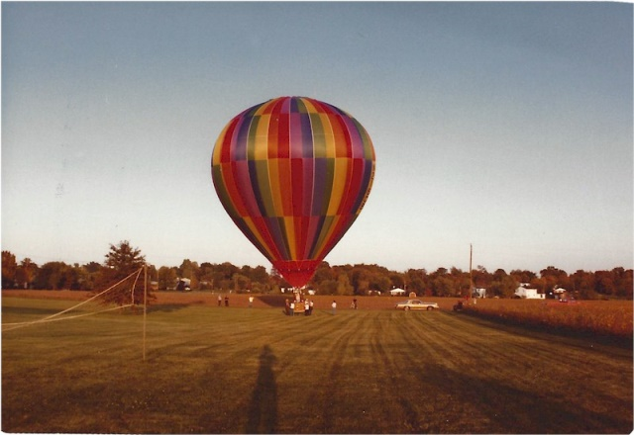
Rainbow End
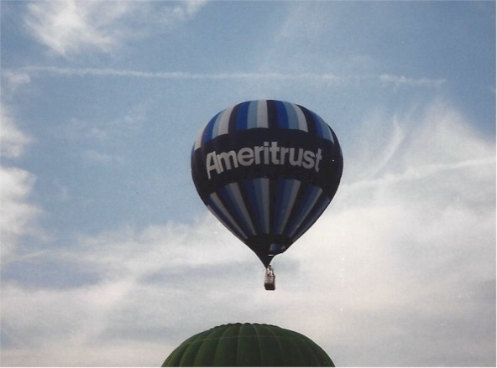
Ameritrust

