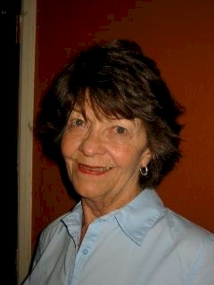
SANDY (BRANHAM) KNEELAND

Notable - Accomplishments/Contributions

Sandy is a native of Denver, Colorado. She began crewing for Chauncey Dunn in late 1969 after seeing his new hot air balloon at a demonstration for his office staff.
Before she saw a balloon, she worked as an executive secretary and administrative assistant for several large companies in the petroleum industry. One of her tasks was writing training manuals which would come in handy in ballooning where she wrote Crew Guidelines, Instructor Syllabus, Event Rules, Waivers, Race Organization Manuals, and numerous articles for newsletters.
Between working and raising a daughter and son, she found time to do some teaching: Sunday School, natural childbirth, and related subjects.
After seeing a balloon and becoming a crew member, she had her reluctant first ride with Chauncey Dunn, and she was hooked. Flight instruction with Chauncey in Stratasaurus, his record setting Raven S60A, complete with fiberglass shin-busting aluminum gondola and two-can burner followed. In April, 1973 she became the first Colorado woman to earn a Commercial Pilot Certificate as Sandy Branham. In 1973 there were 17 women pilots listed in the BFA. Since Sandy didn’t have anything to fly, she formed a flying club, Rocky Mountain Hot Air Balloon Company, bought her first balloon, The Grape Escape (a Raven S55A with two-can burner and aluminum gondola), and began instructing students. The initial six members quickly turned into ten. She instructed 22 students, flew and tethered many balloon promotions in numerous states, and has flown rallys, races and competition in many states. By 1980 she had flown every balloon manufacturer made. In addition, she worked with Chauncey on balloon promotions, and his Raven dealership, and was able to attend several meetings at Raven Industries.
Sandy was a Founding Member of the Colorado Balloon Club in 1974, and through the years has held offices and Board positions. In 1988 she received the Don Ida Spirit of Ballooning Award from the Colorado Balloon Club. She contributed over 10 years as a Board and Committee member of the Colorado Lighter Than Air Safety Seminar. She has also served on several BFA Committees and was publicity chairman for the 1st BFA Convention in Reno, NV in 1977. She has been a presenter at many safety seminars in Colorado and Wyoming, and at other balloon topic meetings.
Her first year to fly Albuquerque Balloon Fiesta was February 1974, followed by flying in the U.S. Nationals in Indianola, Iowa in August 1975.
Repairing balloons just happened because she knew how to sew, but quickly became a passion and profession. After almost 3 years of working with the FAA (they didn’t know what to do with a balloon repair station), and a lot of help from Sid Cutter, Rocky Mountain Hot Air Repair became an FAA Certified Repair Station in 1977. The repair station was sold to Ken Tadolini in 2001 and Sandy continued her repair profession there. By her retirement in Dec 2013, she had logged 4,886 work orders.
Her first experience at race organizing was in 1975, and that led to being involved on many committees organizing events and being on event staffs. In 1977 and 1978 she was CNT Task Balloonmeister at the US Nationals in Indianola, Iowa.
She was on the planning committee for the 1st Snowmass CO Balloon Festival. That festival became her dearest event, and since the mid-1980’s she has been active on that event staff serving as Launch Director, Safety Officer, Assistant Balloonmeister, Honorary Balloonmeister, and in 1995 received the Snowmass Golden Striker Award. Sandy has been involved in planning and being Safety Officer, Launch Director, or Assistant Balloonmeister at numerous events, including Snowmass, Steamboat Springs, Greeley, Erie, Loveland, Colorado Springs Balloon Classic and North Las Vegas, NV. She has written numerous Event Rules and FAA Waivers, and enjoyed a very successful and rewarding working relationship with the FAA both in regards to the repair station and events.
Meanwhile at the Repair Station, maintenance went on, both in the shop and on fun road-trip Annuals/Repairs. Have machine, will travel. Other intriguing projects came along: totally rebuilding my balloon, building a balloon from scratch with a friend, building special shape inflatables and display balloons, helping, being mentor, test pilot, and minor contributor to the Ball Instruments M57, and training numerous people in balloon repair.
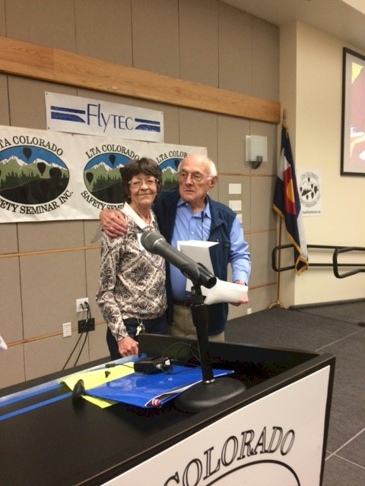
In the late 1970’s, Sandy worked with Nick Saum on his Coors balloon promotion contract as event scheduler and coordinator, scheduling pilots, travel, and maintaining his 3-balloon fleet. She flew and tethered many promotions as PIC in several states.
In an era where many women felt discriminated against and began the Women’s Liberation Movement, Sandy experienced the opposite. She felt very accepted and equal, and the male balloonists both locally and nationally were wonderfully supportive and helpful, emotionally and physically, and were proud to bring women into the sport. Their acceptance was generous, genuine, and enthusiastic. Ballooning is more than a sport—it is a close-knit family with life-long friendships.
Sandy was presented a BFA Directors Award in March, 2018 by Hall of Fame Member Dewey Reinhard.

Nomination for Colorado Balloon Club Spirit of Ballooning Award by Linda “Mauriello” Waidler

I recently had the opportunity to visit a few days with my friend and fellow balloonist of 36 years. Although our paths have changed over the years, one thing never has changed; our many memories of the ballooning community, events, and activities. In other words, the “balloon war” stories. As I reflected on these stories I realized how one thing stood out with my friend, her continued love and service over the years. Never once wavering, going astray, or leaving for other adventures. Always true to her profession and to the balloonists she served.
Many balloonists have ventured into the abyss of risk taking which have brought them great recognition and rightly so. We admire all of our friends both living and flying somewhere in the heavens. However, this particular pilot stayed steady and maintained the sport for more than 40 years. What’s more important is her humility with regard to her accomplishments. This is the reason that I am nominating Sandy Branham-Kneeland for the 2013 Colorado Balloon Club Spirit of Ballooning Award. In my mind, no one deserves it more, for the consistency and true dedication to the sport of ballooning!
Sandy brought it to my attention that she had decided to “retire” from Rocky Mountain Repair Station as of December 2013. This award nomination is very timely, given the fact that she has kept our balloons in the air and our safety at the front of her profession. We need to recognize this amazing woman, not for her altitude endeavors, or her race accomplishments, but for the values, trust, dedication, knowledge, flight abilities, repairs, inspections, and friendship that she has given all of us. These are the attributes that I value in a friend, a balloonist, and human being. To be able to give of yourself in this way for more than 40 years is an accomplishment in itself.
After our evening of reminiscing about our experiences I realized how much I didn’t know about her and her life as a balloonist. I asked her how she wandered in to the sport of ballooning. She told me the wonderful story of how she was invited to see Chauncey Dunn inflate his first balloon of the field of a local high school. She told me how she started the first balloon club with a few people that were involved in the Grape Escape. How she learned to fly and then gave instruction to many more pilots. (Old timers, for sure.) In all the years I have known her she never once bragged about how she was a pioneer in the Colorado Ballooning Community. These stories are real treasures and should not be put on a shelf but be shared in some way with the Colorado Ballooning community. These stories tell the history of your ballooning community in Colorado. You will have to ask her as she is much too modest to volunteer her wealth of information in the area of ballooning.
The next day I thought about our conversations of the evening before and then spotted a copy of your balloon newsletter, The Hot Air Flyer, and asked if I could take a copy with me. It was in the December issue that I saw the announcement about the awards for 2013. I thought to myself that this is one lady that meets all the criteria and then some for Spirit of Ballooning Award. Sandy does not know that I am sending in this letter and I have no idea what she would think about it. So I am taking the liberty of doing it anyway. I know that she made the right decision to “retire” but I also know that it was and still is difficult for her. She deserves the rest but should not be forgotten. It has been her life’s work, keeping us all in the air and she should receive the recognition and love from all of us as she navigates her life without fixing our dang balloons.

