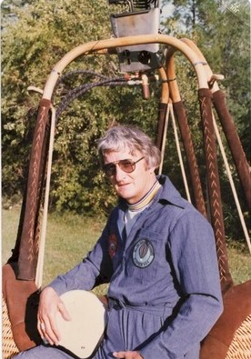
Frank Pritchard

Notable – Accomplishments/Contributions

FAA PILOT CERTIFICATION:
- Student Certificate # AA-1374298 (October 1968)
- Commercial Lighter-Than-Air Free Balloon Certificate
- Limited to Hot Air #1942123 (May 1969)

HOT AIR BALLOON HIGHLIGHTS
- 1968 Formed Flint Sport Balloon Club – Bought “Miss Pepsi” Raven S- 50 N 2324
October: Primary Partners, Frank “Professor” Pritchard and Dennis “Capt Phogg” Floden started training
Instructor: Charles MacArthur from Connecticut
- 1969 January – Approved for Solo and Continued Flight Experience
May Commercial LTA Flight Test – Charles MacArthur, FAA Examiner
July Commercial Flights including over Buick Open – Flint, Michigan
- 1970 – Served BFA Board as FAA Liaison and Continued Flights and Instruction Including:
June Instruction / Training - Washington DC Balloon Club – Arlington VA
July Instruction / Training – Student: Bruce Comstock
5-7 August - Tether at Goose Lake Music Festival – Grass Lake, MI
20-23 August - 1st Place – 1st BFA National Hot Air Balloon Championships
Indianola and Des Moines, Iowa
29-31 August Instruction / Training – Washington DC Balloon Club – Arlington VA
- 1971 – Served BFA Board as FAA Liaison and Flights and Instruction Including:
27-30 August - Competitor – BFA National Hot Air Balloon Championships
Indianola, Iowa
- 1972 – Continued Flights and Instruction Including:
January - Competitor – St. Paul Winter Carnival
St. Paul, Minnesota
11-13 August - Competitor – BFA National Hot Air Balloon Championships
Indianola, Iowa
- 1973 – Flint Sport Balloon Club dissolved. “Miss Pepsi” N2324 sold.
- 1974 – Continued Flights including:
3-7 August – Competitor – BFA National Hot Air Balloon Championships
Indianola, Iowa

NOTE: Frank loved to fly balloons and continued to crew and to fly whenever possible with daughter, Lesley. He retired from General Motors in 1975 and began selling real estate in northern Michigan. His other great passion was snow skiing. Frank was a member of the National Ski Patrol and Ski Patrol Director for 35 years at Boyne Mountain, Boyne Falls, MI. Frank died in October 2014.

