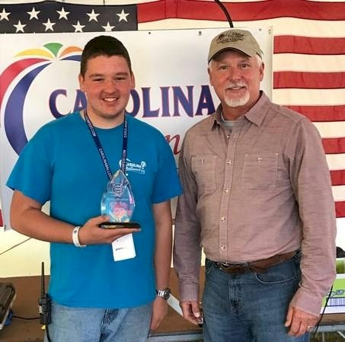
Duncan Dunavent
Notable – Achievements/Contributions

Address: 813 Elmwood Road, Statesville NC
Age: 15

Duncan Dunavent was selected as the Balloon Federation of America National Crew Person of the Year in 2016. Following is the letter of nomination for him:

7-7-16

National Crew Person of the Year Nomination

Nominee: Duncan Dunavent

The interesting part of this nomination for Duncan is that he started chasing Hot Air Balloons at the age of 10! For five years now Duncan’s family has made sure that he could be part of a chase crew for any of us local Statesville Pilots. Duncan’s Mom or Dad made sure that he was dropped off at one of our typical launch sites, he always showed up with the most recent weather forecast and lately he has started bringing one of his new radios that he purchased so he could communicate with any Pilot flying, even if he was at home.
Duncan has attended at least two of the BFA JR. Balloonists camps and has already spoken on the topic of proper crewing techniques at our 2016 Carolina Balloon Association Safety Seminar. He studies everything he can find regarding the different brands of Balloons that he may crew on, providing valuable instruction to other crew members regarding inflation techniques and Balloon rigging.
This past May Duncan volunteered to help with the Scoring team at a Balloon event I direct, saying that he wanted to learn more about a part of Ballooning that he rarely gets to see, the organization side. He was always ready to go each morning, even though it was 2-3 hours before the Pilots and crews were to arrive and he was always eager to help through-out the weekend.
Duncan personifies the dedicated Chase Crew, always eager and willing to assist any of our local Pilots; the unique part about this nomination is that it’s rare to find a teenager these days that would rather learn more about Ballooning essentials, including weather forecasting, landowner relations, map reading and GPS usage instead of staying indoors and playing video games.
I confidently nominate Duncan Dunavent for National Crew Person of the year; even at his young age he is an inspiration to others.

Respectfully submitted,

Sam Parks
Southeast Region Representative
Balloon Federation of America

The following is from the Carolinas Balloon Association Newsletter.

Congratulations to Duncan Dunavent, the BFA’s National Crew Person of the Year. He works tirelessly crewing for the pilots of our association and has since years ago when he made dad Todd “Follow that balloon”. We’re so happy Todd did, and that he and mom Bonnie have encouraged Duncan’s passion for balloons. He’s a student pilot, and we can’t wait to see him continue to develop. The CBA will be supporting you all the way, Duncan. Hope you keep finding soft landings ahead.

