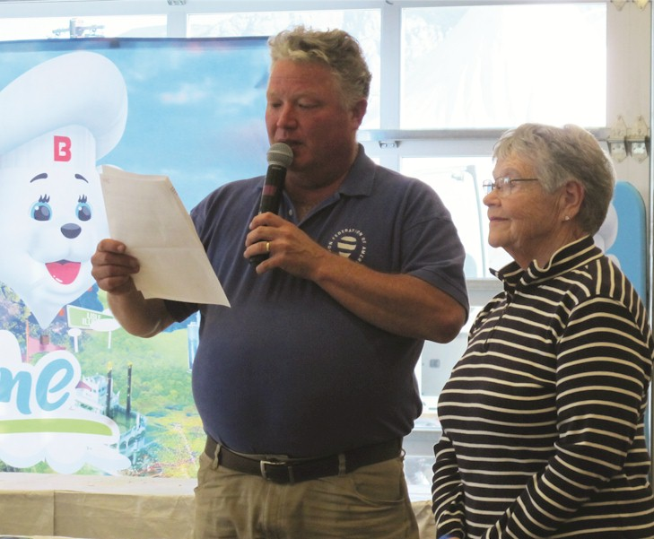
Connie Thompson

Notable – Accomplishments/Contributions

9004 Murano Mews Ct, Kissimmee, FL 34747
Connie@thompsonaire.com

Following is the successful nomination for the 2017 Balloon Federation of America National Crew Person of the year.

Orvin Olivier, Awards Committee Chair
Balloon Federation of America
PO Box 400, Indianola, IA 50125
OOLIVIER@amfam.com

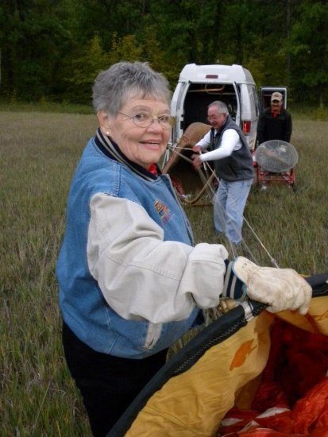
It is my pleasure to present to you a nomination for crew person of the year. This individual has been the crew chief for four family balloonists over the past 40 years and has assisted many other pilots during their time of need at inflations, chases, tethers, or most other occasions. Whenever any pilot or crew forgets or needs any item, whether its gloves, tools, helium, safety pins, markers, pibals, or even such items as champagne their first inclination is to look for this crew chief. They know the items or a substitute will be available. The people working at the refueling stations at all the races came to know her as the one that had a supply of cookies for them.
The chase vehicle is always supplied with all the essentials including pop, beer, champagne, and during the winter months, hot-toddy’s to warm the innards of crews and pilot alike. The champagne is available to toast any first-time flyer and is served in appropriate glasses. At potluck picnics, table cloths are provided for this crew and for any others that are fortunate to sit at the surrounding tables. A candle placed on the table identifies the seating
Many Iowa pilots carry with them First Aid Kits that were made available to the Iowa Balloonist Association through the efforts of this crew chief and through the years many medical needs have been attended to including checks for high blood pressure.
Knowledge of ballooning, as well as knowledge of winds most often leads this crew chief to the landing spot before the balloon arrives and this individual’s friendliness and ability to communicate with property owners is an asset that cannot be matched.
Following is additional information regarding my favorite crew person and one that deserves to be considered for national recognition.
- Started crewing for son when he started his training in 1975 and was his crew chief when he took 3rd in the US Nationals in Indianola in 1978. Started crewing for husband in 1978 and encouraged him to compete.
- Has been a member of the BFA since 1988.
- Received BFA Master Crew Chief Award in 1988. Was chair of the BFA Crew Achievement program in 1990.
- First non-pilot President of the Iowa Balloonists Association in 1994.
- Was crew chief for husband at the US Nationals almost every year from 1980 to 2007, at the 1989 World Championships in Saga Japan, at the 1991 World Championships in St. Jean, Sur Richelieu, Canada. Also was crew chief at four North American Balloon Championships at Barrie, Ontario, at St. Jean, Sur Richelieu, Canada, at San Antonio, TX, and Baton Rouge, LA. Also crewed for husband in Mexico City, Mexico and Bristol, England.
- Assisted with the organization for three BFA Safety Seminars for the Iowa Balloonist Association. Presented various topics at the Iowa Balloonist Association Safety Seminars on crewing and first aid.
- Was selected as the 1986 Iowa Balloonist Association Crew of the year.
- Was selected, along with husband, as the 1996 Iowa Balloonist Association Balloonist of the Year.
- Received the BFA President’s Award as Vice Chair of the 2011 BFA National Convention in Des Moines, Iowa.
- Has served as an observer for many International gas balloon races, including six Coupe de Gordon Bennett races, and two World Gas Balloon Championships, traveling as a member of the crew and on one occasion for 7 days and over 2000 miles.
- Served as an official on a measuring team for the 2011 US National Hot Air Balloon Championships and the 2012 World Hot Air Balloon Championships in Battle Creek, Michigan.
- Served on the chase crew for gas balloons at two North American Challenge gas balloon races in Albuquerque NM.
- Received the John Russell Spirit of Ballooning Award, along with husband Jim, at the 2014 National Balloon Classic in Indianola, Iowa.
- Has continued as crew chief at the National Balloon Classic in Indianola, IA and at the Great Pershing Balloon Derby in Brookfield, MO. Is still active in ballooning as an occasional crew person and chase driver for her son’s hot air balloon ride business in Orlando, FL, at an age that I will not disclose but will note she has been retired from nursing since 2002.

It is my distinct honor to nominate my mother, Connie Thompson, 2004 Murano Mews Ct, Kissimmee, FL 34747 for the BFA National Crew Person of the Year Award.

Respectfully Submitted
Jeff Thompson
cjeff@thompsonaire.com

