Mark Sullivan

Notable – Accomplishments/Contributions, Montgolfier Award, Shields Trauger Award
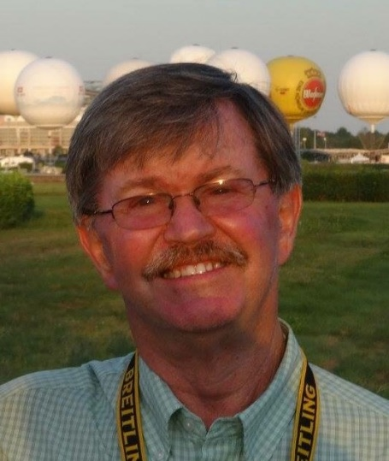

BALLOONING
- Started ballooning in 1983 private certificate in March 1983
- Commercial Certificate in May 1983
- Gas rating October 1985.
- Flown in 30 countries and 38 states
- Flight experience: approx. 3,200 hours (1,900 in gas) 1,210 flights (103 in gas)
- Attended two FAI Hot Air Balloon World Championships
- Attended four FAI North American Championships Hot Air Balloon Championships
- Attended four FAI Gas Balloon World Championships
- Attended nineteen U.S. National Hot Air Balloon Championships starting in 1984
- Attended twenty-one Coupe Aeronautique Gordon Bennetts since 1987
- Attended nineteen America’s Challenge Gas Balloon Race

AWARDS
- 1987 & 1988 U.S. Nationals Balloonmeister Awards
- 1990 Top Gun Award for service to competition ballooning
- 1993 BFA Presidents Award
- 1993 FAI Air Sport Medal
- 1994 Shields-Trauger Award for service to gas and hot air ballooning
- 1996 Al Desmond Award, for service to hot air ballooning
- 1996 CIA Gold Sporting Badge with three Diamonds # 3
- 1998 FAI Montgolfier Diploma for service to Aerostation
- 1999 Albuquerque International Balloon Fiesta Hall of Fame
- 2000 AAAA Sid Cutter Award, Outstanding contribution to hot air ballooning
- 2005 FAI Montgolfier Diploma for best performance gas balloons for two podium finishes in the FAI 10th World Gas Ballooning Championship and the 48th Coupe Gordon Bennett in 2004

SERVICE
- 1984-1986 Board of Directors Albuquerque Aerostatic Ascension Association
- 1986-1996: Board of directors of Top Gun Inc, President 1986 to 1991
- 1986-2000 Board of Directors of the Gas Division of the BFA, Chairman of the Board 1996 and 1997. Helped form the Division and one of the original board members
- 1989 to Present: Board of director of the Albuquerque International Balloon Fiesta, Vice President 1995 & 1996, President 1997 & 1998, Treasurer 2000 to 2003
- 1994 - Present: Chairman of the CIA AA/AM Working Group
- 1995-1997 U.S. Alternate Delegate, FAI, Ballooning Commission (CIA)
- 1998- 2015 U.S. Delegate, FAI, Ballooning Commission (CIA) 12 years as Vice President
- 2016 -present, President FAI Ballooning Commission (CIA)

EVENTS HOT AIR
- 1984, 1994, 2002, and 2005 New Mexico State Champion
- 1984 3rd, 1988 3rd, and 2004 2nd, Albuquerque International Balloon Fiesta
- 1986, 1987, 1989, and 2014 Top Gun Champion
- 1992 1st, 1994 5th FAI North American Hot Air Balloon Championship
- 1994 3rd U.S. National Hot Air Balloon Championship
- 1995 1st U.S. National Team Championship, flying with Sid Cutter and Troy Bradley 2002 1st , 2003 2nd and 2005 2nd S.W. Regional Hot Air Balloon Championship

EVENTS GAS
- 1985 2nd Albuquerque Fiesta Gas Race, Albuquerque .to Wakeeney Kansas
- 1985 1st Thunderbird Gas Balloon Race, Phoenix to Alamosa Colorado
- 1986 4th FAI World Gas Balloon Championship, Glendale Arizona
- 1986 1st Albuquerque Fiesta Gas Race
- 1987 1st Hidden Manor Gas Balloon Race, Allentown PA to NE New York
- 1989 2nd Indianapolis Gas Balloon Race
- 1990 4th FAI World Gas Balloon championship, Tyndall SD
- 1993 2nd U.S. National Gas Balloon Championship
- 1995 1st U.S. National Gas Balloon Championship
- 1995 4th 39th Gordon Bennett Wil Switzerland to Zelve Belarus 1280.0 km, 65:25 forced down by military helicopter
- 1996 2nd 9th FAI World Gas Balloon championship, Bitterfield Germany
- 1996 3rd U.S. National Gas Balloon Championship, St-Louis, MO
- 1997 2nd 41st Gordon Bennett Warsteine Germany to Romanian coast, 1732.3 km 44:45 hours
- 1998 2nd 4th America’s Challenge Gas Race to Side Lake MI 1786 km 60.1 hours
- 2001 4th 45th Gordon Bennett Warsteine Germany to Priseace Romania 1420 km 65:40 hours
- 2001 4th 6th America’s Challenge Gas Race to Black River WI 1695 km 43.3 hours
- 2002 3rd 7th America’s Challenge Gas race to Homer Georgia 2109 km 67.25 hours e
- 2003 4th 8th America’s Challenge Gas Race to Bovine TX 357 km 24.9 hours
- 2004 3rd 48th Gordon Bennett, Thionville Fr, Sveg, Sweden 1472 km 45:17 hours
- 2004 3rd 10th World Gas Balloon Championship Bitterfield Germany
- 2005 1st 9th Frieorich Thode Wanderpries, Marl Germany to Capiquet France 49.1 hours
- 2008 1st 13th America’s Challenge Gas Race to Iowa Falls IA 1419 km
- 2009 3rd 53rd Gordon Bennett Geneva, Switzerland to Faro Portugal 1530 km 71:20 hours
- 2010 3rd 15th America’s Challenge to Cedar Rapids, IA 1507 km 41:05
- 2012 1st 17th America’s Challenge to Beviavillie, NC with a flight of 2623 km and 62:15 hours
- 2017 4th 21st America’s Challenge to College, PA with a flight of 2590 km in 61.55 hours

ORGANIZATIONS
- 1986 Co-Founded Top Gun Inc. the largest competitive balloon club in the US
- 1987-1991 BFA Competition Division Sanction Manager, sanctioned over 300 events
- 1989 Co-Founder of the Special Shapes Rodeo, Balloon Fiesta’s most popular event
- 1993 Organized the 37th Coupe Gordon Bennett in Albuquerque
- 1994 Organized the 9th World Gas Balloon Championship in Albuquerque
- 1995 to present: Events Committee Chairman, Albuq. International Balloon Fiesta
- 1995 Founded the America’s Challenge Gas Balloon Race
- 1996 Founded the Flight of the Nations, held each year during the AIBF
- 1999 Organized the 43rd Coupe Aeronautique Gordon Bennett
- 2000 5th America’s Challenge, first organized use of hydrogen in U.S gas competition
- 2005 Organizing Chairman 49th Coupe Gordon Bennett in Albuquerque
- 2008 Organizing Chairman 52nd Coupe Gordon Bennett in Albuquerque

OFFICIAL
- 1987, 1988, 1994 Assistant Championship Director, U.S. National Hot Air Championship
- 1989 to 1997 Special Shapes Rodeo Event Director
- 1993 Event Director 37th Coupe Aeronautique Gordon Bennett
- 1994 Event Director 9th World Gas Balloon Championship
- 1995 & 1996 Event Director America’s Challenge Gas Balloon Race
- 2000 Deputy Director 44th Coupe Aeronautique Gordon Bennett, Belgium
- 2001 Event Director FAI World Air Games Gas Championship, Seville Spain
- 2006 Event Director 1st Dubai Balloon Festival, United Arab Emirates 74 balloons
- 2015 Liaison for Hot Air FAI World Air Games, Dubai, United Arab Emirates

