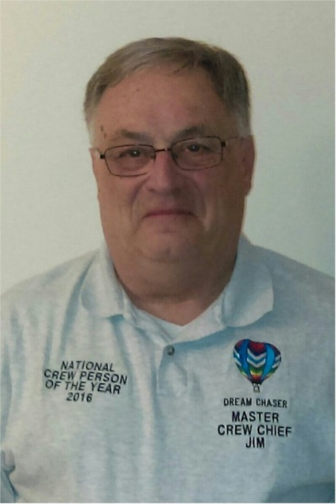
James A. Doerer

Notable: Accomplishments/Contributions

Rahway, New Jersey
616 Maple Avenue
Rahway, New Jersey 07065

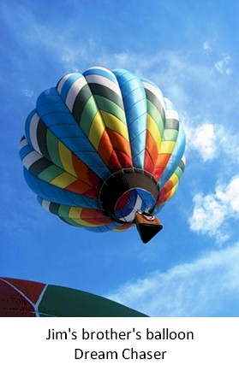
James has been involved in ballooning since 1985. During that time, he has logged over 750 hours crewing; most of those with his brother Joe and Joe’s wife Janet. James has enjoyed his many years of ballooning, making longtime friends and helping other crew members learn about ballooning. Of all the years and flights James has been lucky to fly, two flights stand out the most. One was his first flight, which ended in a fast, windy landing. After the landing he turned to his brother and said, ‘ok let’s do that again’. The second happened when they were at the Festival de Montgolfieres in St Jean-sur-Richelieu in Canada. When they took off, James didn’t know Joe was planning to fly towards the US border. This was before the extra enforcement caused by the tragedy of 911. As they got closer to the border Janet went ahead to see if they could land just past the border. Unfortunately, Customs said no so they landed ¼ mile before the border. They had the fuel and plenty of places to land up ahead, so in their minds James and Joe had achieved their international balloon flight.
James is proud to list the following achievements during the years that he has been involved in ballooning as a member of the BFA and the Great Eastern Balloon Association (GEBA):
- GEBA member since 1985
- BFA member since 1988
- Recipient of the first GEBA Dan Decker Crew Achievement Award in 1991
- Completed the BFA Crew Achievement Awards Program becoming GEBA’s first Level IV Master Crew Chief on the east coast in 1999
- Received the GEBA Above and Beyond Award in 2000
- Recipient of the GEBA Ted Torok Sportsmanship Award in 2001
- With the assistance of Barbara Magnano designed and implemented GEBA’s own Crew Achievement Program to help crew members increase their knowledge of safety in ballooning and to promote the BFA Crew Achievement Awards Program
- Instructed (with Barbara Magnano) at three of the Great Eastern Balloon Camps run with the BFA for junior balloonists in 2014, 2015, and 2016
- With the assistance of Barbara Magnano, designed the “Ballooning Feud” game in 2016 which they continuously update for new presentations
- Recipient of the BFA National Crew Person of the Year Award in 2016
- Presented “Crew Safety” and the “Ballooning Feud” (with Barbara Magnano) at the 2017 GEBA Continuing Education Seminar
- Instructed (with Barbara Magnano) at the FAVA 225/2018 BFA Convention as part of the Future Fliers program

Jim Doerer was selected as the Balloon Federation of America National Crew Person of the Year in 2016. Following are the two letters of nomination for Jim:

June 7, 2016

My brother Jim Doerer has been a member of the Balloon Federation of America for thirty years. He has also been actively involved in the Great Eastern Balloon Association throughout that time. With close to a thousand crewing experiences to draw from, he has become a source of knowledge for many new crew members in our local area. His desire to assist any balloonists when the need may arise has earned him the respect and appreciation of many balloonists. One example of this dedication to keeping pilots safe occurred at a festival in North Carolina where a few pilots launched into weather that deteriorated into heavy rain. When Jim realized a pilot was attempting to land in a field near him, Jim did not hesitate to run and put weight on the basket, knowing he would get completely drenched by the water rolling down the envelope. He knew that pilot needed to get down as quickly as possible and that was the safest place to do it.
In 1991 Jim became the first recipient of the Great Eastern Balloon Association‟s Dan Decker Crew Achievement Award. During the award ceremony he was honored for his attention to “the safety of the pilot and the passengers before, during, and after each flight”. The following year he received the GEBA Ted Torok Sportsmanship Award; presented to a GEBA member who best projects the true spirit of sportsmanship and has made a positive contribution to the sport of ballooning. Jim continues to be involved with the club as years go by, including being the chairperson of the Landowners Relations Committee for a number of years.
Jim has participated in the BFA Crew Achievement Awards program since its inception and in 2000 he earned the title of Level IV Master Crew Chief. Part of the benefits of this title is that it has given him the opportunity to encourage and sign off crew members new to this program. It also supported his „Approved Instructor‟ status with the BFA Continuing Education program, allowing him to be a session speaker at two BFA Junior Balloonist Camps. When not helping out in structured training Jim is always available one on one with any questions another crew person may have.
Perhaps even more important than Jim‟s awards and achievements is the dedication he has to keeping our Dream Chaser balloon team safe and secure. He has made each flight far more enjoyable and less demanding knowing he will make every effort to be there at landing, he will treat the landowner with utmost respect, and he will somehow find a way to get to the balloon. There is no doubt in my mind that my career as a pilot would have been less rewarding, and most likely shorter, had it not been for his assistance over the past thirty years. For me he will always be the best crew person of each and every year.
Thank you for taking the time to read these comments,

Joe Doerer
5 Woodland Way
Whitehouse Station, NJ 08889
BFA # 104148
908-534-9467

BFA National Crew Person Award Nomination
I have the great honor of knowing one of the most safety minded crew people I have come across in my 24 years of ballooning and would like to nominate him for this most prestigious crew award.
He has been ballooning for just over 30 years as crew chief for his brother; it’s a smooth family team that is committed to safe, fun ballooning excursions. His dedication is evident in that he schedules his vacation time from work to be present at various festivals as an integral part of the balloon team. He is a member of the BFA and a local club member of Great Eastern Balloon Association (GEBA), both for many years.
His crewing involvement expands into helping other crew people in so many ways. For the last three years he has stood by my side as we presented Crew Safety to the campers at Great Eastern Balloon Camp in Pennsylvania. This year we really kicked up the interactive level with a game for the kids, much like Family Feud, with ballooning questions, it was a real hit! At the end of the game each camper got a $5.00 card for Subway for participating in the game (from his own pocket). He is excited to be a part of growing the youth into ballooning in a positive and safe way.
I really could go on for several pages with more great thing to say, but without keeping you in suspense any longer,,,, I would like to nominate Jim Doerer for this most honorable award, I think its well-deserved, and he would be extremely proud and surprised with the award.
Thank you for your consideration of the nomination, and for having this in place to encourage crew participation and pride while ballooning into the future.

Respectfully,
Barbara Magnano
Proud BFA Member
BFA Camp (GEBC) main staff for last three years.

