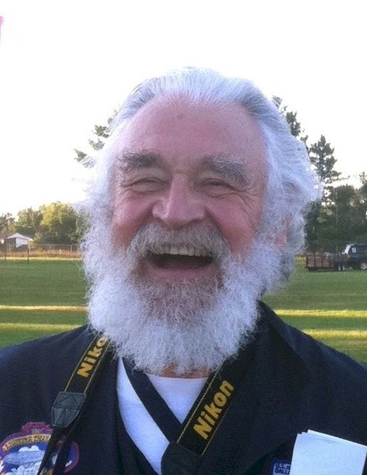
Michael Tuten

Notable: Accomplishments/Contributions

In December 0f 1978 I attended the first Observer Training offered Madison, which was run by Debbie Spaeth, in preparation for Madison’s first sanctioned Hot Air Balloon Competition held the following January. Subsequent to that I either observed, debriefed or functioned as the Chief Observer or Chief Debriefer at most of the National competitions and a number of regional competitions from 1979 through 2011, ending my official observing career as a debriefer for the 2012 Worlds in Battle Creek.
I was appointed the Observer Manager by Alan Blount I believe in 1989, replacing George Popkin. One of my first tasks was editing the Observer Handbook, which the then Competition Division adopted at its December 1990 meeting. I continued as Observer Manager until retiring in 2007 0r 8. I can’t remember when but recall it being one of the most difficult decisions I made. I really loved being an Observer and acting as an advocate for the Observer community. I did it because my life’s other duties prevented me from giving the job the time it deserved.
During my time as Observer Manager I was for a while the Chief Observer as well. The dates for this escape me. During all of this I worked with other senior observers and debriefers to organize and present training for the Observer Corps as needed.
Throughout my involvement as an Observer and Debriefer I sought to share the fun and excitement of ballooning with whomever I happened to be with. During the 1992 Nationals in Middletown Ohio, when we were flying tasks both morning and evenings with no break in sight, I wrote my first ballooning song. At this event the Observers were bussed at O’ dark thirty to the briefing area and by mid-week, most of us were dragging ass as were the competitors. While on the bus, these lyrics to the tune of "The Drunken Sailor" came to me:

What do you do with an Ornery Pilot (repeat 3 times)
Erlie in the morning

Verse 1: Give them maps from another country (repeat 3 times)
Earlie in the morning
Chorus: Way hey and up she rises, (repeat 3 times)
Earlie in the morning
Other verses are:
Verse 2: Give them baggies filled with feathers
Verse 3: Give them task sheets written in Chinese
Verse 4: Give them a compass without a needle (this was pre GPS)
Verse 5: Give them a basket without a burner
Verse 6: Make them demonstrate a flap inflation
Verse 7: Tie them to the crown and fully inflate it
Verse 8: After the launch, go to breakfast
Verse 9: Fill their propane tanks with water

Later in the week, just before the morning briefing a large number of the observers sang this to the assembled and it seemed to provide the comic relief needed. Many of the pilots keyed their radios so their crew waiting in the chase vehicles could hear the song as well.
This inspired me to compose a song that illustrated the art of competitive ballooning from the Observer’s point of view.

The Task Song (sung to the tune Home on the Range)

Verse 1: Oh give me a home, where the Balloonmeister roams,
And I guarantee no one will sleep!
‘Cause well before dawn, he meets with the throng
To hand out the morning’s task sheet
Chorus: Home, home away from home,
Where no one will get any sleep,
Where seldom is heard, and intelligent word
When the sky’s are not cloudy all week
Verse 2: Then it’s up in the air, where Observers are rare,
That Pilots valid goals they all seek.
With the goal soon in sight, the winds shift to the right,
And the pilot gets into a pique.
Verse 3: When as close to the goal, as the pilot can go
To the earth a baggie soon streaks.
And as soon as it lands, with the Observer in hand
The baggie the chase crew will seek.
Verse 4: And when it does land, with spray paint in hand,
To the baggie the Observer will leap.
With colors so bright, round the baggie real tight,
A circle is made in the street.
Verse 5: When the flight it is done, back to the drop they all come
For a measurement they hope is in feet.
With compass and tape, a drawing is made
On the Observer’s reporting sheet.
Verse 6: When the measuring is done, the Pilots have fun
While Observers and Debriefers meet.
They go over the tasks, many questions are asked
Before scores for the Pilots are reached.
Final chorus: Home, home away from home,
Where no-one will get any sleep.
Where seldom is heard an intelligent word,
When Observers and debriefs meet.

Michael was presented the Spirit of Annie Award in 1997 for his work as an observer and work for the Observer Corp.
Currently I am retired from the State of Wisconsin where I worked as an investigator for 37 years dealing with various forms of fraud. My primary efforts now are providing a performance space in my home for traveling musicians whom my wife Carol and I host from time to time.

