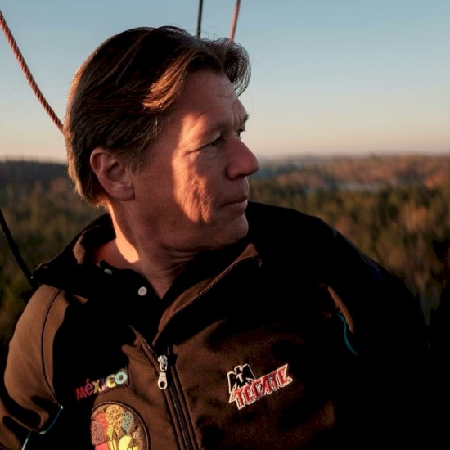
Stuart Enloe

Notable – Accomplishments/Contributions

Stuart Enloe started playing with Hot Air Balloons at Mike Adams Balloon Loft sweeping the floors, crewing, and learning how to build balloons. Fascinated with balloons he attained his LTA certificate and won several awards for competition.
After obtaining his LTA Commercial license he went on to have several commercial contracts, flown in a number of countries, and a few special shapes, then to have the “with airborne heater” restriction removed. Stuart competed in the America’s Challenge and became a National Champion with a 63 hour and 1673 mile flight. He has also competed in the Gordon Bennett. To date Stuart has acquired over 4,000 hours LTA time with over 200 hours in Gas balloons. Additionally, Stuart earned his United Kingdom CPL/BA commercial certificate and became one of only 3 commercially rated Thermal Airship pilots in the USA.
Stuart has served as President of the Georgia Balloon Association, Chief Flight Instructor of a 141 School (was even able to teach his daughter to fly and get her pilots certificate before her driver’s license), Balloonmeister, Weatherman, or Safety officer at many events, Piloting the RE/MAX for 28 years, conducts regional Safety seminars annually at no charge, has given over 300 Young Eagle flights, and currently working with STEM (Science, Technology, Engineering, Mathematics) education in Middle and High schools.
One of Stuart’s favorite sayings, which he still uses regularly, is “I feel like a little kid every time I inflate a balloon”. Stuart is totally in awe of a balloon’s mystical powers to bring joy to thousands of people at any given time. He is still learning every day, and on every flight, something new about aviation.

