Ronald G. Grove

Notable – Ed Yost Master Pilot Award

AERONAUTICAL BIOGRAPHY

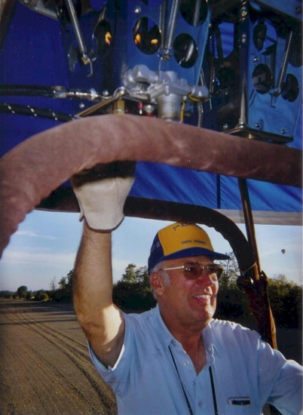
In early 1973 I became interested in hot air balloons. My wife, Sandy, & I had been involved with water ski boats, sports cars and motorcycles so it made sense that flying was the only activity left.
I collected everything I could find on hot air ballooning, filling a three inch thick notebook with color samples and manufacturer brochures (Raven Balloons, Piccard, Barnes, and Semco Balloons). I joined the BFA on May 15, 1973. The Balloon Journal was printed in black and white at that time. I enjoyed the BFA Balloon Journal so much that on January 21, 1977 I updated my yearly membership to “Life Member”. Soon after, I joined the National Balloon Museum as a Charter Member and a “Cornerstone Club Donor”.
On May 23, 1979 it was required to have a third class medical certificate to act as a student hot air balloon pilot. In March 1974 I checked the Los Angeles Yellow Pages and found one of the early hot air balloon flight training schools in Southern California. Sandy & I scheduled our introductory flight for March 29, 1974. We drove from our home in Santa Barbara to Perris Valley, CA for our first hands-on experience with an aerostat.
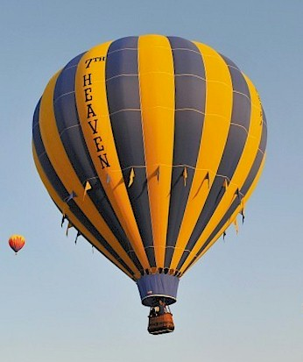
Naturally, we assisted with the set-up, inflation, flight & pack up. During the flight I asked the instructor how I could start my balloon flight training. He stated that we could start the instruction on this flight. We discussed the instruments, fuel system, and the burners. During our one hour flight I was able to log my student training as “dual instruction received”. It took me from March 29, 1974 to September 1, 1974 to achieve my commercial balloon pilot certificate (in part because of me living 166 miles north of Perris Valley and my instructor’s varied work schedule as a pilot for United Airlines).
In 1974 you could receive your commercial hot air balloon pilot certificate after a minimum of eight hours of logged flight time. By having a commercial certificate, legally you could instruct student pilots.
After completing my commercial rating we designed and ordered our first hot air balloon system, “7TH HEAVEN”, from Raven Industries in Sioux Falls, SD. Our first system was an AX-7. Years later we upgraded to an AX-8 and still fly that size today. (At that time Sid Cutter, World Balloons, in Albuquerque, NM was Raven’s western states distributor).

INTERESTING EVENTS
3/29/1974 Introductory flight
7/27/1974 First solo flight
9/1/1974 Received pilot’s certificate – Lighter than Air Free Balloon with Airborne Heater
6/1975 Our ride business, “7TH HEAVEN”, was started in Santa Barbara, CA. We also have operated the business in Prescott Valley, AZ and presently in Salem, OR.
12/1975 I began training Sandy for her private rating. I found that I really preferred giving balloon rides to first time passengers. Their involvement and reaction to the unique feeling of the entire balloon experience, from bringing the balloon to life out of the bag to the quiet flight and gentle landing is very rewarding.
3/1978 Due to an FAA oversight in the regulations, I was qualified to have my commercial hot air balloon pilot certificate (Lighter than air free balloon – limited to an airborne heater) restriction removed because I had met the requirements for a “Lighter than air free balloon” rating. The FAA Regulations did not state the upgrades had to be done in a gas balloon. So, I received my gas balloon rating prior to taking any gas balloon flights.
9/1978 “7TH HEAVEN” was used in a general merchandise catalog photo shoot for the Gemco Courier located in Buena Park, CA.
3/7/1979 We did a television commercial and magazine ad with Michael Landon for the Kodak Camera Company.
7/1982 Factory tour through Raven Balloons in Sioux Falls, SD.
7/1982 Toured Ed Yost’s Sky Power Gas Balloon manufacturing facility in Tea, SD.
8/1995 I assisted with the hot air balloons used in the movie “Steal Big-Steal Little”. The movie was filmed near Santa Barbara, CA and starred Andy Garcia and Alan Arkin.
1998 “7TH HEAVEN” was featured in the “Santa Barbara Magazine” along with three other types of non-powered aircraft.
9/2009 I started coordinating the “Landowner Appreciation Flights”, in the Willamette Valley of Oregon. Local balloonists donate their time & equipment to show their appreciation to landowners by giving them a flight, in thanks, for letting us land on their property.
12/2011 I was voted to receive the “Willamette Valley Aeronaut of the Year” award by our local balloon club, the “Willamette Aerostat Society”.
11/2012 The “BFA Directors Award for 2012” was presented to Ron & Sandy Grove for their “support and dedication to the sport of hot air ballooning”.
4/2014 Factory tour through Firefly Balloons in Statesville, NC.

MEMORABLE FLIGHTS
3/17/1978 I was able to log a one hour introductory flight with “hands-on-the-controls” in the Goodyear Airship Columbia, GZ-20 N-4A, from the Carson, CA airship facility.
12/30/1978 We flew to 16,700 ft ASL (with a Braniff Airline level with us) in Riverside County, CA with Sandy and my instructor.
12/22/1979 Gave our daughter, Angela, her first balloon flight at four weeks old. Now our three young granddaughters enjoy flying with “Poppa”.
5/8/1982 I was the co-pilot aboard the “Destiny” gas balloon, US II, competing in the Gordon Bennett Gas Balloon Race out of Fountain Valley, CA. The 194 mile flight from the Los Angeles Basin to Needles, CA took 13.5 hours with a maximum altitude of 11,000’ ASL.
7/5/1982 Co-pilot of the “Destiny” gas balloon at the McDonnell-Douglas Aero Classic Balloon Race in St. Louis, MO. The 561 mile flight lasted 9 hours.
8/1989 I was invited to fly our balloon in Metz, France, for “Fraternite 89” for the 10 day celebration of the bi-centennial anniversary of the French Revolution.
10/1989 Backup corporate pilot for the “In & Out Burger” balloon.
8/1991 Returned to France to fly in “Fraternite 91”.
1/10/1999 Took a tandem paraglide flight from the 3,000 ft. coastal mountain range in Santa Barbara, CA to celebrate my 50th birthday.
10/16/2010 Co-pilot for a hot air balloon flight over the Cascade Mountain Range in Oregon.

BALLOON SYSTEMS FLOWN
Raven AX-6, AX-7, RX6 and RX7 Aerostar AX-8
Balloon Works AX-7B and 8-B
Piccard AX-6W
Cameron N-90 & N-120
Avian AX-9

For my flight training, I flew a Raven S-55A with an aluminum & fiberglass (G-series) basket. I still have my 1975 (W-Series) wicker basket with the “horse shoes” in the corner. We are currently on our fourth envelope with the same identical design. We have upgraded to a stretch basket and a more powerful burner.

OTHER AIRCRAFT FLOWN
Powered hang glider
Cessna 180
Blanik Sail plane

One of my future goals is to make some hydrogen gas balloon flights.

Posted on Facebook on 5/01/2018



Balloon Federation of America
19 hrs ·
It is with heavy hearts we share of Lifetime BFA Member and Ed Yost Master Pilot award recipient, Ronald Grove's passing. Ron's first solo flight was in 1974 and he became a life member in 1977. Early last month Ron passed after a long battle with cancer. Our thoughts are with his family and friends.

