
Mike Adams

Notable – Development

The following was taken from http://adamsballoons.us/index.php?main_page=about_us and reproduced with their permission.

MIKE ADAMS AND ADAMS BALLOONS

The birth of Adams Balloons originated in 1971 with Mike Adams' enormous amount of enthusiasm for the potential of the modern hot air balloon. In the beginning, with very few resources progress was slow but over a period of 10 months, serial number one took shape. Work at the drawing board and shopping for the perfect materials took most of the time.
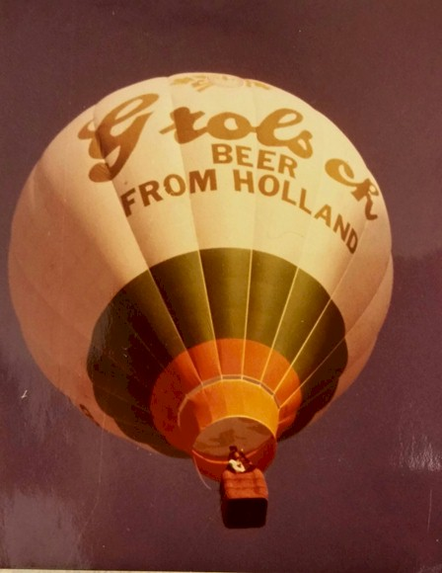
What was a home to Mike Adams became a workshop where nights and weekends were spent designing and making the balloon. Week days were spent working to make money to support the ballooning hobby; until 1973 when balloon building became a full time job. The fledgling company was primarily a flying business that built its own balloons, and a few balloons here and there for other people.
The regular flight activity stimulated new designs and many refinements of existing designs, while basic attitudes and philosophies about the standard balloon design became firmly established. The early balloons flew quite well, but needed frequent repairs, the philosophy at Adams soon became “redesign rather than repair”...
The pioneering spirit of the 70’s which dictated that one must innovate and not simply copy others was shown throughout the continual progressive development of all Adams' products.

MIKE ADAMS' INNOVATIONS
Since the throat of the balloon was guaranteed to get the brunt of the radiant burner heat, Nomex was added to the bottom panel of the balloon. This fire retardant fabric was the perfect choice to prevent burns at the mouth, and soon the other manufacturers followed.
Next, stronger fabric was desired to extend the life of the balloon. From the wear and tear of ground handling, UV rays and Georgia's envelope eating pine trees, fabric weight was increased for strength and longevity. Other high temperature fabrics were considered but ultimately Nylon was the final choice.
While other balloon companies focused on manufacturing bulbous balloons of either eight or twelve gores, Adams recognized that a smooth horizontal construction would allow for perfect artwork to be applied to the side of an envelope. As a result Adams adopted a flat sixteen gore design, whatever the envelope size.
Adams Balloons always offered a choice of deflation systems with its envelopes, including both parachute valves and the lightning fast pop-top. Extremely popular with owners, the rapid deflation pop-top is perhaps the single most distinctive feature that the ballooning community associates with Adams envelopes.
It took substantially different basket designs to come up with the end result. The distinctive square/ round standard baskets are beautiful and simple yet strong. In 1975, the Smithsonian Air and Space Museum chose Adams for its modern gondola display and the basket is still on display representing a modern hot air balloon. Adams gondolas are the most rugged available on the market and the standard of excellence was set 40 years ago.
The Adams burner has an ingenious heat exchange manifold to keep the O-rings warm on cold winter days so they do not leak. Redundant blast valves and pilot lights have all been part of Adams evolutionary success.

THE FIRST SPECIAL SHAPES
Adams also built the very first Type Certified Special Shape. Working with Kentucky Fried Chicken, Adams designed a KFC Chicken envelope with a matching Chicken Bucket basket. In 1975, the complete balloon was tested and then submitted for approval with the FAA issuing a Standard Type Certificate in early 1976. Two Chickens were built and both balloons earned Standard Airworthiness Certificates, a full 6 months before British company Cameron Balloons (TM) built Golly; the first shape in Europe.

