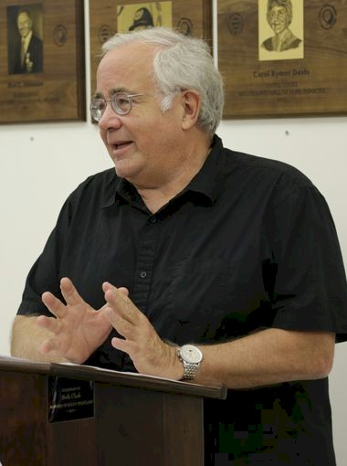
Eric Barnum

Notable – Accomplishments/Contributions

Current Contact Info: 117 Cass Street
Maumee, OH 43537
(419) 893-9938 Home
(419) 838-6921 Work

BUSINESS AND MANAGERIAL EXPERIENCE:
- 1970 to Present Crow Executive Air, Inc., President Managed all business functions of Crow Executive Air, Inc. after the sale of Great Lakes Aero Distributors.
- Coordinated transition of Crow Executive Air, Inc. from an aircraft sales organization to primarily an air carrier service and maintenance facility Generated five-fold increase in revenues since becoming President
- Purchased family held business in 1991
- 1981 to 2002 Mid-American Aviation Insurance Agency, Inc., OWNER Specialty aviation casualty insurance
- 1988 to 2008 Foxtrot Alpha, Inc., PRESIDENT Aircraft investment and leasing company
- 1992 to 2000 Fintec Corporation, PRESIDENT Aircraft investment and leasing company
- 1994 to 2006 Tango Juliet, L.L.C. Aircraft investment and leasing company
- 2011 to present N414MW LLC Aircraft investment and leasing company
- 1975 to 1982 Great Lakes Aero Distributors., Inc., VICE-PRESIDENT
- Wholesale Aircraft Sales, Division of Crow Executive Air, Inc. Responsible for all management and planning functions of the company
- 1966 to 1970 University of Denver, Denver, CO., Office of Student Work. Included various maintenance and service jobs on campus.

PROFESSIONAL ASSOCIATIONS
- Toledo Area Chamber of Commerce
- National Fed of Independent Business
- National Eagle Scout Association - Life Member.

PROFESSIONAL QUALIFICATIONS-Lighter-Than-Air:
- Currently own Cameron C-60 “NBI”; 1967 Raven Vulcoon S-40A;
- Accident Prevention Counselor -FAA (expired)
- Operated, managed and flew Special Shape Commercial Balloon operations in North America for Champion “Spark Plug” balloon 1980; Planters “Mr Peanut” balloon 1980-1999
- BFA - Served as National Safety Committee Chairman, 1982-1985
- Hot Air Balloon Pilot Examiner - FAA (1976-1996)
- Hot Air Balloon Events.. over 100 events all over USA (almost every state) and Canada
- Balloon Federation of America - Master Instructor Rating (expired)
Level VII Pilot (highest rating)
- Championship Director – Fiesta Division – U.S. National Hot Air Balloon Championships 1981, 1982, 1983, 1984
- Pilot Ratings:
  - Private single and multi-engine
  - Single engine seaplane - 3000 Hours total time
  - Glider
  - Commercial Pilot – Lighter Than Air - 1400 Hours total time

PROFESSIONAL AVIATION ASSOCIATIONS:
- National Aviation Trades Association - Served on National Aircraft Maintenance Committee
- National Business Aircraft Association
- Balloon Federation of America
- Aircraft Owners and Pilots Association
- Antiques Aircraft Association – Life Member
- Quiet Birdmen – National Pilots Fraternity
- National Aeronautique Internationale
- British Balloon & Airship Society
- Experimental Aircraft Association

PERSONAL:
- Married – Sally R.
- Children
  - Caroline T – Veterinarian, NY
  - Andrew R – Professional Pilot, Toledo, OH

EDUCATION:
- 1970 Graduate University of Denver, Denver, CO., B.S.B.A. Marketing & Business Management
- 1966 Graduate Ottawa Hills High School, Toledo, OH

CONTINUING EDUCATION:
- Numerous courses in Aviation Business Management; Accounting, Xerox
- Professional Selling Skills I & II; FAA Pilot Examiner Standardization Course;
American Airlines – Administrator of Maintenance Course, Property & Casualty Insurance Agent Continuing Courses

FAA PART 135 EXPERIENCE AND QUALIFICTIONS:
- Administrative Assistant to Director of Operations – 1970 to Present
- Director of Operations, Crow Executive Air, Inc.-1998 to 2002
- Assigned Operational Control per 135.23(a), - 1972 to Present
- National Air Transportation Association Part 135 Compliance and Audit Schooling
- NATA National Maintenance Committee Member 1991 – 1992
- Sole responsibility at Crow Executive Air, Inc. for the following Part 135 functions since1970:
  - Write, revise, and manage Company Part 135 Operations Manual
  - Write, revise, and manage Company Part 135 Training Manual
  - Write, revise, and manage MEL Manuals for the following aircraft:
    - Lear 24D, 24B, 25B, 35A
    - Cessna C-441 Conquest; C-208B Grand Caravan; Cessna 414
    - Beechcraft BE-18, C-90, B-100
    - Piper PA-31-310/325/350, PA-23-250, PA-44-180, Aerostar
  - Write, revise, and manage AAIP (Approved Aircraft Inspection Programs) for the following aircraft:
    - Lear 24D, 24B, 25B, 35A
    - Cessna C-441
    - Beechcraft C-90, B-100
    - Fairchild SA-226-TC
    - Beechcraft Hawker 400/731
    - Ultimate responsibility for coordination of effort between Flight, Following/Dispatch Department, Flight Crews, and Maintenance Department
  - Complete responsibility for regulatory review, audit, and compliance with audit oversight of Chief Pilot, Director of Maintenance and Director of Operations

