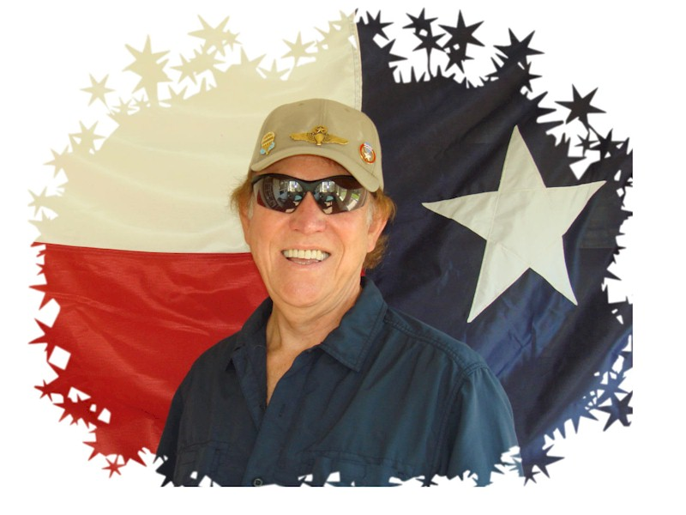
Gordon L. Hall

Notable – Ed Yost Master Pilot Award

Colonel “Flash” Gordon is an accomplished veteran professional aeronaut. He has been an active participant in hot air ballooning at all levels for now over 45 years and continues to be the chief pilot for his company, Lone Star Balloon Port. He started way back in 1972 in Dallas, Texas, and flew in one of the first Albuquerque International events as a student pilot. A few months after getting his licenses in 1973, he competed in his first Nationals back in Indianola, Iowa which he did for several subsequent years and doing well in all. On May 9th 2018, he will celebrated 45 years of having held a Federal Aviation Administration issued commercial hot air balloon license. On May 11th 2013, he was presented, in front of his ballooning peers in Walla Walla, WA, as the BFA’s 4th pilot ever to receive their coveted “Ed Yost Master Pilot” for his, then, 40 plus years of safe ballooning and conducting himself in way that exemplified the sport! Gordon has logged hundreds of hours flying competition, providing flight instruction for many students, and performing commercial flights through-out at lot of the continental United States, and in Alaska, where he resided and flew for several years.
Gordon has also flown internationally in balloon competition and rallies in such places as Canada, Brazil, Mexico and France. Gordon has competed in and has successfully won many balloon competitions. He was the 1st State of Texas Champion after having his licenses only six months and was presented his trophy by the famous Hollywood star, Slim Pickens! He is also one of the former winners of The Great Reno Balloon Race where he was a continuous participant for 25 straight years! Gordon has worked with some of the major corporations and organizations like Baskin Robbins, Pizza Hut, Justin Boots, Paramount Studios, Miss Teenage America Pageant, while doing commercial promotions, which involved balloon free flights and / or tethers. He also did balloon stunt work in the acclaimed movie “Rat Race”. Gordon has helped organized and served as Balloonmeister for several balloon rallies. For over thirty years, he represented one of the major balloon builders then, Firefly Balloons, as a West Coast Dealer / Area Coordinator. He was one of the founders and a “Charter” Board of Director member of the Southern California Ballooning Association (SCBA) in the eighties. Since getting into ballooning, he has been a lifelong member of the national organization for ballooning, the Balloon Federation of America (BFA) and has participated in their elections by running for the Board of Directors on several occasions.
Gordon continues to actively participate in local and regional and national balloon safety seminars and continuing pilot education activities. His love for the sport continues to be evidenced by the intensity of his continual active involvement ever year for now over four decades! He says his most enjoyable ballooning flight ever was in Monument Valley, Arizona / Utah and his most harrowing flight was along the California coast near Morro Bay, California and his most sensational was a roof top landing on a high rise heliport in the down town of a major USA city. Although, he is quick to admit that they are all enjoyable because no two flights are ever the same because of weather, location, track and of course, people. His association with ballooning has yielded him many good friends and cherished memories which are all priceless. He recognizes that the continued practice of good safety habits, quality equipment, and staying constantly alert of your surroundings at all times can help any balloonist to better become an old, long-time balloonist, like him!
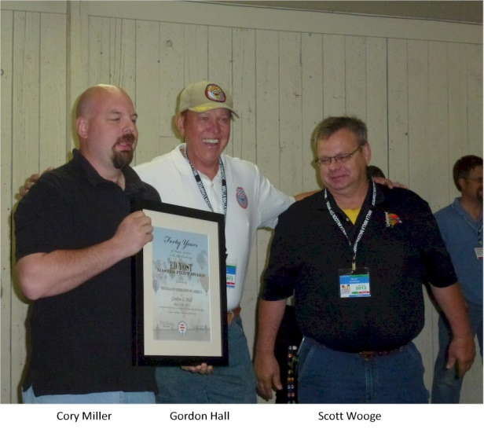
The following was submitted for the Ed Yost Master Pilot Award

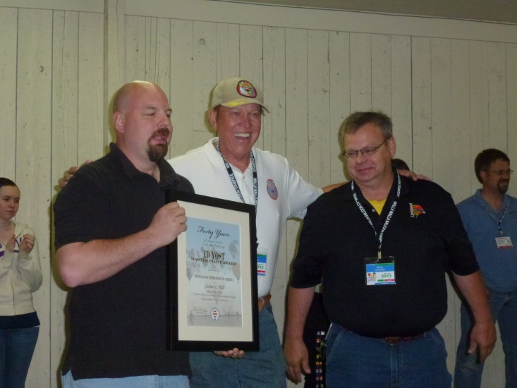
Gordon first started flying on 9/2/72, soloed on 4/7/73, and got his license on 5/9/73. On 2/7/73, he logged time in Albuquerque at the Fiesta and on 2/17/73 flew in his first Nationals in Indianola. He has flown in each and every year since, including 2013 and has owned 20 plus balloons along the way. He does not recall ever hurting anyone or himself that required a doctor’s visit. Of course, there were a lot of very hard landings. He has never had any insurance claims and has been accident free. He has never had any FAA or other enforcement actions. He joined the BFA back in 1973 and has maintained his membership 019650 ever since. He has been a goodwill ambassador for the sport over the years. He ran for the BFA Board of Directors on three separate occasions but narrowly lost each election. None the less, he continued to promote both the BFA and the sport of ballooning in a very positive way, at all levels over his ballooning career and has encourage others to do the same!

Two balloonists Portis Woolley, Jr. and Robert Bruce Pegram that started this aeronaut journey with him back in 1972, attested to his 40+ years of LTA piloting experiencing no accidents. Both are iconic balloonist in their own right because of what they added to the development of the sport. Gordon was one of the founders of the Southern California balloon club many years ago. He started his ballooning career flying a Piccard balloon, thus Don Piccard knows him well. Other balloon legends that he flew with in his start up days were Bill Murtorff, Sid Cutter, Chauncey Dunn, Matt Wiederkehr, Deke Sonnichsen, Brent Stockwell, Tracy Barnes, Bill Meadows, etc.
Gordy was presented the Balloon Federation of America’s Ed Yost Master Pilot Award for 40 years of safe flying in 2013.

