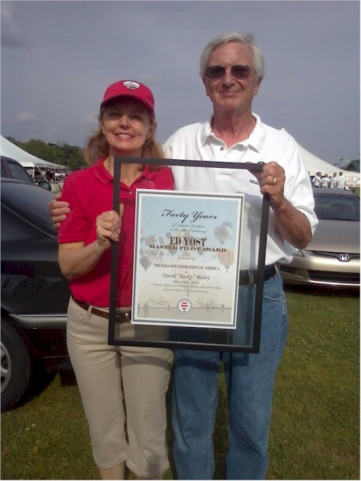
David W (Rocky) Bailey

Notable – Ed Yost Award, Shields Trauger Award

Following are remarks made at the Alabama Jubilee Balloon Event upon the presentation of the Ed Yost Master Pilot award to Rocky.

Rocky is being presented the Ed Yost Master Pilot Award from the BFA recognizing his efforts as a lighter than air pilot who has maintained safe flight operations for 40 consecutive years or more.
Purpose of the award is to recognize LTA pilots who have demonstrated professionalism, skill and aviation expertise by maintaining safe operations for 40 or more consecutive years as active pilots. Rocky has flown continuously throughout his 42 years as a lighter than air pilot.
Rocky received his LTA commercial certificate in 1972. Karl Stefan was his instructor. Rocky has been designated as a DPE in Dallas and Atlanta and has given check rides to: (here is a sampling of pilots that I know of…Robert Harrison, Kevin Thompson, Coy Foster, Tom Hamilton and Laurie Lee…who went on to become Mrs. Bailey).
Rocky was awarded the Balloon Federation of America’s highest award, the Shields Trauger Award in 1989 for his efforts in the BFA Instructor programs.
He has been a sought after speaker for safety seminars for many years and assisted in writing the Balloon Flying Handbook as well as other publications. Safety, professionalism and promotion of ballooning are always first on his list. While he has achieved ratings in just about everything there is to fly and receive a rating in and has had an incredible far reaching aviation career, ballooning has always been, and continues to be, his first passion. Rocky has been accident and incident free through his entire ballooning career and is the ultimate professional at all times.
Rocky Bailey flies in festivals across the country to date and has been safety officer at many. Safety is always first and foremost. At the same time, Rocky always promotes ballooning, ready to answer any questions, offer advice and encouragement, give tethered rides to kids after a flight and is an advocate for landowner relations. He has been interviewed on local and national television including CNN, Weather Channel and Auction Kings! Always, he presents a wonderful and positive image of our sport.

