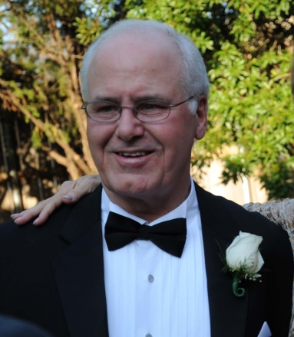
Philip M. Bryant

Notable – BFA Past President

Philip began his aviation career in 1957 flying as a cadet with the Civil Air Patrol in Tucson, Arizona. In the years following he obtained his Private, Commercial and Instructors license in Single Engine Land Aircraft. In 1977, he obtained his Multiengine and Instrument Flight Instructor ratings while instructing at Norris Aviation in Houston, Texas, 1978.
With a total of 4800 hours in fixed wing, Phil discovered hot air balloons in 1991 and obtained his Private Pilot Hot Air Balloon rating on March 7, 1993, and his Commercial Pilot Hot Air Balloon rating was earned on January 15, 1994. Phil earned his Hot Air Balloon Designated Pilot Examiner Certificate, March 8, 1997 and opened a Balloon Repair Station in 1996.
With experience as a Safety Professional with the oil industry, Phil has a keen interest in all aspects of safety. He has applied the principles of Safety Management and Crew Resource Management to produce a successful Hot Air Balloon Flight Team. Phil organizes and sponsors the Lone Star Balloon Association Safety Seminar in Houston during the first Saturday of February each year.
Phil served on the Balloon Federation Board of Directors for six years, served as Vice President for one term and was president from 2002 to 2005. He presently is a member of the Board of Directors of the BFA Gas Division and served as Chair of the Division in 2014.
After taking up Gas Ballooning, Phil has made numerous flights in Germany, and the Americas Challenge, also represented the United States as team 1 for two successive years (2014 – 15) at the Coup Aeronautique Gordon Bennett.

