BALLOON FEDERATION OF AMERICA
HALL OF FAME COMMITTEE
RECOMMENDATION FOR INDUCTION IN 2018

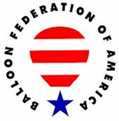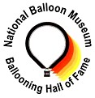

UNITED STATES BALLOONING HALL OF FAME
A Partnership of the Balloon Federation of America and the National Balloon Museum

Candidate Information Form

Date Submitted:

CANDIDATE NAME: Mike Ehrler

Contact Details:

Address: 1601 Tartan Way City: Louisville State: KY ZIP: 40205

Telephone: (502) 459-3505 E-mail: ehrlerm@bellsouth.net

Briefly describe the basis for the submission:

In 1973, Mike Ehrler was the first to purchase a hot air balloon in the Commonwealth of Kentucky and was the first recognized FAA hot air balloon pilot in the commonwealth. He won the prestigious Kentucky Derby Festival Great Balloon Race in 1974. He has continued to participate in the event every subsequent year and was recognized in 2013 for 40 years of continuous years of participation.
Mike was also instrumental in the development of ballooning in the local, state, and regional community. He was a founding member and is still active in the Balloon Society of Kentucky which is recognized as the second oldest and one of the most active balloon clubs in America. Over the past 40 years, Mike has also provided countless hours of instruction to prospective pilots on their journey towards certification. His mentoring did not stop there as he served as the FAA Designated Flight Examiner for our community and provided certification for over 100 pilots in the region.
Mike is an avid enthusiast of aviation and first started his journey as a bomber pilot in WWII. Mike was also honored by the FAA with their most distinguished honor, the Wright Brothers Master Pilot Award in 2011.
PERSON MAKING THE SUBMISSION:

Name: Debbie Spaeth

Address: PO Box 674 City: West Bend State: WI ZIP: 53095

Telephone: (262) 338-2300 E-mail: dasdeb@sbcglobal.netw

REFERENCES:

Reference Name: Brian Beazley Telephone or E-mail: brianbeazly@gmail.com

Reference Name: David Troutman Telephone or E-mail: dtroutman@its-ky.com

CANDIDATE HISTORY

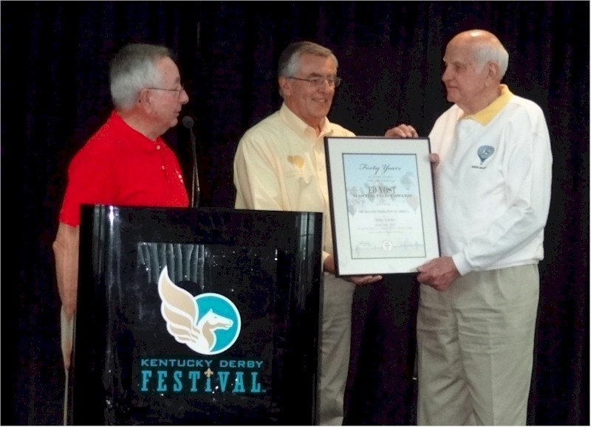
Mike Ehrler

Notable: Achievement/Contributions,
Ed Yost Master Pilot Award

The following is information nominating Mike Ehrler for the Ed Yost Master Pilot Award and was submitted by David Troutman on April 4, 2013.
Please accept this as my letter of nomination for Mike Ehrler to be recognized by the BFA with their Distinguished Pilot Award.
In 1973, Mike Ehrler was the first to purchase a hot air balloon in the Commonwealth of Kentucky. Shortly after receipt, he became the first recognized hot air balloon pilot in the commonwealth by the FAA. In 1974, he piloted his balloon to victory in the prestigious Kentucky Derby Festival Great Balloon Race. He has continued to participate in the event every subsequent year and will be recognized at this year’s event for 40 continuous years of participation.
Mike was also instrumental in the development of ballooning in the local, state, and regional community. He was a founding member of our local balloon club, the Balloon Society of Kentucky. He is still an active member in the club which is recognized as the second oldest and one of the most active balloon clubs in America. Over the past 40 years, Mike has also provided countless hours of instruction to prospective pilots on their journey towards certification. His mentoring did not stop there as he served as the FAA Designated Flight Examiner for our community and provided certification for over 100 pilots in our region.
Mike is an avid enthusiast of aviation and first started his journey as a bomber pilot in WWII. In the late 70’s, Mike designed and built his very own chair balloon (more commonly known today as a cloud hopper) and was featured on the cover of Popular Mechanics Magazine. He was also an owner in the American Blimp Company, a global manufacturer of airships. In 2008, Mike was also recognized as one of the “Legends of Ballooning” at the BFA Convention hosted by his own Balloon Society of Kentucky. As if those accomplishments are not enough, Mike was also honored by the FAA with their most distinguished honor, the Wright Brothers Master Pilot Award in 2011.
In summary, I cannot think of an individual more deserved of this recognition. Ballooning in our part of the country would not exist in the fashion it does today without his stewardship to the sport. His impact can be felt far and wide and he is a true ambassador of the sport and I am honored to have been mentored by him over the course of my life.

