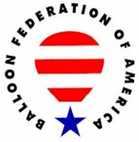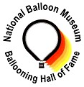

UNITED STATES BALLOONING HALL OF FAME
A Partnership of the Balloon Federation of America and the National Balloon Museum

Candidate Information Form

Date Submitted: March 1, 2017

CANDIDATE NAME: Bill Meadows

Address: 4193 Cambridge Cove #2 City: Southport State: NC ZIP: 28461

Telephone: E-mail: airships@ec.rr.com
Briefly describe the basis for the submission: Bill Meadows began his ballooning career in 1969 with an instruction flight with Tracy Barnes. Tracy sold him his first balloon, a new Piccard AX-6 that year and he soloed in October with his FAA pilot certificate issued in January 1970. He founded Balloon Ascensions LTD in March 1970 and trained over 100 pilots. He completed over 300 balloon promotions nationwide. He started as a distributer for Piccard Balloons and also was National Sales Director for Barnes Balloons. In 1974 he started the National Balloon Rally, now the Carolina Balloonfest, which is still an active event. He flew in the National Championships in 1970-1983 and served on the BFA Board of Directors from 1976 to 1980 and was active in the organization in many positions. He flew in the first Albuquerque Balloon Fiesta and founded the National Balloon Racing Association (NBRA) in 1980 and organized over 100 events nationwide. He was active with The Blimp Works with Tracy Barnes and founded the United States Airships International in 1988.

Provide references: Identify two individuals that can speak to the quality and significance of the achievement, and to the character of the candidate.

Reference Name: Sam Parks Telephone or E-mail: sam@parksqualityair.com

Reference Name: Beth Wright Smith Telephone or E-mail: pilotschool@lobo.net

PERSON MAKING THE SUBMISSION:

Name: Jim Thompson
Address: 9004 Murano Mews Ct, City: Kissimmee State: FL ZIP: 34747
Telephone: (515) 229-5804 E-mail: jim@thompsonaire.com

CANDIDATE HISTORY:

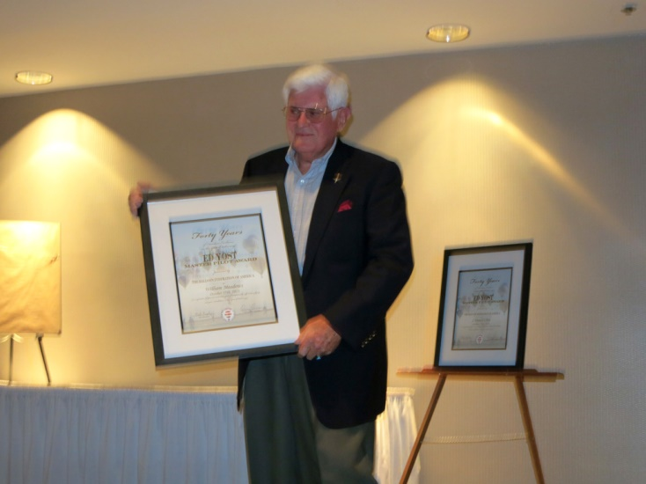
Bill Meadows

Notable – Accomplishments/ Contributions, Ed Yost Award

- Bill Meadows took his first hot air balloon flight in Statesville NC Oct. 4th 1969, his Instructor was Tracy Barnes.
- Tracy Barnes sold him a new Piccard AX 6 in Oct. 1969. This was before Tracy started building his own balloons.
- Bill’s first solo in the new balloon was also Oct. 1969
- Bill’s FAA pilot certificate was issued Jan. 1970
- Founded Balloon Ascensions LTD in March 1970 (2nd. FAA 141 Balloon School). The Company trained over 100 pilots, sold over 50 balloons and completed over 300 balloon promotions Nationwide
- East Coast Distributor Piccard Balloons 1970-1974
- National Sales Director Balloon Works 1974-1981
- Started the National Balloon Rally in 1974 (Now called Carolina Balloonfest) the first year 36 balloons flew, which was double the number of Balloons at the National Championships that year.
- Flew in the US Nationals 1970-1983
- BFA Board of Directors: Southeast Region, 1976-1979
- BFA Board of Directors: At Large 1979-1980
- BFA Events Committee: 1973-1975
- BFA Instructor Certificate Committee: 1976-1977
- BFA Liaison Committee: 1976-1977
- In 1971 Bill organized a promotional series of flight across North Carolina. He started in the mountains and after 31 flights over 69 days which covered 377 miles he landed on the beach in Surf City NC.
- Bill flew in the first Albuquerque International Balloon Fiesta
- Bill has had over 1,200 flights in Hot Air Balloons
- Bill founded the National Balloon Racing Association (NBRA) in 1980 and they operated until 1990. In the 10 years they operated he organized over 100 balloon events nationwide and had a pilot membership of 760.
- In 1990 Bill became the National Sales Director for The Blimp Works. Tracy Barnes had sold the Balloon Works to Sid Conn and Tracy started building helium filled airships and blimps.
- Bill Founded United States Airships International in 1998

Bill still flies Hot Air Balloons and will be flying in the 40th Anniversary Carolina Balloonfest in October, 2013 in Statesville. Bill has not had an accident nor has he had any FAA enforcement action

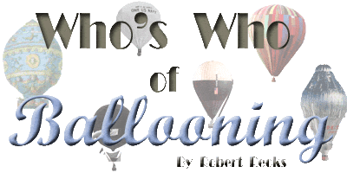
MEADOWS, William USA (1937- (HB)
See APPENDIX-BI/BK/BX. Professional balloonist
b: 30 June 1937, Lillington, NC.
e: N.Carolina State College.
s: U.S.Air Force.
p: Salesman, Professional B-Pilots Assoc.; Electronics technician; Electronics engineer for Blimp Works-1992.
f: First B-Flight 4 Oct.1969 w/T.BARNES; First B-Solo 1969 from Statesville, NC.; FAA B-License 1970; B-Pilot Examiner; More than 1000 B-Hours by 1983.
l: 1970-90, Participated in all U.S.Nat. Hot-Air championships; Developed successful balloon "auto-pilot"; Certified first (?) FAA/FAR-141 Balloon Flight School in the USA.
m: BFA, Board of Directors, Events Chairman. ***Epic series of flights 1971 from Rutherford, NC. Crossed the State of NC (376 miles) in 44 hours, ending at Topsail Beach.

See additional information on following page

