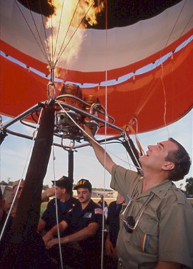
John R Petrehn
Notable – Records, Montgolfier Award
The following is from The World Record of Ballooning as created by Cindy Petrehn and reproduced with permission of the family.

Operation S.H.A.R.E
(Southern Hemisphere Atmospheric Research Expedition)

John R. Petrehn, Pilot
1934 - 1990

John Petrehn took his first balloon flight in 1974 and was captivated by the experience. He spent the rest of his life setting records and pursuing his dream by attempting to fly around the World in a Balloon. Several of his records still stand today.
Petrehn stated "Our first successful world record came using standard technology meaning open wicker baskets and aluminum tanks in 1982, when we bettered Julian Nott's AX6 duration record of 12 hours, 20 minutes with a new record of 13 hours, 24 minutes in a flight from Prior Lake, Minnesota to Richland Center, Wisconsin. For this effort we were awarded The Harmon International Air Trophy." In 1984 with new technology that he developed and received letters of Patent, in his specially constructed Kevlar "Flying Bagel". He flew from Huron, SD and landed in Middletown, Illinois. In his Flying Lightbulb he set 5 world records in distance and duration and was awarded the Montgolfier Diploma for this achievement.
“Anything one man can imagine, another man can make real.” Jules Verne, 1863 … now, more than a hundred years later, Jules Verne’s dream of a grand balloon adventure has become a reality… This was also my father, John Petrehn’s dream. Being from a family of eleven children is usually an adventure in itself, but make the ratio nine males to two females, with interesting parents, add hot air balloons and it has been a never-ending story. As children, we joked that our dad was full of hot air, but as we witnessed his first balloon flight that spring day in Kansas, somehow I sensed that we were closer to the truth than we realized.
Back in 1994, when Steve Fossett began his quest to fly solo around the world, I had the opportunity to have dinner with him and Per Lindstrand (who was also pursuing an around the world record) at the home of Tom and Lesley (now Pritchard) Davies’ in Edwards Colorado. The discussion for the evening at several points turned to my father, John Petrehn and his Operation S.H.A.R.E., my father’s own quest to fly around the world. Both Steve and Per were interested in what had become of his capsule, his thermoelectric heat system and his project in general.
Dad's quest really began with his first balloon flight in Topeka, Kansas with his best friend Chuck Tantillo in 1974. He purchased his first balloon Charlie Brown shortly after that flight. Thus, began his passion for hot air ballooning. That continued until his death in March of 1990, he spent his life setting records and pursuing his dream to Fly Around The World in a Balloon.
At first his balloons were used for tether operations to promote his lighting company. After obtaining his pilot license he purchased his “famous flying lightbulb”. He began showing off light systems, flying his Light Bulb at night, “Flying at night requires that instead of going with the wind, you have to find out where the wind is going.” (John Petrehn) To learn more about the winds, he contacted the National Severe Storms Forecasting Center in Kansas City and was put in touch with Mr. Paul Hammett, a winds aloft expert for NOAA. Paul went for a balloon ride with John and the experience of actually flying a balloon was pleasantly overwhelming. He joined dad’s team in 1980 and taught him about winds and weather.
Recently, our family was asked to participate in a parade in conjunction with a touring Smithsonian exhibit “Yesterday’s Tomorrows” in Middletown, Illinois, the town that dad landed in setting 5 world hot air balloon records. I spent Father’s Day with my mother as we poured through files, boxes of paper, memories and photographs as we put together a display for the Middletown event. I was able to put together the information and events for this story.
"Our first successful world record came using standard technology, meaning open wicker baskets and aluminum tanks in 1982, when we bettered Julian Nott's AX6 duration record of 12 hours, 20 minutes with a new record of 13 hours, 24 minutes in a flight from Prior Lake, Minnesota to Richland Center, Wisconsin. For this effort we were awarded The Harmon International Air Trophy." (John Petrehn) Thirteen hours and 24 minutes today does not seem like much but it was done with standard equipment no GPS, no cell phones and still beats most long jump records.
In 1984 with new technology that he developed and received letters of Patent, with his specially constructed Kevlar "Flying Bagel" he flew from Huron, South Dakota and landed in Middletown, Illinois. 530 miles in 24 hours and 12 minutes. In his Flying Lightbulb he set 5 world records in distance and duration and in 1985 was awarded the Montgolfier Diploma, the world’s highest honor for a balloonist for this achievement.
Nearing the end of his flight, John chose to land in Middletown because of the flat terrain, the fading light and he was near the end of his fuel supply. After landing, he walked to the road and was picked up by local Grant LaForge a Middletown hog farmer. The Logan County Sheriff’s department also received a call of a possible balloon down approx one mile north of Middletown. It was a coincidence that Middletown is also the location of the first transcontinental air mail flight in October of 1911 and in 1926 Charles Lindbergh landed in Middletown on his way to Springfield, IL.
With these two flights, he raised over $10,000.00 for charities and it evolved into his quest to fly around the world. From the publicity he received, he was contacted and purchased 21 crates of government surplus plastic weather balloons. Intending to cut them up for windscreens, he found some of the largest and strongest balloons that had ever been built. He began exploring how they could be used and began to think he could do an Antarctic expedition. After a visit to NCAR in Boulder he began to study the prospects of the first non-stop, un-refueled balloon flight around the world.
John spent the next few years researching wind and weather patterns and the NASA “Ghost Project” where some 380 weather balloons had successfully circled the Southern Hemisphere and been completely recovered. He spent a year evaluating the criteria for such a flight, the logistics of transporting the team, the equipment and fuel, tying in scientific research and his charitable causes and he began Operation S.H.A.R.E (Southern Hemisphere Atmospheric Research Expedition).
Beginning with building a pressurized custom gondola from a seamless high-density polyethylene shell, fitted with survival buoy bag for landing. His life support system included a newly developed thermoelectric generator that would include a heat exchanger to maintain cabin pressure and temperature. The balloon system was to be a dual gas and hot air balloon in a tandem configuration with dual fuel tanks mounted below the gondola made of the same polyethylene. “The plan was to track an orbit at approximately the 45th latitude south, a distance of 17,545 miles which is more than sufficient to meet the requirements for a circumnavigation flight. (John Petrehn)
It was to be a fourteen-day voyage around the world. The original plan was to launch from Perth, Australia.
John obtained a 240,000 cu ft hot air balloon made by Colt, added a 75th year of Naval Aviation Logo and did promotional flights, including a 1986 flight at the Washington Memorial in DC. Dad was a promoter and a salesman he pursued and received all sorts of support and sponsorship. He chose retired Air Force Colonel Rowland Smith as his co-pilot.
Together they were able to have the project declared “Of National Interest” and in March of 1987, with two C141 Starlifter cargo planes, they loaded up 12,000 pounds of equipment, 24 team members and 325 cu ft of helium and flew to Argentina. For this non-profit, scientific expedition, they were graciously offered by the government of Argentina, the use of an air force base in Mendoza.
So what ever happened? To this day, I regret that I was not able to go along on the expedition. It was exciting and I was nervous at the thought of what was really about to happen I stayed in touch with the project headquarters in Kansas City. In Mendoza, while filling the gas balloon, the wind gusted and they developed a tear near the top of the envelope. With only enough helium to fill the balloon one time, they were unable to launch. Disappointed, John stayed in Mendoza for several weeks doing logistics ad planning for a return trip, planning to try again in 1990 or 1991. Later, Steve Fossett flew from that same location and several of John’s team assisted with his flight.
I spent several days with dad the following summer, helping him to plan the actual launch sequence, filming and photographing the models that he had set up. His enthusiasm never waned and he could not wait to go back and try again.
Unfortunately, he had a sudden and fatal heart attack on March 3, 1990. The month before, he had hit a hole in one while golfing. That summer he had made the “cut” at BFA Balloon Nationals in Baton Rouge. He had a successful life and left us knowing that he had attempted to live his dream and the dreams of men for hundreds of years. He had much to be proud of and he did have a grand balloon adventure after all. As the hawks circled overhead at the cemetery that rainy afternoon, I knew he was up there soaring around the world.

See pictures on following pages.

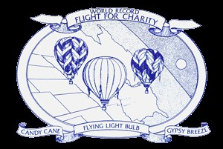
The World Record Flight for Charity

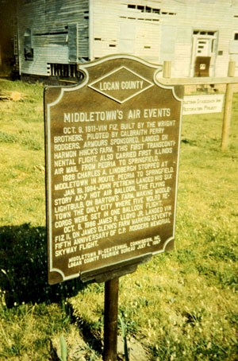
Middletown, IL Historical Society Marker
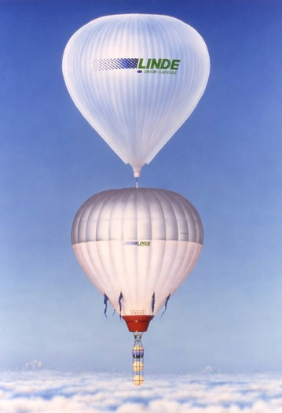
Around the World Concept
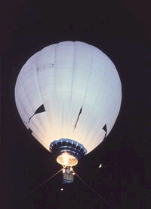
The Flying Lightbulb
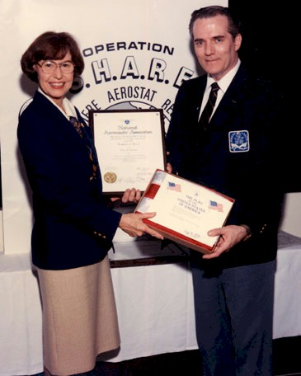
Kansas Congresswoman Jan Meyers Presenting the Montgolfier Diploma

