BALLOON FEDERATION OF AMERICA
HALL OF FAME COMMITTEE
RECOMMENDATION FOR INDUCTION IN 2018

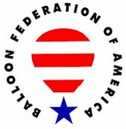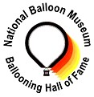

UNITED STATES BALLOONING HALL OF FAME
A Partnership of the Balloon Federation of America and the National Balloon Museum

Candidate Information Form

Date Submitted: 2017 (Not selected for induction by BFA Board of Directors)

CANDIDATE NAME: Brian Boland

Address: 104 Robinson Hill Rd – PO Box 51 City: Post Mills State: VT ZIP: 05058

Telephone: (802) 333-9294 E-mail: balloon@vermontel.net
Website: www.ballooninvermont.com

Briefly describe the basis for the submission:

Brian Boland has been ballooning since 1970, is one of the most experienced pilots in the world, has set numerous world records, won national championships and has flown all over the world, including flights over the Alps and Andes. In addition, he is a world famous balloon designer. Brian owns and operates the Post Mills, Vermont, airport where he maintains an extensive experimental balloon construction facility and a private collection of more than 100 balloons, airships, antique vehicles, and other collectables. Brian is one of the most experienced (if not the most experienced) experimental balloon builders in the world. Since 1971, he has built more than 130 balloons of all shapes, sizes, and materials, including six hot air airships.

Provide references: Identify two individuals that can speak to the quality and significance of the achievement, and to the character of the candidate.

Reference Name: Telephone or E-mail:

Reference Name: Telephone or E-mail:

PERSON MAKING THE SUBMISSION:

Name: Mick Murphy

Address: PO Box 1528 City: Litchfield State: CT ZIP: 06759

Telephone: (203) 910-4955 E-mail: info@aerblarney.com

CANDIDATE HISTORY:

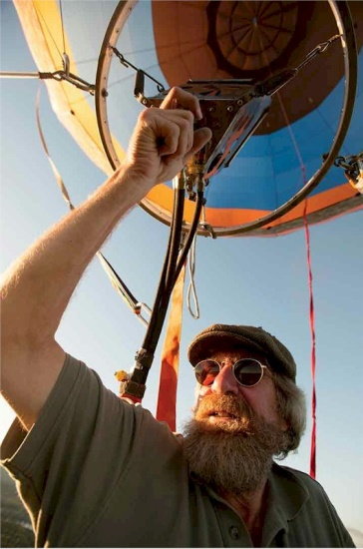
Brian Boland

Notable: Contributions

In 1971, Brian was pursuing an M.S. in Art Education at Pratt Institute in Brooklyn, New York. For his creative thesis project he designed and built a two person hot air balloon he named The Phoenix. On May 17, 1971, Brian flew the tethered Phoenix over the Pratt Campus. Every year on May 17, its birthday, Brian inflates The Phoenix so it can feel the wind on its skin.
In 1988, Brian moved from Connecticut to the Post Mills Airport. In addition to being a fantastic launch site, the 52-acre airport offered Brian a place for his collection of balloons and related items, and space for balloon and airship manufacturing. Always interested in the designs of others, Brian has acquired the largest single collection of balloons and airships that can be found anywhere. In the early 90s, Brian built a private museum at the Post Mills airport to house his antique chase vehicles, ballooning paraphernalia, and more than 200 balloons and airships. Everything in the Boland domain has that homebuilt, experimental patina, from the house he lives in — which ambles and segues into a sewing room, a balloon museum and a wide-open loft workspace — to the vehicles he drives around the grounds.
He's accumulated about 10,000 hours of flying time, and flown in far-flung parts of the world. He's also the overseer of the loosely organized Experimental Balloon & Airship Association (EBAA), which has no dues, no bylaws, and no forms to fill out. Anyone, anywhere in the universe, who builds or owns an experimental lighter-than-air-ship, is automatically a member, whether they know it or not.

BFA Service

- 1978-1979 volunteered “Staff Writer” for Ballooning Journal Magazine.
BFA Life Member
- 1979-1980 volunteered “Staff Writer” for Ballooning Journal Magazine.
- 1989-2001 volunteered as a graphic artist for the Ballooning Journal for ten years.

Achievements

- Brian has currently logged over 10,000 hours in hot air balloons
- Built over 200 balloons
- 1970-71 - built first balloon Phoenix for college art thesis.
- 1972-solo flight from Farmington, CT using home-built balloon and the load tapes caught fire and melted, Brian made hard landing with minor injuries.
- 1972 Introduced the Boland Balloon Menu offer Fred Balloon Kits made out of Tyvek.
- 1973 - Earned airman's certificate FAA B-License #2220650
- 1975-Introduced the Balloon Menu introducing Fred II and the “Porta-Pack” solo systems.
- 1977 - left teaching career for ballooning
- 1978-On 02-Nov-1978 set AX-3 Altitude record 3,477.00 (meters) 11,375 feet
- 1978-On 27-Aug-1979 set AX3 Distance and Duration Record 57.30 kilometers and 03:40 minutes
- 1978-On 30-Nov-1978 opened repair station TV5R2373N
- 1982- On the 14-May-1982, with Kathy Wadsworth & Jorge Delano made first flight over Angle Falls in Venezuela.
- 1988-On the 19-Feb-1988 established Guinness Book of Records from Sebago Lake with 61 passengers flown
- 1988 - purchased Post Mills, Vermont airport
- 1988, Set the Absolute World Altitude Record for all types of airships, 5,059 meters (16,600 feet).
- 1994 -formed Experimental Balloon association and held 1st experimental meet
- 1995- March 3, 1995, flew his homebuilt BX-3 hot air airship to 20,496 feet. Boland’s flight covered a distance of 75 miles. Both altitude and distance attained during the flight surpassed the previous records for BX-3 through BX- 9 categories. Reportedly it would have cost approximately $2,200 in sanction fees to the NAA to claim all of the records.
- 1997 - Completed 100th homebuilt balloon
- 2006-logged 680 balloon flights

Awards

- 1983 Irish Hot Air Balloon Champion, Ballymahon, Ireland
- 1992 Irish Hot Air Balloon Champion, Killkenny, Ireland

See additional information on following page.


BOLAND, Brian Jeffrey USA (1949- (HB/GB)
See APPENDIX-P/BA/BB/BC. Aeronaut extraordinaire.
Ex-husband of balloonist Katherine; Father of balloonist Jeffery.
b: 15 Apr.1949, Queens, NY.
e: MBA-Pratt Institute, NY-1973.
p: Art teacher to deaf; Semi-Professional balloonist; Flew "tour-balloons" in Europe for B.BOMBARD; Owner/operator of Aero Sports facility.
f: First B-Flight 1970(solo) self taught, 1970 from Farmington, CN; FAA B-License #2220650 on 10 Mar.1973; One Gas B-Flight with Tony FAIRBANKS.
l: Built & flew more than 100 self-made balloons & airships by 1998; Holder of many FAI-World AX-Class records; Aerostation author for many Aerostat Publications; 1982, Competitor at Irish National B-Championships; 1983, Completed Hot-Air Airship "Rover" (80,000 Cf.); 1988, Established a World BX-Altitude record of 16,200'. ***Epic flight Spring of 1972 (solo) from Farmington, CN. Load tapes on self-made balloon melted in-flight. Pilot impacted with the ground with the basket & burner, sustaining minor injuries. ***Epic flight 14 May 1982 (W/wife & Jorge Delano) from "Angel Falls" in Venezuela. First successful flight over the falls, landing in the jungle. ***Epic flight 19 Feb.1988 (W/61-pax) from Sebago Lake, ME. Flight established a record in the Guinness Book of Records, for the number of passengers flown. (see C.DAVY-1979=32, H.BRINK-1987=44).***Epic flight 34 Mar.1995 from Sebago Lake, ME. Flight set (not FAI sanctioned) altitude and distance records for BX-3 thru 9 airships.
r: Bio-Data Nov.1983; BL-Feb.1988, Apr.1995p9; Pers.interview.

