Andy Cayton

Notable – Records, Montgolfier Diploma

SPEAKER BIOGRAPHIES
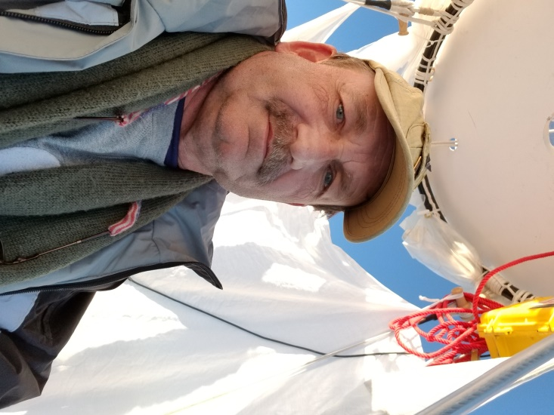
2008 BFA Convention
Louisville, KY

4326 Wilma Edwards Rd. Phone (912) 858-2529
Black Creek, GA 31308 E-mail featherair@comcast.net

Pilot Background:
- Instrument Helicopter: UH-1H, OH-58A&C, UH/MH-60A,CH/MH-47B, C, &D
- Lighter-Than-Air Free Balloon with no restrictions

Flying Experience:
- US Special Operations Helicopter Pilot with 3,000 plus hours
- US team member 2005 Coupe Aéronautique Gordon Bennett (1,219 miles - 1,962.1 Km)
- US team member 2006 Coupe Aéronautique Gordon Bennett
- 2006 America’s Challenge Gas Balloon Race winner (1,478 miles – 2,378.6 Km)
- 2007 America’s Challenge Gas Balloon Race winner (1,054 miles – 1698 Km)
- US team member 2008 Coupe Aéronautique Gordon Bennett

Officiating Experience:
- Owner of Feather Air Hot Air Balloons, Savannah Georgia 1997 to present.
- Aviation Safety Officer / Pilot for Special Operations US Army 1987-1995.
- Aviation Safety Officer / Pilot US Army: 1984-1987
- Event Organization: Event Organization:
- Balloonmeister, 2000-2006 Pembroke Balloon Festivals - Pembroke, Georgia

Affiliations:
- V.F.W. (life time member),
- Army Aviation Heritage Foundation (life time member),
- Balloon Federation of America, Gas Division board member 2006-2008,
- National Aeronautic Association,
- Chamber of Commerce, Savannah, Georgia.

Awards and Recognition:
- 3 World and 9 National Records in Hot Air Balloons:
- Duration AX-6 @ 23 hrs.55 min.51 sec.
- Distance AX-8, AX-9 @ 1,066 miles – 1,716 Km
- 2005 Montgolfier Diploma for hot air balloons (longest solo hot-air flight in history)
- Bronze Star,
- Meritorious Service Medal (x2),
- Air Medal with Valor,
- Air Medal,
- Army Accommodation Medal (x2),
- Army Achievement Medal (x2),
- Senior Aviator Badge,
- Parachutist Badge,
- Air Assault Badge,
- Boeing Defense and Space Rescue Citation (x2).
- Safety Seminar Participation: Safety Seminar Participation:
- Carolina Balloon Association Safety Seminars participant 1996- 2003.
- Speaker at Georgia, Carolina and Texas Safety Seminars on various topics from 2004 – 2006

Most Memorable Flights: Most Memorable Flights:
- February 2007 gas balloon record attempt for distance in AA-6 from Southern California to the East Coast.
- Spending 8 hours the first night circle navigating “Area 51” in Nevada while Air Force ATC explaining why we would be “forced” down if we entered the restricted area.
- Every record flight.
- Every gas balloon flight in excess of 1,000 miles.

