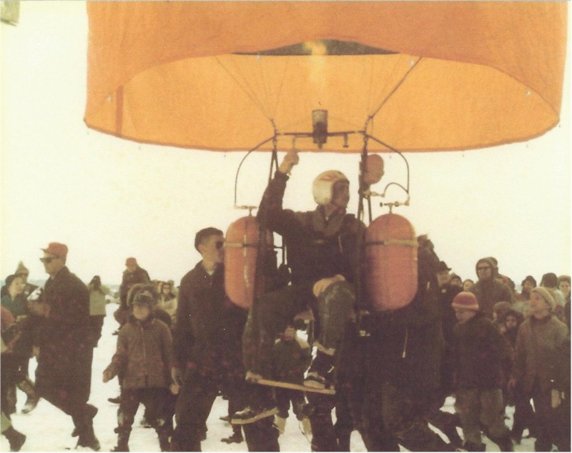
Richard Keuser

Notable – Development

1931 – 2004

Education:
- Georgetown University, Washington, D.C.
  - Pre-law 1949 – 1950
- U. S. Air Force, Biloxi, Mississippi
  - Radar Mechanic School 1950

- University of Minnesota, Minneapolis, MN
  - Electrical Engineering 1957 – 1959

Fields of Competence:
- Balloon Flight Operations – launching techniques, instrumentation, data reduction
- Design and testing
- Supervisor Field Operations
- Hot Air Balloon Pilot
- Scientific Liaison
- Field Site Administrator

Balloon Career:
- 1952 – 2001

1951 - 1959: General Mills, Minneapolis, MN
- Senior Electronics Technician using gas balloons in Panama (collecting air samples for “Project Grab Bag”)
- Worked with Philco Ford: Participated in an attempt to launch a rocket into orbit from a balloon on the island of Eniwetok

1959 – 1968: Raven Industries, Sioux Falls, SD
- Director of Flight Operations
- 1959 – In charge of high altitude balloons launching at Goose Bay, Labrador
- 1959, ’60, ’61, ’62, & ’67 – Director of flight operations at Fort Churchill, Manitoba for ONR (Naval Research)
- 1961 – A contract from the Office of Naval Research allowed further development in Balloon inflation. Dick conducted these balloon flights in Sioux Falls, SD
- 1962 – In Taiwan, Dick dropped leaflets into the mainland of China using small helium balloons
- 1963 – In Palestine, TX he was Director of Flight Operations with NCAR using high altitude balloons
- 1966 – Director for the “Strata Jump” II and III (Nick Piantanida as pilot)

1968 – 1979: Winzen Research, Minneapolis, MN
- 1961 – Alace Springs, Australia, Dick worked as flight director on a contract with the government
- 1971 – Worked with Jack Kelley Helium Inc. in British Columbia, doing log ballooning

1972 – 1979: Started Universal Systems, Sioux Falls, SD (1973 Ed Yost became a partner)
- Las Cruces, NM, launch director for project Da Vinci
- April 1973 – Albuquerque, NM Universal Systems helped as judges for the First Hot Air Balloon Championships
- Summer of 1973 – Dick flew in the Gordon Bennett balloon race for Export A Cigarettes in Canada
- Fall of 1973 – Dick trained and flew the complete trans America Hot Air Balloon Flight with Malcolm Forbes
- February 18, 1974 – Dick was crew chief for launching for Tom Gatch’s Trans-Atlantic Balloon Flight
- 1974 – 1977 – Built gas balloons and wicker baskets
- 1977 – Participated in building balloons for Silver Fox Balloons and launched Double Eagle I and II for Ben Abruzzo, Maxie Anderson and Larry Newman. Also built the balloon for Joe Kittinger for his first solo attempt across the Atlantic
- 1979 – Built the Rosie O’Grady gas balloon for Bob Snow
- Summer of 1979 – Launched balloons in France for Malcolm Forbes

1980 – 2001 – Started HMK, Inc.
- Did government contracts and other miscellaneous projects
- Retired in 2001

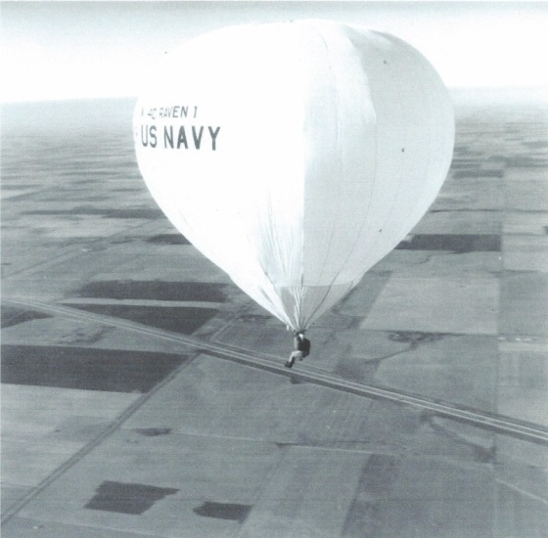
Dick Keuser is referenced in the following publications:
- History of South Dakota Aviation
- Magnificient Failure by Craig Ryan
- Ballooning Magazine (Winter ’74-’75 p. 36)(May- June ’82 p. 47). This is a well-known photo

