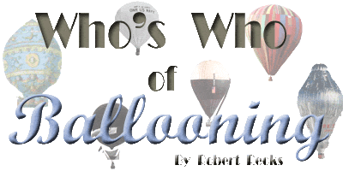

McCRACKEN, Alan E. USA (1897?1960) (GB)
See APPENDIX-AH/AI/AJ/AX. Professional Aeronaut.
p: Balloon pilot for Goodyear, 1925-56; Vice Pres. of E.P. Lambert Co. 1948.
f: Received B-Training with Ward van ORMAN in 1929; No record of FAI B-License.
l: 1929, Aide to ORMAN in the U.S. National B-Race; 1929 & 30, Aide to ORMAN in the G-Bennett B-Races; Owned and operated his own blimp.
r: BF-1950.

