Bert Padelt

Notable – Development, Montgolfier Award, Shields Trauger Award
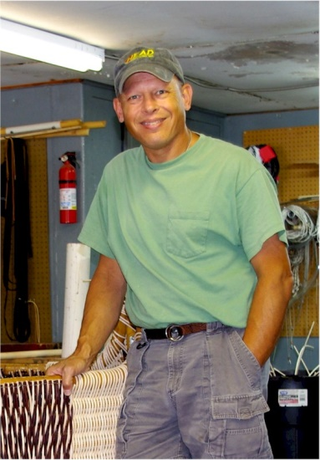
Bert Padelt built the Successful 2015 Two Eagles Transpacific balloon envelope, and was responsible for the logistics, assembly, launch, and recovery process. With the success of this flight, he is now the only builder of gas balloons that have successfully crossed both the Atlantic and Pacific oceans.
Owner of “Best” Aviation services in Bally Pennsylvania, Bert and his wife Joanie run a full time repair station for both hot air and gas balloons. His balloons hold FAI world class records in AX (hot air), AA (gas), and AM (Rozier) categories. His gas balloons now hold distance and or duration records in all but three of the 15 categories. He was the Systems Director for the late Steve Fossett’s round the world balloon attempts including his successful flight in the summer of 2002.
Also in 2002 he built the tetrahedron smoke balloon used in the acclaimed Japanese documentary “Return to Nazca”. It was this balloon that renewed the interest in amateur home built tetrahedron hot air balloons around the country. He built the smallest manned gas balloon to ever cross the Atlantic Ocean when David Hempelman Adams flew his thousand cubic meter balloon from St. Johns Newfoundland to Nolay, France in the summer of 2007 and in so doing set 5 FAI world class distance and duration records.
In 2011 Bert was awarded the FAI Montgolfier Diploma, the highest honor bestowed on a balloonist worldwide, for his contribution to the sport of gas ballooning. In 2015 Bert and his wife Joanie were awarded the Shields Trauger award, the Balloon Federation of Americas highest honor for their years of work in Gas and hot air ballooning. Bert is a founding member of The Aero Club of America. This is the first active gas balloon club since the 1950’s. In 2015 this club received the FAI’s Group Diploma, an international award recognizing the club member’s contribution to the sport of gas ballooning in the United States.
Bert is the Vice Chairman of the BFA Gas division. He has sat on this board for the past 18 years. Bert and Joanie have been married for 27 years and have two sons James, and William.

