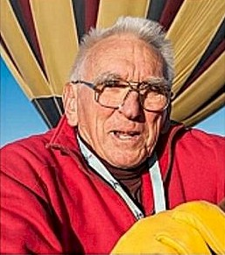
Brent Stockwell

Notable – Accomplishments/Contributions, Ed Yost Award

brentstockwell@verizon.net
PO Box 4055;
711 Industrial Park Dr
Manteca, California 95337
(209)825-4290

Occupation:
- Co-Owner & Chief Flight Instructor, FAA-Approved Balloon Flight School, IA8S209Q
- Previously, an FAA-Designated Pilot Examiner, Balloons
- FAA-Designated Aviation Safety Counselor
- Co-Owner & Chief Inspector, FAA-Approved Balloon Repair Station, WD3R941L

Federal Aviation Administration (FAA) Certificates:
- Commercial Pilot, Free Balloon, no limitations
- Private Pilot, Airplane Single Engine Land
- Previously, a Designated Pilot Examiner, Balloons
- Aviation Safety Counselor, Balloons
- Repairman/Inspector, Balloons

Other Relevant Certificates:
- Credential, Aeronautics/Aircraft, California Community Colleges
- Master Instructor, Balloon Federation of America
- FAA Pilot Proficiency Award, Phase XDC

Education:
- BA, Broadcasting, San Francisco State University
- Many Aviation Certificate Courses:
- Annual FAA Examiner Course;
- Balloon Manufacturer Maintenance Courses;
Industry Flight Instructor Courses.

Some Pertinent Dates:
- 1966, started ballooning; 1968 first solo flight
- 1970. Earned FAA Commercial Pilot Certificate, Balloons
- 1971. First FAA-Approved Balloon Flight School in US
- 1973. Appointed Designated Pilot Examiner, Balloons, Oakland Flight Standards District Office
- 1974. FAA-Approved Balloon Repair Station
- 1981-85, Director, Balloon Federation of America
- 1982, Awarded Distinguished Aeronaut Award, Balloon Federation of America
- 1989-1997, worked with FAA on revision of Federal Aviation Regulations, Parts 61 and 141
- 1990, Team Captain, Experimentation Balloon Flights in Soviet Union, Joint Venture
- between US, Soviet Union, and France, Mars Exploration Program
- 1993, Awarded FAA Certificate of Excellence, Diamond Award, FAA Aviation Technician Training Program
- 2001. FAA publishes Balloon Flying Handbook, FAA-H-8083-11, based on How To Fly A Balloon by Brent Stockwell and Christine Kalakuka
- 2002. Member of Board, Balloon Historical Society

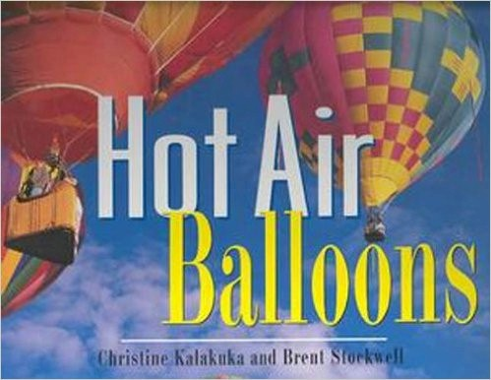
Co-author, with Christine Kalakuka, of the following books:
- Hot Air Balloons, Friedman/Fairfax, August 1998
- How To Fly a Balloon, Balloon Publishing Company, 1993-2005
- Balloon Ground School Home Study Manual, 1987-2005
- Balloon Instructor's Manual, 1992-2005

Other Information:
- 4000+ hours in balloons
- Trained over 350 students to fly balloons
- Flown at least 32 different models of balloons
- Own and fly single engine airplane; have flown gas balloons, airships, helicopters, seaplanes, and gliders

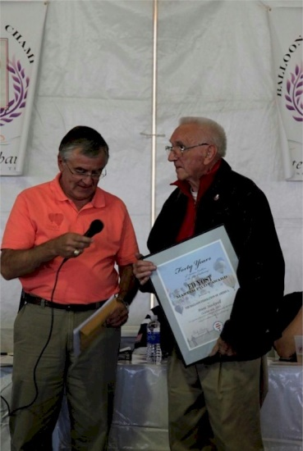
Ed Yost Master Pilot Award:
Brent was presented the Balloon Federation of America’s Ed Yost Master Pilots Award for 40 years of safe flying in 2013.

ABOUT BALLOON EXCELSIOR
- Balloon Excelsior was founded in 1969 by Brent Stockwell and Christine Kalakuka.
- In 1972 we became the first balloon flight school approved by the FAA, and in 1974 we became the first
- FAA-approved balloon repair station in the west.
Orvin Olivier Brent Stockwell
Ed Yost Master Pilot Award
- Balloon Excelsior was the first balloon company in the western US to offer paid passenger rides. In 1989 we stopped offering rides in order to concentrate on flight training.

- Brent Stockwell, formerly the FAA's Designated Pilot Examiner for the district, has tested and issued certificates to hundreds of balloon pilots for over 30 years. He is Chief Pilot for the school and Supervisor of the repair station. Stockwell has flown balloons in England, Europe, Guatemala, Jamaica, Japan, Russia, Ukraine and Mexico, and trained pilots of many different countries, Stockwell and Kalakuka founded the Balloon Repair and Maintenance Association, a national organization of balloon repair professionals. Both write for several balloon publications.

EVENTS
We sponsor several balloon rallies a year, and organize balloon meets for other sponsors and promoters. We have over 35 years experience presenting successful balloon events.

MUSEUM & LIBRARY
Our facility, "The Balloonery", is an informal museum of30+ years of ballooning and we have an excellent library of balloon and airship books. LTA scholars are welcome to use our library for research.

CONSULTING/LEGAL ADVISER/RESEARCH
We have assisted many balloon pilots, balloon companies, and passengers with legal matters and can provide expert witnesses for civil and FAA disputes. Our experienced researchers can provide documented information on ballooning activities.

MAINTENANCE TRAINING
We offer training to become a balloon maintenance repairman.

SAFETY SEMINARS
Since 1978 we have presented at least one balloon safety seminar each year. Our format is a round-table discussion in a relaxed atmosphere as we leam from our peers.

BALLOON HISTORICAL SOCIETY
In 2002 we joined Ed Yost to form the Balloon Historical Society, a small group of balloonists and friends dedicated to recognizing and memorializing the important advances to science made with high altitude scientific balloons. Our first project is the recognition of the flights made by the U.S. Army Air Corps and the National Geographic Society from the Stratobowl in the thirties. Memorial stones have been placed at the rim of the Stratobowl and we are now in the process of gaining National Monument status for the memorial with a paved road, site improvements, and a museum.

