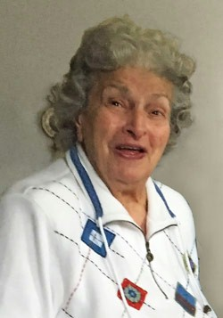
Eleanor Vadala

Notable – Accomplishments/Contributions

Eleanor Vadala is one of the first women pioneers in ballooning in the United States. She had an illustrious career beginning in 1952 flying with many of the distinguished pilots of the time including Hall of Fame balloonist Don Piccard. In her flight career she also flew with Hall of Fame members Peter Pellegrino, Tony Fairbanks, and Connie Wolfe. In June 1973 she flew a flight with Hall of Fame member Bobbie Sparks in “Private Eye” from Allenstown, PA to a landing in New Jersey.
- Eleanor is described as truly a 20th century pioneer in ballooning.
- Eleanor’s first flight ever was the Balloon Club of America’s FAVIA Commemorative flight January 9, 1954 with Don Piccard. It was the 4th flight of the Balloon Club of America N9071-H. This is the flight in which she so remarkably describes their landing as being as gentle as a one of snowflakes falling around them in the Jersey Pines – so quietly they did not even disturb the deer grazing nearby. The flight resulted in a six page story in the April issue of Argosy Magazine.
- Her second flight in the same year was from Valley Forge Airport with Tony Fairbanks on July 4, 1954. A fitting launch site for Independence Day.
- She passed the FAA written exam June 27, 1962
- She passed the FAA Flight Test on July 13, 1963. Her temporary Flight Certificate was signed by Tony Fairbanks.
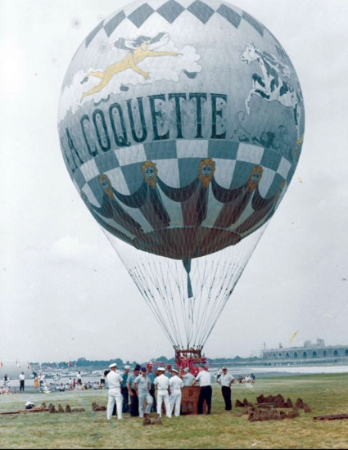
- Her solo flight was October 20, 1962 from Lafayette Hill, PA in the La Coquette. They landed on College Ave., Havertown, PA., a short street about a mile long on the northwest side of the Haverford College campus.
- She was the first Secretary of BFA, appointed by Peter Pellegrino.
- Eleanor’s certificate for her FAA airman written examination was dated June 27, 1962.
- Eleanor’s check ride/flight exam was on July 13, 1963, with Tony Fairbanks. The flight was from Doylestown, PA to Hilltown, PA.
- Eleanor piloted the La Coquette on July 29, 1967 for a 50th Anniversary of the U.S. Naval Air Engineering Center at the Philadelphia Naval Yard. She spoke of that flight as “a Lady flying a Lady!”
- Eleanor participated in 13 International flights hosted by the FAI in Europe from 1959 to 1963. The Gordon Bennett was not held during those years. She was one of the earliest female pilots to participate in the European flights.
- Over the course of the years Eleanor participated in 66 balloon flights, 47 in gas and 19 in hot air balloons.
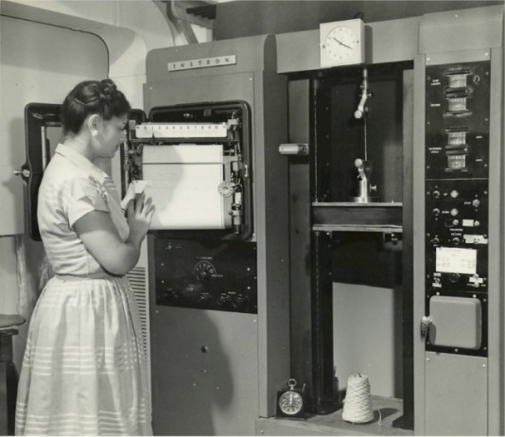
Wherever Eleanor worked, it seemed that “somehow, someone always found out that she flew balloons!” And so it was when she was working as a Materials Engineer at the Philadelphia Navy Yard. She was working for the Naval Air Development Center on the development of synthetic materials of lighter weight for aircraft. She was asked to inspect their balloons which had not been used for a while. “A daunting task!” she said. “The balloon shed looked like it was a mile long!!!” The bag of the balloons was of 2-ply material, but the inner adhesion had disappeared leaving the inner and outer layers independent of one another, as two single envelopes, one inside the other.
The balloon shed was located at the Naval Air Facility in Lakehurst, NJ, so each day Eleanor would take a section of a balloon from Lakehurst back to the Philadelphia Navy Yard for immediate testing. Using a state of the art Instron Tensile Testing machine, she evaluated the weight and the compressive and tensile strength of each layer of fabric. Her findings caused her concern for their safe use, and she “condemned” them, much to the disappointment of a third party who was interested in acquiring them.
Eleanor working on an Instron machine
This picture hung for a while in the Pentagon

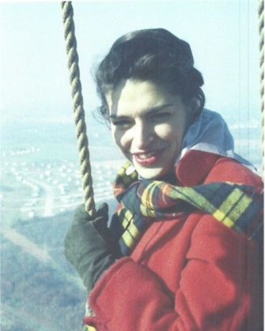
Eleanor
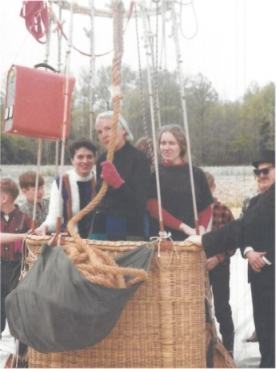
Lt-Eleanor, Center-Connie Wolfe

See additional pictures on following page.

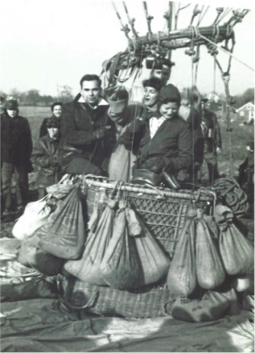
First flight with Francis Shields and Don Piccard

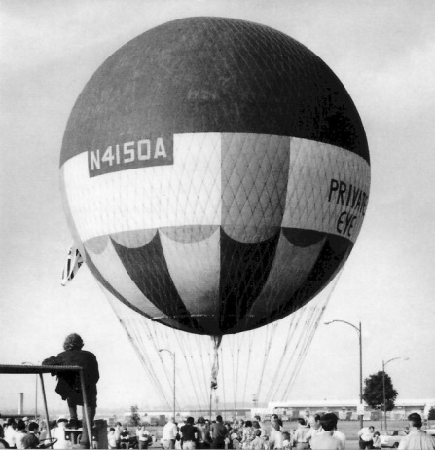
Private Eye with Bobby Sparks

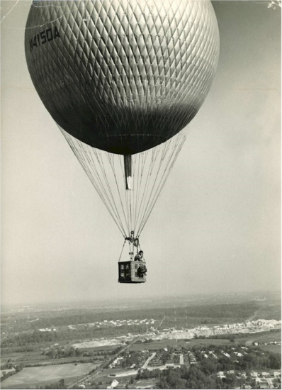
Eleanor's solo flight

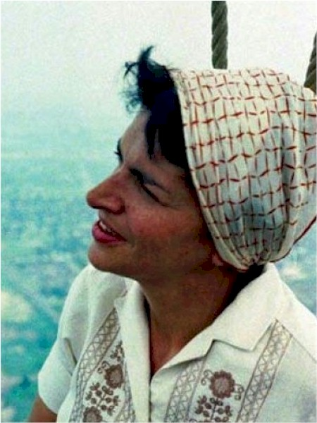
Eleanor

