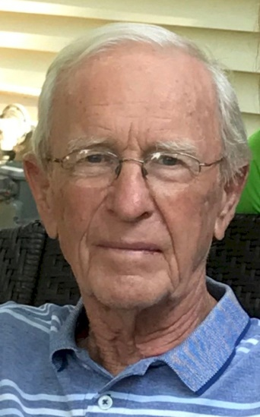
John “JJ” Johnson

Notable – Accomplishments/Contributions

I started my balloon career in 1974 crewing for a friend, Dave Friedley, who was taking lessons from Phil Gray. Phil is one of the pioneer balloonist and commercial pilots from Indianola, Iowa. Phil had a Raven 7 with an aluminum gondola, ouch, and two burners that looked like coffee cans. The pilot light went out periodically so you had to fly most of the time with the Fire Two. I do remember, however, the first time they put me on the mouth for inflation. It was sooo hot; I thought both the balloon and I were done for.
I found the sport interesting and fun. But I never was, and still am not, an early riser and I had wondered how I was ever going to continue in the sport. It was only after I was introduced to the competition aspect of ballooning that I was “in”.
I started my student flying in 1974, got my license, flew some more and received my commercial license in 1975.
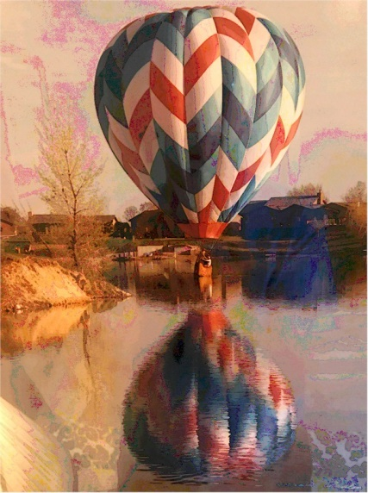
In 1975 my wife Pat and I purchased our first balloon. It was a red white and blue Balloon Works Fire Fly 7 named “Challenger”. Our second Balloon Works was also a red white and blue spiral designed by our daughter Denyce and a crew member Molly Brandt. My wife named it “J J’s Mistress” and all the gals loved the name. They were a good aircraft and great burner. The burner is still being used today by, my daughter Julie’s husband, Tom Ricke who is a pilot. Tom loves the sport and donates many hours of his time as the Safety Officer at the National Balloon Classic and other races in the area. He said he was happy that he married into a ballooning family otherwise he most likely would not have gotten involved in the sport.
For over 20 plus years we participated in many balloon events in our area and surrounding states plus an event in Mexico City along with 100 balloonists from the U S.

Competition Memories

My first introduction to balloon competition was crewing in 1974 at Indianola during the National Balloon Championship. The main target was by the water tower located on Simpson College. You could make as many runs at it within a certain time frame and energy.
In 1977 I had enough hours to qualify for the Nationals in Indianola. I sent my registration in and received the material but didn’t read it because I was too busy. I thought I knew what was going on anyway and low-and-behold they were using the World Rules that year. My crew and I started reading the rules after the first pilots meeting out on a picnic table. We flew in the Nationals every year for 20 years. My best finish was 9th place. I’ve flown a lot of good fun tasks and enjoyed tough competition. My biggest problem was getting the task sheet away from my kids so I could read it. We had had great times, lots of fun, and it was a great to get away on the weekends with nice people.
I’m proud of being the #1 qualifier for the U S National Championships, twice, once in 1999 and in 1982 along with the Budweiser Trophy.
I flew in the National Balloon Classic in Indianola most years. It’s been a very enjoyable, well run, and organized week-long event. I finished in the Top 10 several times that also included a 1st and 2nd place finish. The balloonists who take turns serving on the Board of Directors should be very proud of themselves. I know it takes a lot of their time to manage the operation to keep this event alive and strong. Congratulations too all of you.
One of our most favorite weekend qualifying, sanctioned, events each year was the Wisconsin Dells Race run by Tom Shepard and Debbie Spaeth. It was always the first weekend in June for 20 years starting in the late 70’s. It was the largest sanctioned race in the county. Over 100 balloons flew and many states were represented. It was run very professionally and was a “must” event to attend. I’m happy and proud to say I won it twice and finished in the top ten several times.
I served on the BFA Championship Board of Director for four years in the 80’s. I served as the Assistant Director along with Dick Drake at the National Balloon Classic in Indianola.

Some Memorable Events

- I won all three events at a weekend race held in Davenport, Iowa.
- I had a flight to 15,000 feet.
- Cross Country Flight - After obtaining an anticipated winds aloft forecast for the next day we planned a cross county flight. It was a comfortable, mild Sunday afternoon in snow covered December. I flew 80 miles to the SE direction for an hour and fifteen minutes. When I took-off for the first 1,000 feet I flew NW, then started my turn to the SE. Fortunately, when I descended and got to about 1,000 feet again I turned NW again and had a stand up landing. I flew most of the flight at 10,000 feet. Because the GPS wasn’t around at that time, I don’t know the actual wind speed but the forecasted at 9,000 feet was 70 mph. Maybe it’s a good thing I didn’t have a GPS on board!
- We participated in a two week Kodak Tour with our balloon and Dick and Phyllis Drake crewed. We started in Chicago then were off to Kansas City and ended in St. Louis over the 4th of July. As a result, our balloon was featured on many Hallmark greeting cards, puzzles and wrapping paper.
- Several years after retiring from ballooning the Drake’s asked Pat and I to crew for them at the National Balloon Classic in Indianola. Sure, we’d love to do it and did. It was a fun time going to the pilots meeting together, reviewing the task sheet and agreeing on a launch area. Dick was the pilot and I tossed the baggies. The gals were the chase crew. Over the years we attended races together with our families competing separately. But, this was a nice event flying together AND we finished in 2nd place. It was a great week. Try it sometime!

It’s a Great Sport! Loved it!

