Caton, Roy

Notable – Ed Yost Award

I started flying hang gliders in 1974. Greg Hanson suggested that I might be interested in crewing for his brother, Mel Hanson, who recently bought a balloon. Like most other pilots, I crewed several times and then received a ride or two. I then got my cousin larry Salters involved and after one and a half years, we decided we also could be balloon pilots. We bought a balloon, took lessons, and studied on our own for the written exam. And yes, back in 1978, it was a written exam taken with a #2 pencil. Larry passed his check ride in late May and I followed up a week or two later. We did the usual flying after that, taking friends and family for rides and becoming involved with the local ballooning community.
In the mean time, Mel Hanson was building his business, The Balloon Inc.. In three years he had build it up enough that he needed more pilots and I was given the opportunity to become a corporate pilot. I figured I could do this for about seven or eight years before it either went away or I got tired of traveling around the country , staying in motels and being away from home. About fifteen years later I decided that I had better start calling it my career. I was still enjoying the travel and flying and had made a lot of friends all over the country. How lucky can a guy get? Not only was I getting paid to travel around the country, going to balloon events and other promotions, but my corporate sponsors turned out to be some of the greatest people I have gotten to know.
The events of 911 impacted all of aviation including ballooning. Unfortunately this included The Balloon, Inc.. Between the loss of some corporate sponsors and some health issues, The Balloon, Inc. closed shop leaving the United Van Lines as the only company wishing to continue it’s 21 year program. I was very fortunate to be able to take over running United’s balloon operations from that point on. A year later Unigroup, the parent company, decided to add a Mayflower balloon to the fleet. I recommended hiring Kevin Knapp to captain the Mayflower balloon, and for the next five years Kevin made me look good. Thanks Kevin! After twenty nine years, five standard shapes and three truck shaped balloons, and a change in marketing managers, Unigroup decided to end the program.
Luck smiled on me again! The St. Louis (home) ride business, Balloons Over The Rainbow, was looking for a pilot willing to fly it’s larger balloon. At that time it was a 180,000 cu. ft. eight passenger balloon. I became a ride pilot and loved showing a group of people a good time. I was also flying where I grew up and where I learned to fly. And to top it off, I was home after every flight! Well, not after every flight. We took a balloon to Albuquerque to fly rides in Rio Rancho, giving me a chance to visit with a lot of friends that I would not get to see by being on the road.
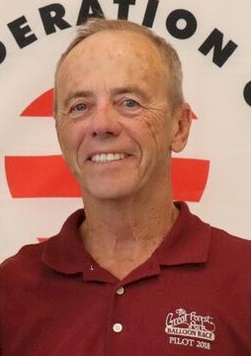
I’m happy to say that after forty years and 3,100 hours, the only injuries to any of my thousands of passengers has been a bruise or scrape after a particularly sporting landing. For his safety record, Roy was presented the Ed Yost Master Pilot Award at the 2018 BFA Annual General Meeting in Albuquerque.
Like I said, how lucky can a guy get. Gentle breezes to all of you.

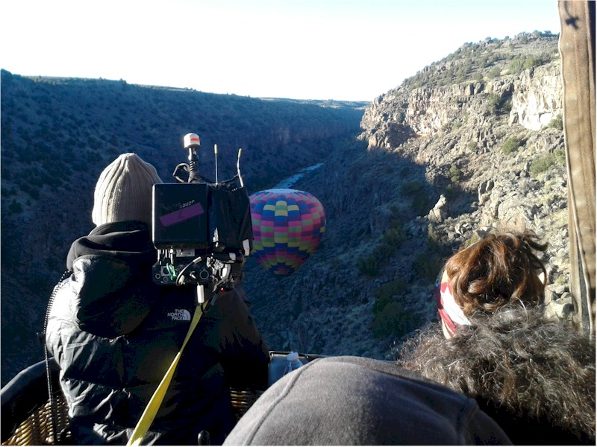
Flight for the Batchelor TV Show.
Article on the Flight was in Ballooning

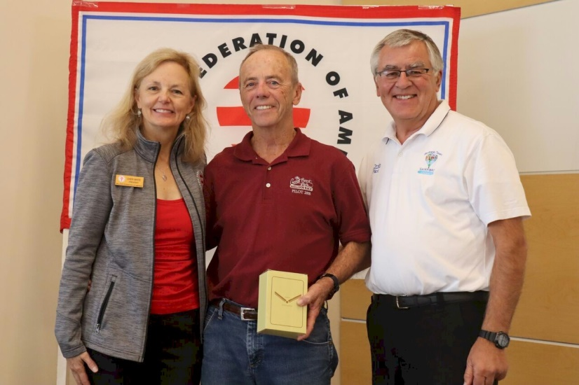
2018 BF Annual Meeting

