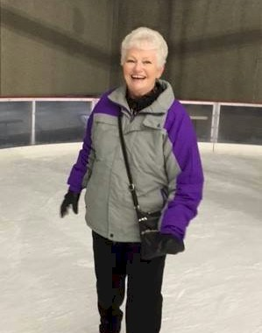
Annie Laurie Points

Notable – Accomplishments/Contributions

Anyone living in Indianola, IA, in the 1970’s was well aware of hot air ballooning due to the U.S. National Hot Air Balloon Championships held each summer on the Simpson College campus. Like so many in the community, Annie Laurie Jones wondered how she could become involved. At that time the Indianola Education Association was active on the event publicity committee, which included manning the public address booth on the balloon field. In 1976 Laurie was in the booth supporting NM State Senator Tom Rutherford who was announcing the balloons as they launched off the field in front of the fraternity houses when a scoring official entered the booth.
Conditions were right for the Elbow Bender competitive event and more scorers were needed. Could the PA booth spare a few volunteers? Laurie volunteered not realizing that she would be riding in the balloon that she was scoring. Grabbing the scoring map, she climbed in the basket of Phil Hibbard from Houston, TX, and enjoyed documenting their long slow flight. That was an expensive flight because Laurie was heard to say as she exited the basket, “I’ve got to get one of these!”
Gary Ruble signed on as her private pilot license instructor where she earned twenty flight hours using his Raven “Spectra”. Laurie’s solo flight was unique due to -13 degree weather on a sunny February day. The flight went well until she decided to land. Spectra was a black balloon that must have absorbed the sun’s warmth because she couldn’t vent enough to be able to land. After flying for several minutes without landing, Gary told her to turn off the metering valves in case they were adding heat. Only then was Laurie finally back on the ground. FAA Examiner Phil Gray approved her private license on June 2, 1978.
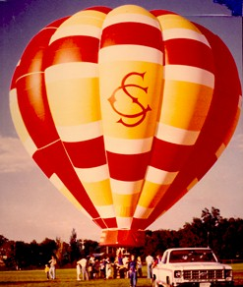
During the year, husband Dr. Fred Jones negotiated with the college to allow bids by manufactures for a Simpson College balloon. In July of 1978, along with Simpson alums Gary and Kathy King the Hawkeye Wind Drifters, Inc. was formed. They celebrated the ownership and arrival of the red and gold Simpson College balloon, a Piccard AX6, named “Simplicity’s Charm”.
Having trained on the Raven system, Laurie enlisted the assistance of Dennis Cox, pilot of the Shorty’s balloon, to familiarize her with the differences of the Piccard. To some degree she felt that she had to learn how to fly all over again!
After additional hours, FAA Examiner Thomas H. Sheppard approved Laurie for the Commercial License in August. Laurie had increased her involvement in the National Championship by becoming the event General Chairman for Indianola Balloons Inc. (IBI) the local sponsoring organization. In a yearlong effort, she marshaled the activities of 4,000 volunteers to produce the 1977 U. S. National Hot Air Balloon Championships. They were divided into seven committees: the governing IBI Board, Finance, Publicity, Public Services, Pilot Services, Logistics, and Hospitality Squad. She worked with BFA Balloonmeister John C. Davis IV from Albuquerque, NM. They welcomed 176 pilots from all over the nation with Bruce Comstock from Ann Arbor, MI, taking home the Championship honors.
In June of 1978 Annie Laurie attended the BFA National Convention in Knoxville, TN, along with IBI representatives, Charles and Irene Laverty, Gary Ruble, and Fr. Lawrence Burns. Flying from Pickle Island with Fr. Burns in “Astra” she enjoyed sharing the sport when they landed at the Holston Country Club. Out of the clubhouse poured elegant ladies in floor length gowns that were celebrating an 80th birthday. For their pleasure and to their delight tether rides were provided for all the ladies, which was a challenge in their gowns!
Anxious to see how she might improve her leadership, Laurie continued as IBI General Chairman for the 1978 Nationals. With Thomas H. Sheppard as Competitor Balloonmeister the BFA expanded their staff to include an Observer Corps, a contingent of scoring officials, under the leadership of Debbie Spaeth. Non-Competitor Balloonmeister A.L. Nels lead parallel tasks for these pilots. A total of 165 pilots came to fly tasks with Sid Cutter from Albuquerque, NM, achieving the title of National Champion.
To further the expansion of competitive events, Thomas Sheppard invited Laurie to present the IBI system of utilizing volunteers to save costs to an organization in Battle Creek, MI. They were considering a bid for the World Championship as well as developing their own event. She prepared a notebook outlining the yearlong activities of the IBI Nationals staff and presented visual aids leading the discussion.
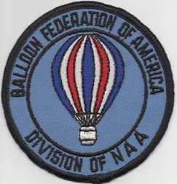
About this time Laurie met with BFA Membership Chairman Dave Beukelman from Ft. Dodge, IA. The BFA was growing rapidly and the membership services had almost become a full-time job. She took on the Membership role with the hope that the BFA or IBI might consider hiring someone to assist. Like Dave, she processed new memberships, sent out Welcome booklets with pins and patches, worked with the Ballooning Journal to maintain an up-to-date address list and made reports to the BFA Board of Directors. After a variety of negotiations, office space was found just off the southeast corner of the square and Sharon Ripperger was hired to provide the BFA with membership services. Today this office is at the National Balloon Museum in Indianola.
During the 1979 U. S. National Hot Air Balloon Championships Laurie became the IBI Chairman of the Observer Corps Services. She worked closely with Debbie Spaeth, Assistant Chief Observer/Debriefer, as well as Balloonmeister Thomas H. Sheppard to meet the needs of the observer scoring officials throughout the week.
As a member of the Iowa Balloonist Association Laurie and Terry McGonegle coordinated the organization of a Safety Seminar to benefit pilots through shared experiences, equipment trends, and latest safety practices. For this continuing education effort they received Outstanding Service Awards from the IBA.

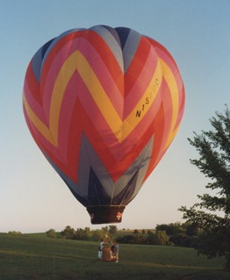
Perfect Match
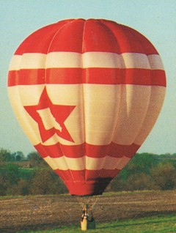
Red Dawn
Over the years Laurie joined area pilots in Iowa balloon events in Ft. Dodge, Clear Lake, Oskaloosa, Altoona, Quad Cities, Adair, Ottumwa, Keokuk, and Creston. She participated in Cloudbustin’ Kansas City and the Pershing Balloon Derby in Brookfield, MO. Laurie flew competitively in the U. S. Nationals with a final ranking as high as 29th in “Simplicity’s Charm”. Her last Nationals competition was in 1985 in a balloon named “Mnementh”. Valuing the Balloon Works system, she purchased an AX7B called “Perfect Match” continuing to fly in Iowa events.
After moving to Las Vegas, NV, Annie Laurie flew in and served as Assistant Balloonmeister for the North Las Vegas Fairshow Balloon Rally. Laurie worked with the North Las Vegas Chamber of Commerce, Balloonmeister Dale Points and the Clarke County Community College to produce the Nevada Championship Balloon Race for three years.

She flew in the National Classic in ‘05 & ‘06 in Indianola in the balloon “Red Dawn” owned by Old World Balloonery, Inc., her son Jason Jones’ Ride Company out of Overland Park, KS. Laurie returned to the Classic in 2017 in “Heaven Sent”.

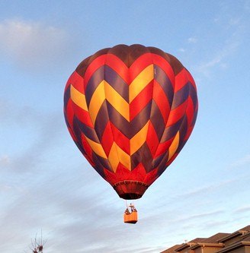
Hollywood Nights

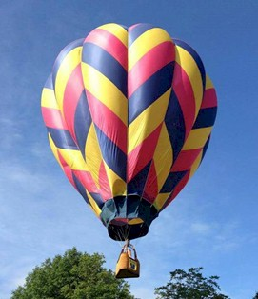
Heaven Sent

The first week in October is a difficult time for any teacher to ask for time off to balloon. Annie Laurie chose to wait until she retired and was living in Overland Park, KS, before she could fly in the Albuquerque International Balloon Fiesta. Along with son Jason she flew “Hollywood Nights” in 2015 and on her own in her balloon “Heaven Sent” in 2017 which was a dream fulfilled.
Flying is her passion but Annie Laurie also likes to crew for her son Jason Jones as he competes. She has crewed for him in U.S. National Championships in Columbia, MO, Waco and Longview, TX, and Shreveport, LA. In 2001 Jason and teammates Rick Jaworski and Matt Fenster won the U.S. National Team Championships in Battle Creek, MI. Jason serves on the Hot Air Balloon Competition Division Board, trains new pilots, and introduces passengers to ballooning with his ride business continuing the family commitment to the sport.
In 2018, Annie Laurie received the Ed Yost Master Pilot Award for Forty Years of Safe Flying. Totally surprised, she thanked presenter Orvin Olivier, the BFA and IBI for giving her so many opportunities to serve. The ballooning community will always be her second family. Ballooning will continue to provide the sensory experience that she treasures.

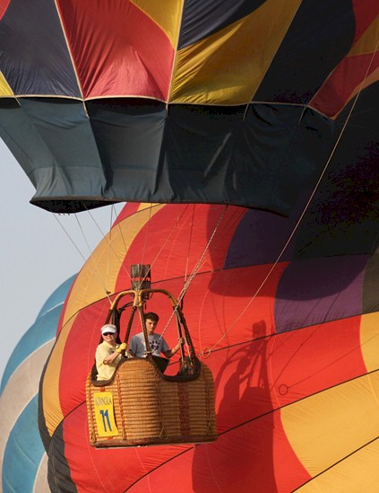
Flying “Heaven Sent” at the National Balloon Classic in 2018.
Picture taken from Des Moines Register website.

